Classroom Plan
Objective: Whether and how the artificial light affects the observation of the astronomical objects at night.

Prerequisites: Knowledge about the constellations.
School year: 7th grade (years 11-12)
Time: 90 min (or two periods)
Material: For the Teacher - Computer with Stellarium and Excel, data projector and, if available, an interactive board.
For Students - Computer with internet connection and Stellarium.
Level of engagement: High.

How many stars can I see at night?
The teacher should distribute Worksheet 1 to students prior to this class, so they can do their respective observations. Preferably distribute the worksheet several days before class in order to realize the night watch with good weather conditions, and with the help of their parents.

1. The teacher can show a video observing the night sky in timelapse. View: https://vimeo.com/78978601

2. Distribute the students in groups of 2 or 3.

3. The Teacher fulfill the Excel table with the observations of students. Example:

Number of stars | Number of students
0-10 | 0
11-20 | 1
21-30 | 3
31-40 | 6
41-50 | 9
51-60 | 2
61-70 | 0
71-80 | 0

4. Plotting the distribution of the observation of the astronomical objects based on the number of students.
Example:

5. Open the discussion with the students (brainstorming). Build the important and relevant questions about this topic.
Example:
- Do we see the same number of stars if we are in the same region?
- Can some students observe more stars than others?
- Can any factors (human, nature) influence our observation?
- Is any factor more important than another?

6. The Teacher fill the Excel table with the students’ results about the maximum number of astronomical objects observed with the cardstock when facing the constellation of Orion. Example:
Student | Max of astronomical objects observed
1 | 10
2 | 8
3 | 10
4 | 11
5 | 14
6 | 15
7 | 12
8 | 13
9 | 12
10 | 10
11 | 14
12 | 12
13 | 13
14 | 11
15 | 9
16 | 10
17 | 12
18 | 13
19 | 11
20 | 12
21 | 10

7. The Teacher calculate the mean, draw the graph, and discuss the results with the students (They can compare this results with the previous in 5). Example:

Mean = 12 astronomical objects

8. Gather some explanations from the students. Example:
- We can’t see many stars at night sky because of:
- City lights (even if we are in an urban region);
- The pollution from industry;
- The clouds;
- The moonlight;
- Volcano’s activity;
- The atmosphere, air;
- The satellites (too many).

9. The Teacher can now open the Stellarium software (see image in the next page).
9.1. Choose → Sky and window options [F4]
9.2. In the “Atmosphere” area, select a value for artificial light.
9.3. With the students’ help, ask them if the projected image is close closer to the sky night observed (can count the stars, for example).
9.4. The room should have the lights off and be as dark as possible.
9.5. Now light up a light (can be the board light or a flashlight) and ask students to describe what they observe.

Note: The students may try to make a small count of observed stars in the constellation of Orion with the lights off and on).

10. Change in the “Atmosphere” area the value of the artificial light and repeat the observation with the lights off and the light on.

11. Remove the atmosphere and artificial light in the program options (see step 8) and ask students to describe what they observed. Noted that there are places on the planet where the observation of the Universe is very close to that observed here in the program (not to mention what places is, it will be a task of Worksheet 2).
Note: Students can try to perform the count with the lights off and on.

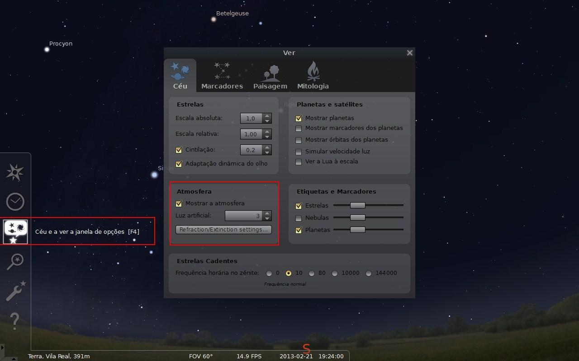

12. Now students in the respective computers (one computer per group) can explore a little bit the program and they can locate they observation in the Google Maps or Earth.

13. Distribute Worksheet 2. Students will conduct research on the Internet to answer some of the questions.

14. As a conclusion, show the image that follows (we can provide the address for the students to explore the simulations in the classroom or at home: http://www.need-less.org.uk/)

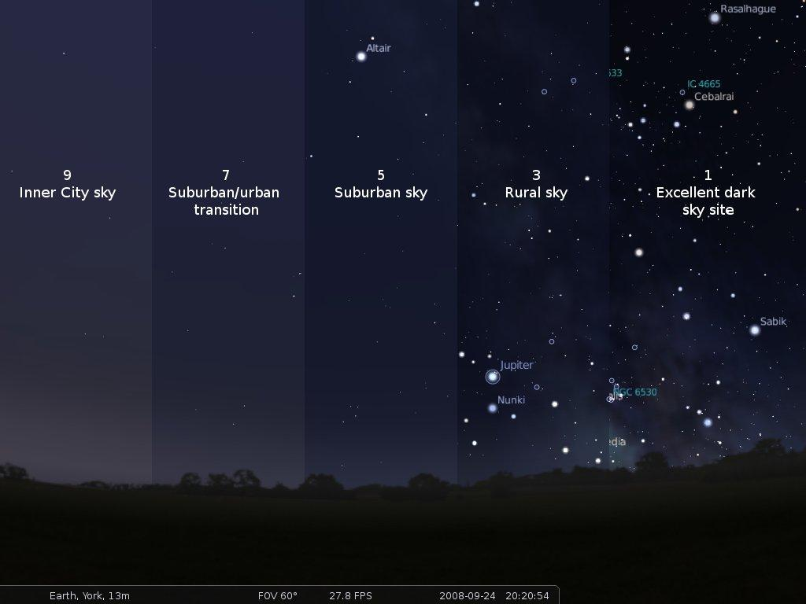
Credit: http://www.need-less.org.uk/

15. Refer to the Homework (explain how the observed sky night can be inserted on the Globe at Night website).
Homework: Take a look to the constellation of Orion and register it at:
http://www.globeatnight.org/webapp/

Participation data for Globe At Night 2013:
- From 3 to 12 of March;
- From 31 of March to 9 of April;
- From 29 of April to 8 of May.

José Gonçalves
www.eufisica.com

Worksheet 1
1. Identify some of the night sky constellations already studied. Represents three constellations, with all the stars that you can observe in the following spaces:

Note: You can use your smartphone, tablet or laptop, with your astronomical app, to recognize some constellations.

2. Cut one black cardboard with the dimensions shown in the figure below.
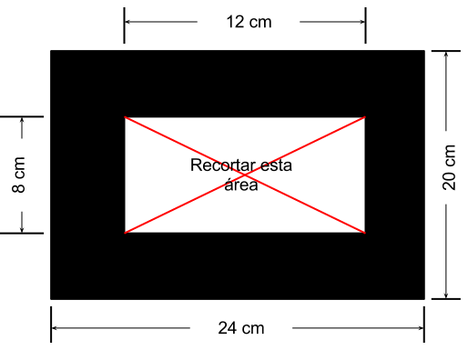
Also cut this area
Looking only at the cropped area, try to count the highest number of stars that you can see. Notes the observation in the table.
Now, you have to change the direction and make a new observation. Register again.
Complete the table with the number of observations requested.

Observation | Number of Astronomical Objects
1
2
3
4

3. Try to locate in Google Maps the place where you made the observations and register the coordinates:
Longitude: ________________ Latitude: ________________

4. Looking now to the constellation of Orion, you must count the maximum number of stars that you can see, by using the same cardstock.
TOTAL: ________________
José Gonçalves
www.eufisica.com

Worksheet 2

1. You have been able to observe that the higher artificial light, the lower the possibility to look at our universe.

1.1. Discuss with your teammates and write which are the main causes of light pollution, by their nature:
a) natural causes;
b) anthropogenic causes.

____________________________________________________________________________
____________________________________________________________________________
____________________________________________________________________________
____________________________________________________________________________

1.2. Working out with your fellow two measures to reduce light pollution.

____________________________________________________________________________
____________________________________________________________________________
____________________________________________________________________________
____________________________________________________________________________

2. In your view which may be the best places to make the observation of the Universe. Justify your answer (if necessary, do a search on the internet).

____________________________________________________________________________
____________________________________________________________________________
____________________________________________________________________________
____________________________________________________________________________

José Gonçalves
www.eufisica.com

