The Story of the Viking Galmi
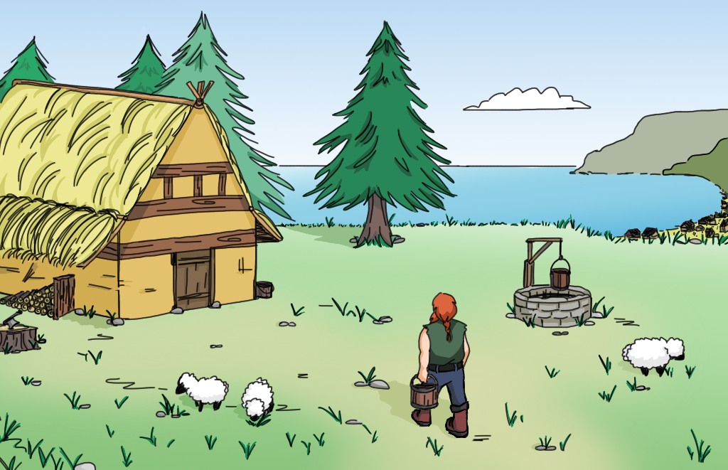
“This is the day”, Galmi thinks by himself as he looks out into the bay of Vikebygd. He is a Norseman in his early thirties and has spent most of his life struggling to feed his family on his farm. His wife Sága and his daughter Oda have endured a lot, but Galmi has made plans that could change things for the better. He came here 15 years ago with his parents who set out to find their own little piece of land and live peacefully. However, the last two winters have struck them hard leaving only little that could be spared for sowing out next spring.
© Arianna Musso Barcucci
Last night, Galmi told Sága and Oda that he would go to Avaldsnes and sign on for the next raid to the land in the West. News had travelled about the riches his fellow Vikings had brought home from the realm of the Scots and the Picts. And he definitely wanted a share. “We would be able to buy us food and seeds to survive until next summer”, he explains. Galmi packs his pouch for the hike that should take not much more than 9 hours. Sága and Oda are sad and afraid, but they also know that this would probably be their last chance. And if everything turns out for the best, Galmi should be back within a week the latest.
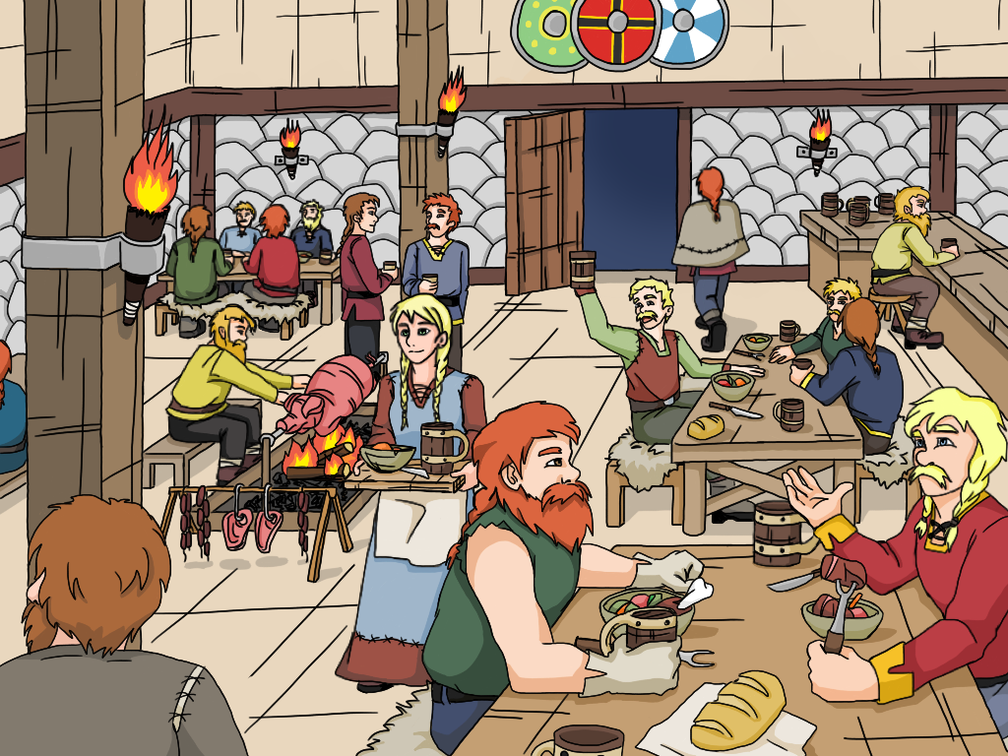
He arrives in Avaldsnes just before sunset. It is a busy little town with about 15 houses, a market place, the chief’s residency, and, of course, a harbour with a handful of longships anchoring. Tomorrow will be the last raid for this season, and Galmi wants to be on board. He enters a tavern and quickly finds a group of experienced sailors. They share a few drinks and Galmi befriends them. It turns out that one of them is the nephew of an old friend of his fathers, Floki. And Ragnar is the leader of this group. They are about to head for the mead hall where the chief of the island of Karmøy, Augvald, assigns the raiding parties to their ships. Galmi is lucky. Together with Ragnar, Floki and 21 other Vikings, he will set sail for Inbhir Nis next morning, a rich Celtic village at the mouth of the river Ness.
© Arianna Musso Barcucci
Galmi does not get much sleep during the night. He is torn between the excitement of the journey and the battle ahead and the insecure future of his family. Just as his fatigue starts to win against the racing thoughts in his head, Ragnar calls him. And Floki is already at his side. It is before sunrise and the chilling breeze from the North delivers a glimpse of the nearing autumn. As they reach the shore, three ships have already left the pier and 8 oars at each side of the boats accelerate them quickly north to the mouth of the fjord. The rest of Galmi’s crew is already here and prepares the ship. It is a real beauty. “Galmi! Here is your seat”, shouts Rollo. “You’ll be among the first to row!” Galmi shrugs, “Sure! Why not?” Ragnar and Floki smile and they jump on board.
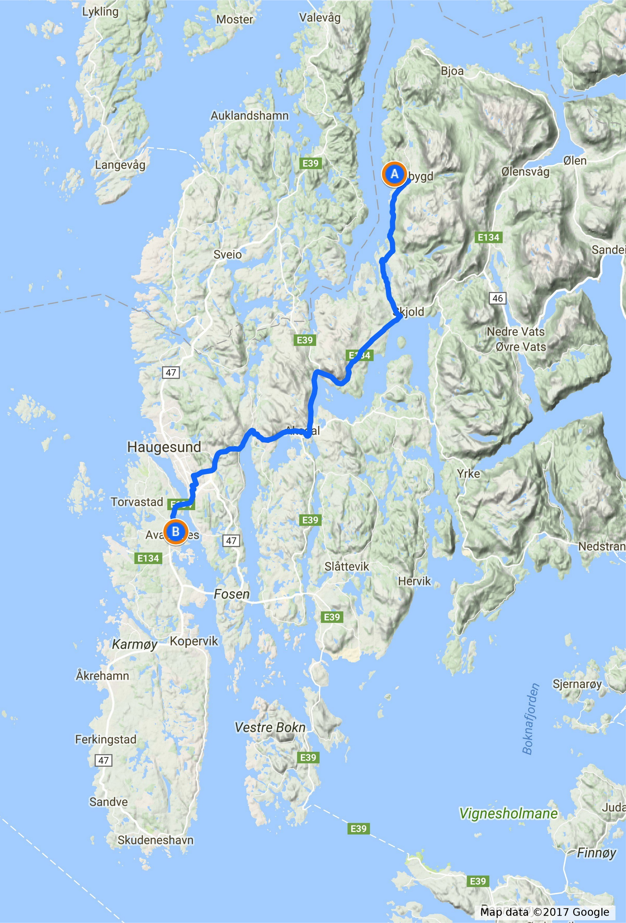
Avaldsnes
Vikebygd
Figure 1: Hiking route of 43 km that takes Galmi from Vikebygd to Avaldsnes in southwestern Norway.
One hour later, the ship leaves the fjord and the winds turn out to be favourable. They set their sail and the ship accelerates smoothly out to the open sea. Galmi is excited and surprised how steady this ship is despite the waves and the shallow draught. It is a sunny day and the gods seem to be with them.
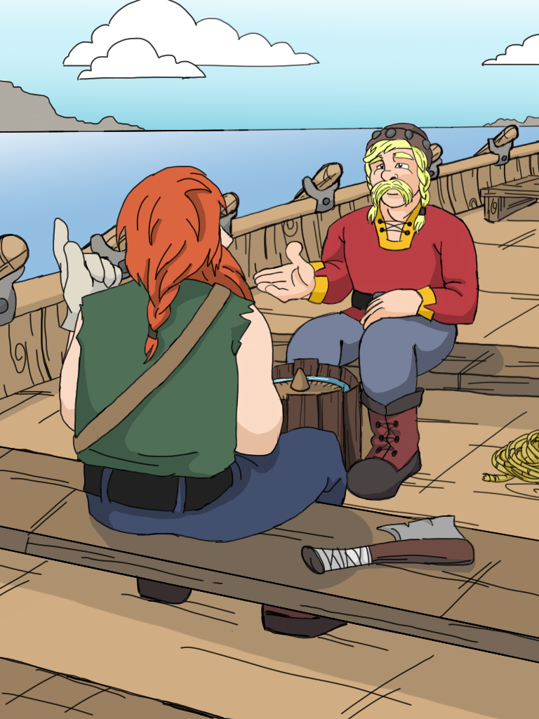
The journey continues without any problem. Galmi uses this opportunity to get to know the crew. They tell him stories from their last expeditions and how proud they are being a part of this. “Galmi, bring me a bucket with water”, Floki suddenly suggests. “What for?”, Galmi returns puzzled. “You’ll see.” Galmi hands him the bucket while Floki grabs a wooden disk. “It’s noon and the Sun is shining, let’s see.” He puts it into the bucket where it begins to float. As Galmi looks closer, he discovers a ring incised about half way between the edge of the disk and the centre, where a small cone sticks out. A shadow extends to the edge of the disk and slightly beyond the ring. “Okay,” says Floki,”we have to continue our course to the Southwest for another five hours. Then we’ll turn west.”
Galmi is surprised. Is Floki a seer or a magician? Is he in contact with Kvasir, the god of wisdom? “Not at all”, laughs Ragnar, “he is just our navigator. Floki, can you explain what you do?” “Sure. You see, Galmi. The Sun shines on this board and the shadow points north. You know that the Sun is south at noon, do you? The length of the shadow tells me, if we are on course. If the shadow is too long, we are too far north. The Sun is lower there. Is it too short, we know that we are too far south.” “How do you know all this?”, asks Galmi. “My grandfather taught me. He was one of the first to scare the hell out of the Scots”, Floki replies with pride in his eyes.
© Arianna Musso Barcucci
Four hours after the course correction the steady breeze picks up and dark clouds appear at the horizon. “Darn! Seems like Thor is angry again!”, Ragnar shouts. “Get prepared for some rough weather ahead!” The wind evolves into a storm. Floki strikes the sail. “Okay guys! Take the oars and row!” Ragnar has to shout in order to be heard through the howling wind. Galmi pulls as hard as he can. It starts to rain heavily and thunder and lightning seem to tear the skies apart. “Pitch the tent!”, Ragnar shouts. The crewmen pull up a thick and long piece of linen and cover the ship almost from bow to stern. The ship rolls heavily, but the men keep on rowing. Two hours later, the crew at the oars changes. Galmi tries to get some sleep. He is so tired that neither the rocking boat nor Thor’s hammer can keep him awake.
Galmi dreams of Sága and Oda. He feels a warm sensation on his cheeks and opens his eyes. The Sun is rising and the wind has died, but through the silent hissing of the waves the snoring of the crew sounds like the howling of the Fenrir wolf. The sail is up and Floki leans at the rudder. “How did it go, Floki?”, Galmi asks. “Oh, it wasn’t too bad. Nothing we hadn’t managed before. It is about 12 hours until we reach the shores.” “Come, let me take the rudder for a while and get some rest. I think I can hold that stick for you.” Floki smiles. “Thank you, my friend.”
Twelve hours later Ragnar hears the distant calling of seagulls. Everyone on board knows that this means they are right on course and the shore is not very far. “Can you smell the smoke, Galmi?”, asks Floki. “The Scots burn peat for heating their homes.”
© Arianna Musso Barcucci
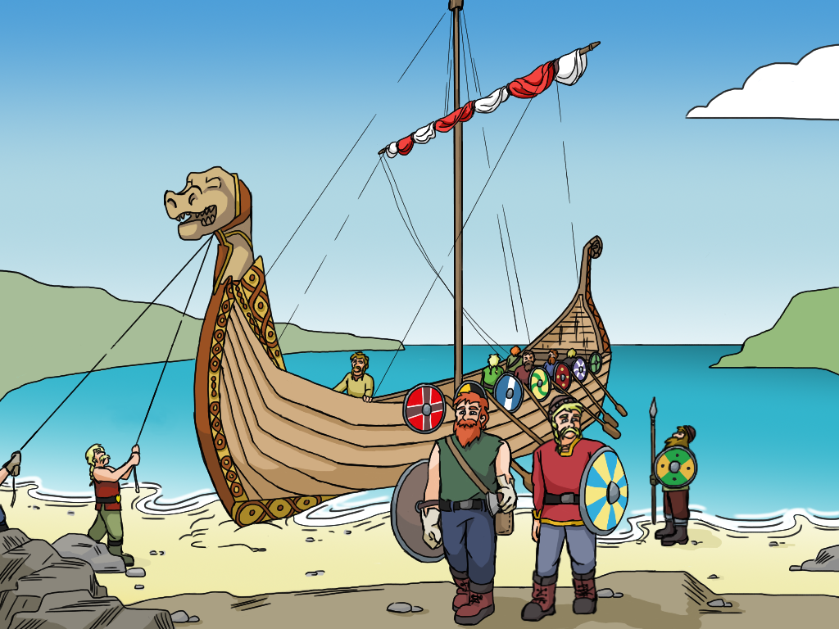
“Land ahead!” Rollo is the first to discover the coastline. But it is another four hours until Inbhir Nis. Ragnar discusses the plan with his crew. They will beach outside the town and camp until the next morning. After the tiring passage everybody needs the rest. Two days after they left Avaldsnes, Ragnar, Floki, Rollo and Galmi are prepared as is the rest of the crew. They ask for Odin’s support and head for Inbhir Nis, whose clueless inhabitants will be struck by surprise. “This is the day”, Galmi says to Floki.

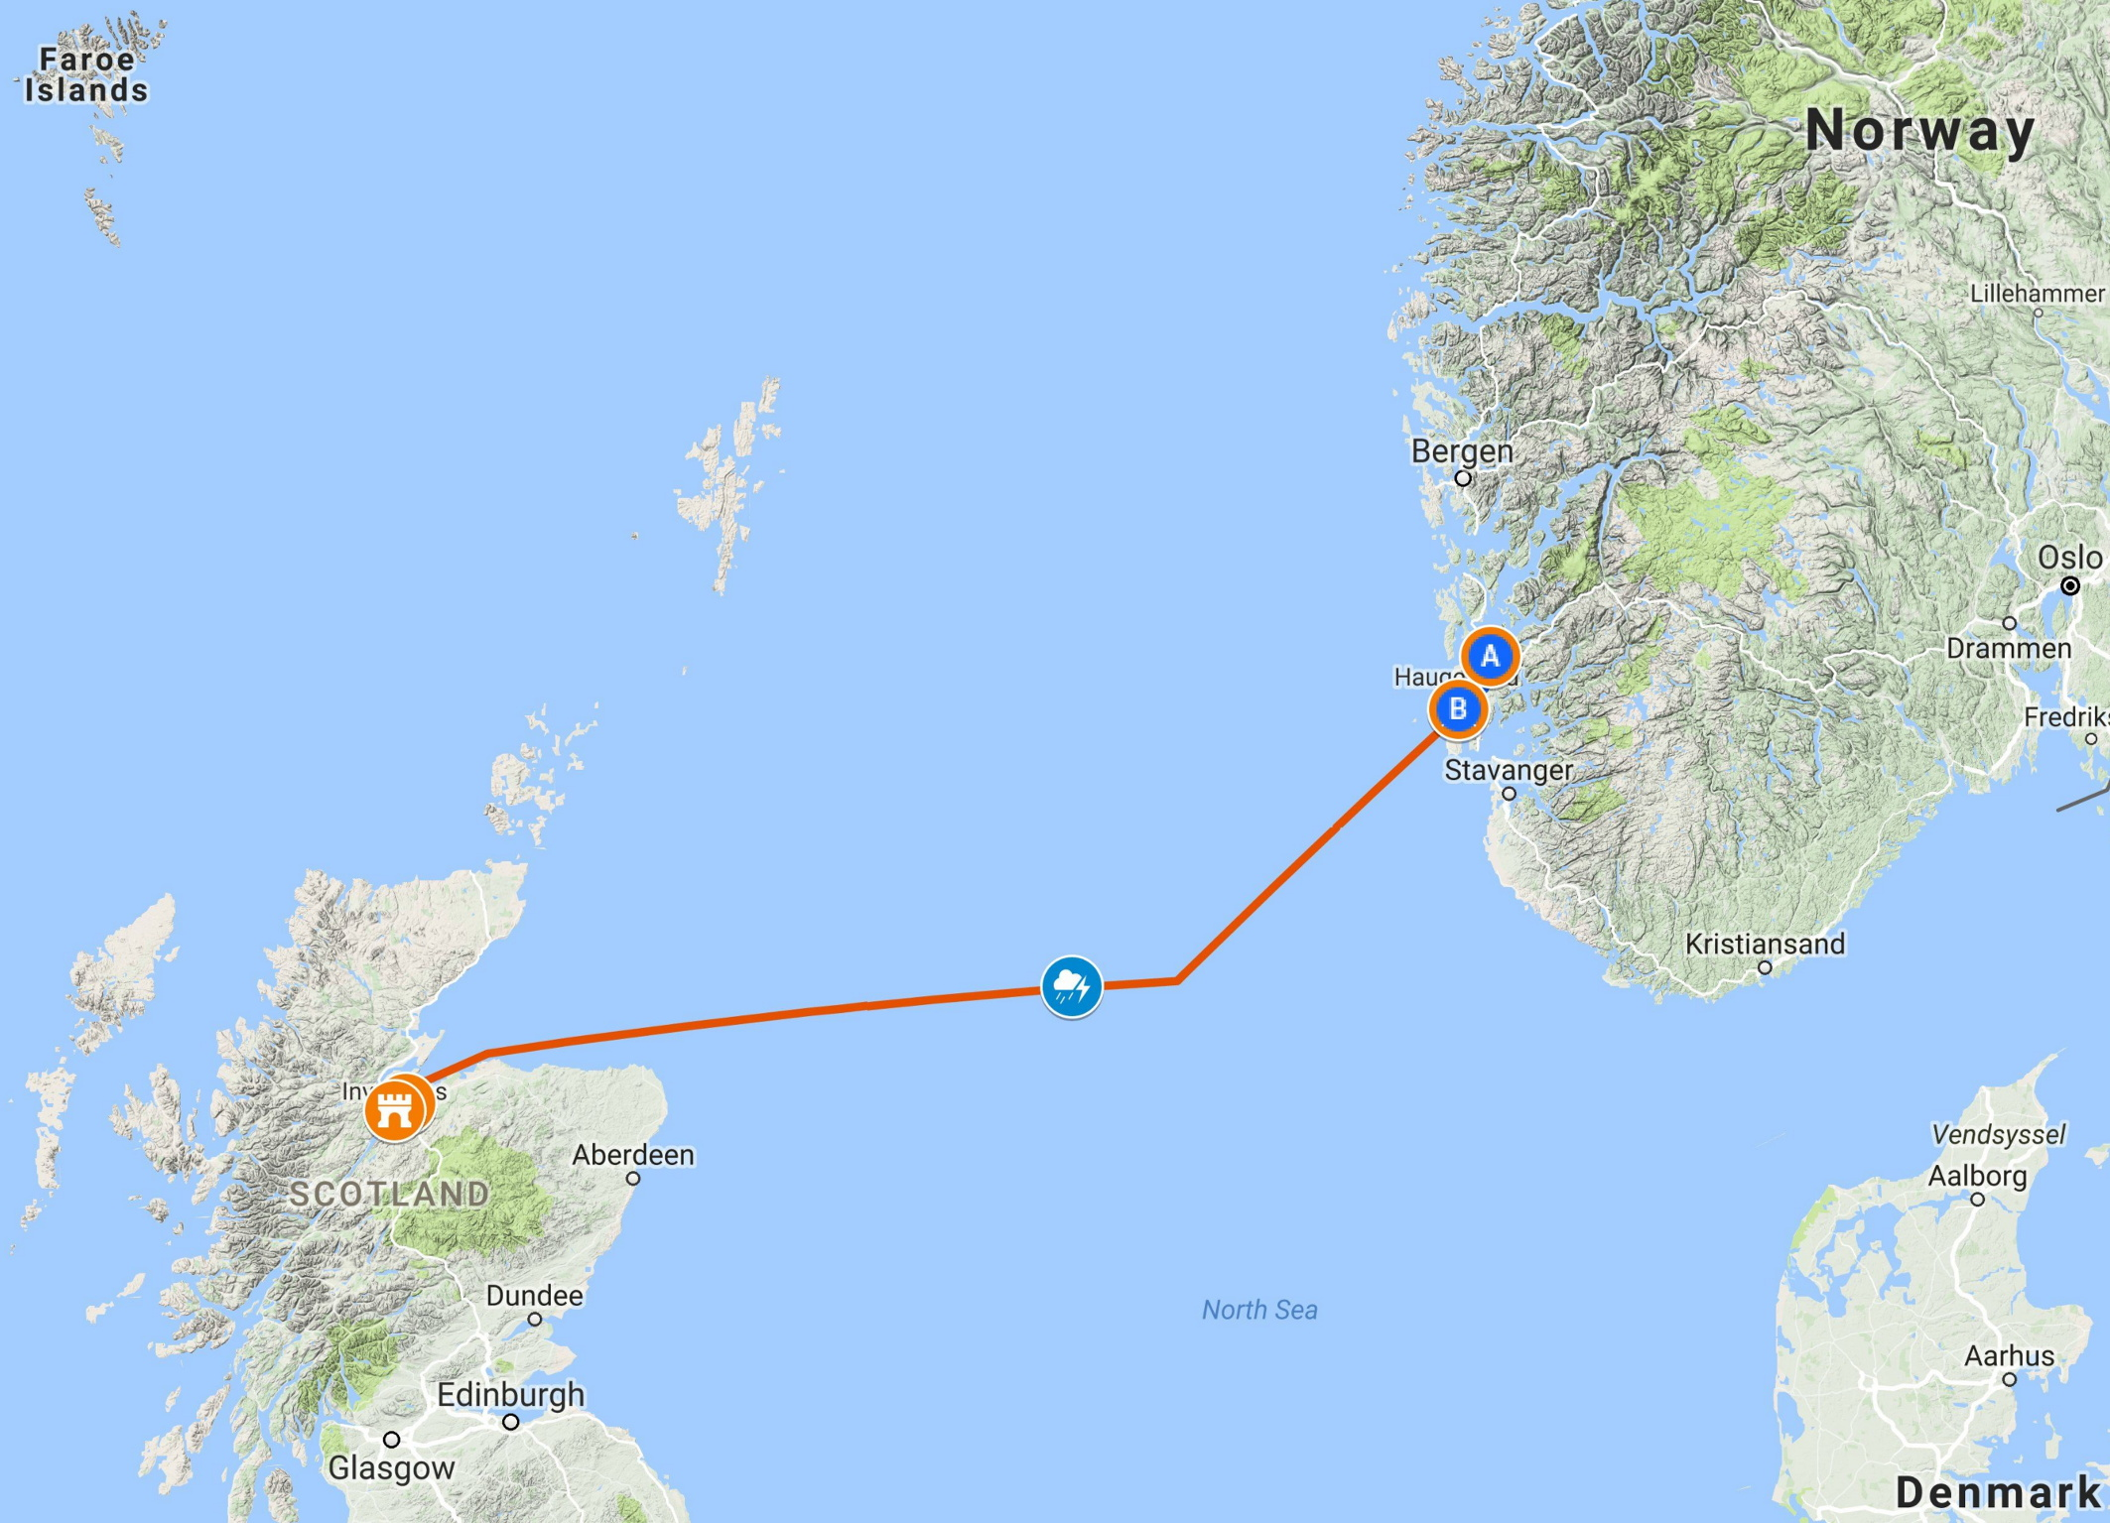
Inbhir Nis
Map data ©2017 GeoBasis/DE&BKG (©2009), Google
Thunderstorm
Figure 2: Overview of the journey Galmi undertakes from southwestern Norway to Scotland.

