Oceans as a Heat Reservoir – Supplemental Background Information

Thermal radiation of solid bodies
Any given body with a temperature above absolute zero, i.e. $T>0 K$ radiates. According to Planck’s Radiation Law (ideally for a black body), the distribution of frequencies of the emitted spectrum depends on the temperature.
$$U\left(ν,T\right)=\frac{8πhν^{3}}{c^{3}}⋅\frac{1}{e^{\frac{hν}{kT}}-1}$$
Integrating overall frequencies leads to the Radiation Law of Stefan Boltzmann, which describes the total emitted power. In reality, black bodies only exist up to a certain degree of approximation. Therefore, Kirchhoff’s Radiation Law about the radiant power of any given body can be applied:
$$L_{Ων}\left(β,φ,ν,T\right)=L_{Ων}^{o}(ν,T)⋅a_{ν}^{'}(β,φ,ν,T)$$
This means that the radiant power $L_{Ων}\left(β,φ,ν,T\right)$ of a given body is as large as the total radiant power of a black body $L_{Ων}^{o}\left(ν,T\right)$ having the same temperature and the same absorptivity $a_{ν}^{'}(β,φ,ν,T)$. The spectral radiance and absorptivity may also depend on the angle of incident radiation. Thus, according to Kirchhoff’s Radiation Law, the radiant power of any given body is directly proportional to the radiant power of a black body with the same temperature.
Further, Kirchhoff’s Radiation Law leads to the conclusion that with a given temperature, a body with good heat absorption also releases heat well.

Stefan Boltzmann’s Law
The Stefan Boltzmann Law describes the emitted power of a black body radiating isotropically in all directions. For the total radiation power of a black body, the following equation applies:
$$P=σ⋅A⋅T^{4}$$
$A$ is the area of the radiating cross section of the body, and $σ$ is the Stefan Boltzmann constant, a natural constant with the value of:
$$σ=\frac{2π^{5}k_{B}^{4}}{15h^{3}c^{2}}=\left(5,670 367±0,000 013\right)⋅{10}^{-8}\frac{W}{m^{2}K^{4}}$$
Together with Kirchhoff’s Radiation Law, the Stefan Boltzmann Radiation Law for any given body results in
$$P=ε\left(T\right)⋅σ⋅A⋅T^{4}$$
with a temperature dependent emissivity $ε(T)$.
Emissivity is a parameter that reflects the properties of the radiating substance and surface. For a given temperature, surfaces with different emissivity appear differently bright. As a result, the thermic radiation is also stronger.
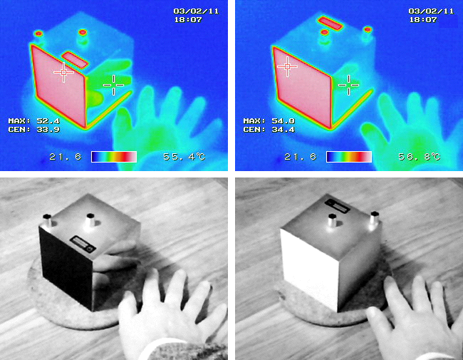
Figure 1: Photographs of Leslie's cube. The colour photographs are taken using an infrared camera; the black and white photographs underneath are taken with an ordinary camera. All faces of the cube are at the same temperature of about 55 °C. The face of the cube that has been painted has a large emissivity, which is indicated by the reddish colour in the infrared photograph. The polished face of the aluminium cube has a low emissivity indicated by the blue colour, and the reflected image of the warm hand is clear (Pieter Kuiper, https://commons.wikimedia.org/wiki/
File:LesliesCube.png, public domain).

Heat capacity
If heat $Q$ is added to liquids (or other material in general), their temperature $T$ rises. Both increases ($ΔQ$, $ΔT$) are directly proportional to each other.
$$ΔQ∝ΔT$$

Thought experiment
An immersion heater with the radiative power $P$ will add energy to the liquid within a certain period of time $Δt$ according to:
$$ΔQ=κ⋅P⋅Δt$$
In this case, $κ$ is a dimensionless quantity with $κ∈[0;1]$, corresponding to the percentage of the energy transformed and absorbed by the liquid.
$$ΔQ∝P⋅Δt$$
means that the energy needed by the immersion heater is directly proportional to the temperature change $ΔT$.
Remark: This experiment also works with a water filled paper cup, positioned over the flame of a Bunsen burner.
If you double the amount of liquid with $m$ being the mass, you find the following correlation:
$$ΔQ∝m$$
In summary, the following is valid
$$ΔQ∝m⋅ΔT$$
with a proportionality constant
$$c=\frac{ΔQ}{m⋅ΔT}$$
The quantity $c$ is called the specific heat capacity. It depends on the material. The dependence on the temperature is neglected in this example. The unit of the specific heat capacity is:
$$\left[c\right]=1\frac{J}{kg⋅K}$$
It is commonly listed in units of:
$$1\frac{kJ}{kg⋅K}=1\frac{J}{g⋅K}$$
With a value of $c_{W}=4.182\frac{kJ}{kg⋅K}$, water has a high specific heat capacity and thus is an excellent heat reservoir due to its simple and low priced availability.

Cooling process of materials
The cooling process of a given body with the temperature $T(t)$ and an environmental temperature $U(t)$ can be described with the following differential equation:
$$\frac{\text{d}T\left(t\right)}{\text{d}t}=-k⋅T\left(t\right)+k⋅U\left(t\right),$$
with the initial condition $T\left(t_{0}\right)=T_{0}$. Provided the environmental temperature is constant, the differential equation describes an exponential decline (or an exponential increase). The cooling constant $k$ is given as:
$$k=\frac{αA}{mc}$$
It depends on the heat capacity, the mass of the body, the area of the interacting surface cross section, and the heat transfer coefficient $α$. Applied to our experiment, this means that due to its higher heat capacity, water cools down more slowly.

