Oceans as a Heat Reservoir

Purpose of this activity
With this activity, you will explore the ability of water to store heat. This is an important process when investigating the climatic system of the Earth. By taking away heat from the atmosphere, oceans help reduce global warming. Water reacts differently to irradiation than solid materials like dirt or soil. You will conduct an experiment that demonstrates this behaviour.

Questions
We experience day and night and the different seasons. What causes the different temperatures when the seasons change?

How much of the Earth’s surface is covered by water and how much by land (approximately)?

So, between land and oceans, which is the heated the most by insolation?

In the deserts, the temperature changes between day and night are very strong. Can you imagine why?

In comparison, how rapidly does water respond to heating? Imagine a pot of water on a stove.

Activity
Materials needed:
- Strong lamp
- Water
- Dirt, soil, or sand
- 2 bowls or trays (e.g. petri dishes)
- Stop watch
- Pen and paper
- Colour pencils
- Ruler
- Thermometer
- Calculator
- Anything the helps maintaining the thermometer in an upright position
This activity is part of a larger educational package called ‘Our Fragile Planet – The Climate Box’. This box contains a collection of items that are needed to conduct the experiment (see pictures below).

Experimental set-up 1
In this activity, you will measure the temperature changes of water and soil over time. You will be working in groups of two (or more). To ensure similar conditions for both substances, the experiment is carried out in two steps.
- Fill one tray with water and the other with soil or sand. The quantities should be the same.
- Place the tray filled with water below the lamp.
- Immerse the tip of the thermometer in the water. Its orientation should be as parallel as possible to the angle of irradiation. This grazing angle helps to reduce the direct heating of the thermometer.
- Let the substances assume room temperature.
- In the meantime, prepare a data table for filling in the measurements. It should allow for 21 lines of data and four columns (see Table 1).
- The first column lists numbers from 0 to 20 (minutes).
Table 1: First lines of the data table, including the header.
Time  t (min) | Water  ϑ (°C) | Soil  ϑ (°C) | Difference  Δϑ (°C)
0
1
$$⋮$$
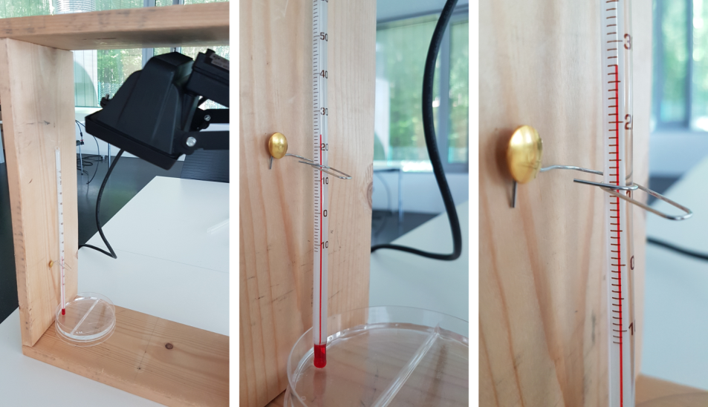
Figure 1: Experimental set-up for the temperature measurement of water. A petri dish is filled with water, and a thermometer is ready to measure the temperature. In order to maintain the thermometer in an upright position, it is attached to the frame with a pin and a paper clip. The lamp is set to illuminate the dish (own work).

Predictions
What do you think: how do the temperatures change after switching on the lamp?

After examining the water, you will use soil. Do you expect a different temperature response?

Experimental procedure 1
The procedure is the same for both experiments. Begin with water.
- Take the first temperature measurement before switching on the lamp.
- Start the stop watch and switch on the lamp (Figure 2).
- For 10 minutes, take a measurement every minute and note down the value in the corresponding row in the table.
- After 10 minutes, switch off the lamp and continue measuring the temperature as before.
- Stop measuring after 20 minutes. You should have 10 temperature readings with the light switched on and 10 with the light switched off.
- Replace the water tray with the one filled with soil.
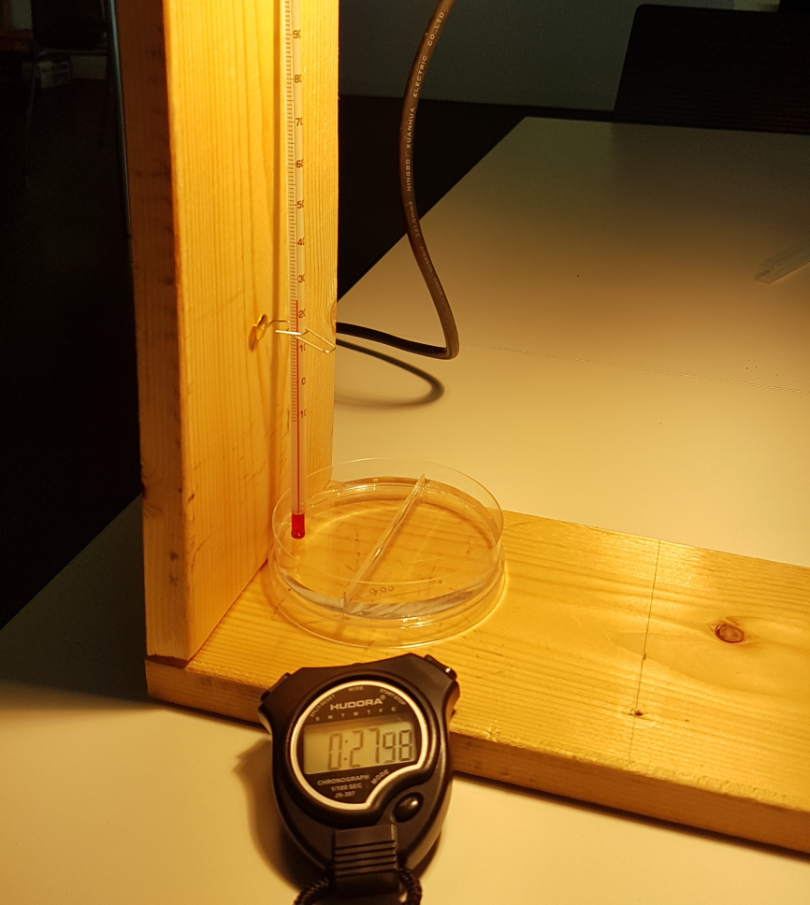
Figure 2: While illuminating the water, the temperature is read from the thermometer every minute (own work).

Analysis 1
The data are analysed by producing a diagram that shows the time elapsed during the experiment vs. the temperatures measured.
While one of the students of your working group continues to fill the data into diagram (Figure 3), the other prepares the second experiment with the soil.
- Prepare a diagram (e.g. Figure 3, upper panel) with two axes. The horizontal axis lists the time elapsed during the experiment, while the vertical axis lists the temperatures. Be prepared for a temperature range between 20 and 35°C.
- While the thermometer assumes room temperature again, enter the data into the diagram. For each measurement, add a small cross at the coordinate that matches the time and the temperature.
- Connect the data points of the diagram.

Experimental set-up 2
Let the students prepare the second experiment in the same way as the first (Figure 4). Instead of water, the students will examine the soil (dirt, sand).
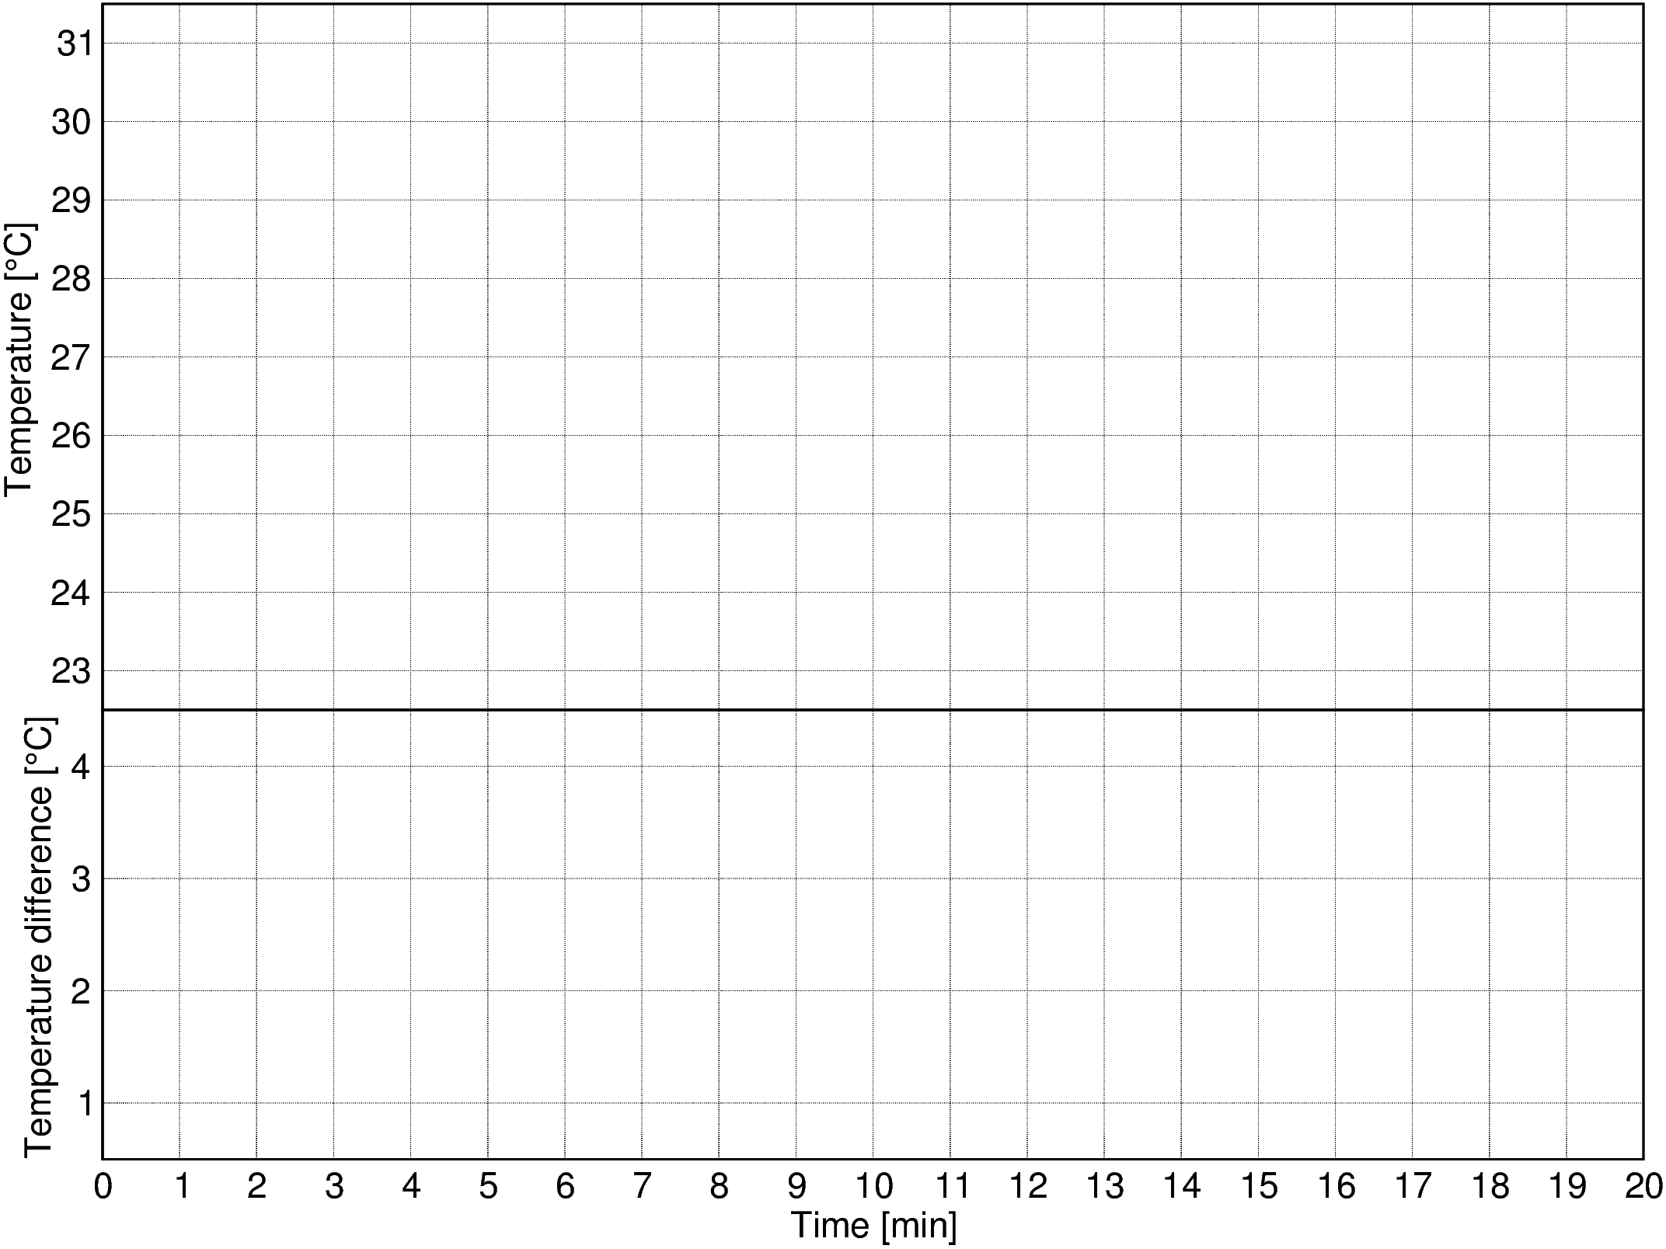
Figure 3: Template for the diagram to record the temperature measurements. The upper panel will contain the temporal changes in the temperatures. The lower panel is reserved for plotting the difference between the water and soil temperatures. Use different colours to represent the data (own work).

Experimental procedure 2
The procedure is the same as before.
- Take the first temperature measurement before switching on the lamp.
- Start the stop watch and switch on the lamp.
- For 10 minutes, take a measurement every minute and note down the value in corresponding row in the table.
- After 10 minutes, switch off the lamp and continue measuring the temperature as before.
- Stop measuring after 20 minutes. You should have 10 temperatures with the light switched on and 10 with the light switched off.

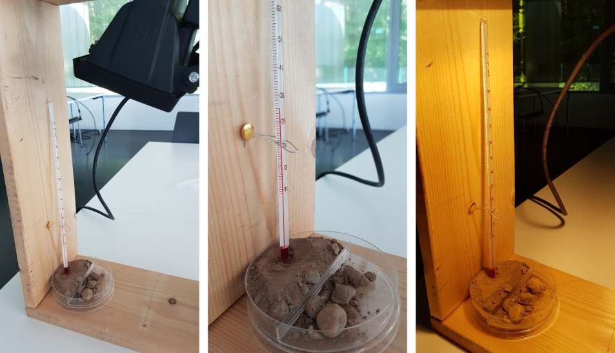
Figure 4: The set-up of the second experiment is the same as for the one with water, but this time the petri dish is filled with dirt, sand, or soil (own work).

Analysis 2
- As before, add the new data to the diagram.
- Connect the data points.
- In the diagram, indicate the ranges, when the lamp was switched on and when it was switched off.
- For each time step, calculate the temperature difference and add it to the table.
- Prepare a second diagram that shows the temporal evolution of that difference.
- Fill that diagram with the corresponding data.

Conclusion
Describe and discuss the results with your group members or classmates. During the discussion, try to focus on the following questions.

How did the temperatures change while the lamp was switched on and off?

Do you recognise a difference between the two substances?

The temperatures rose differently. What is causing this? What changed between the experiments?

Imagine now the Earth with its oceans and continents. Describe how these components react to solar irradiation.

Can you determine the role the oceans have in the global climatic system? Think of what would happen to global temperatures without oceans.

What happens to the oceans, if the heating rate rises, while the cooling rate stays the same?

Background information

The oceans as a heat sink
The global warming caused by the increasing greenhouse effect is one of the biggest challenges for human beings today. Different from other planets in the Solar System, the Earth is covered by large oceans that make up for 2/3 of the total surface area. Therefore, they are an important player in the process of heating and cooling. Oceans act as a heat sink, as they react slower and with a less temperature change than land masses do. As a result, the oceans store more than 90% of the total global heat (Figure 5).
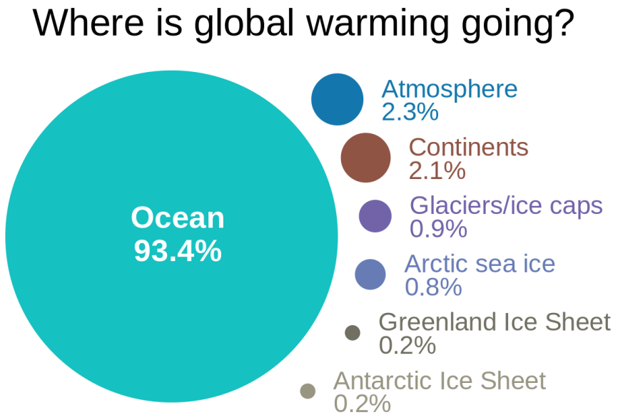
Figure 5: Amounts of energy added to the various parts of the climate system because of global warming, according to the 2007 IPCC AR(4) WG1 Sec 5.2.2.3 (http://www.ipcc.ch/publications_and_data/ar4/wg1/en/ch5s5-2-2-3.html), (Credit: Skeptical Science, vectorised by User:Dcoetzee (https://commons.wikimedia.org/wiki/
File:WhereIsTheHeatOfGlobalWarming.svg), https://creativecommons.org/licenses/by/3.0/legalcode).
The temperature distribution of the waters on Earth is efficiently monitored from space by remote sensing Earth observation satellites. Monitoring the sea is one of the key objectives of Europe’s Copernicus Earth observing programme.
Figure 6: Map of averaged global land surface temperature for March 2016 obtained with the MODIS spectrograph on board NASA’s Aqua satellite, which is part of the EOS programme. The colour code indicates temperatures between -2°C and +35°C (NASA Near Earth Observations, http://neo.sci.gsfc.nasa.gov/view.php?datasetId=MYD28M).

The relevance to climate change
These monitoring programmes have shown that just like the atmosphere, the oceans are continuously warming up.
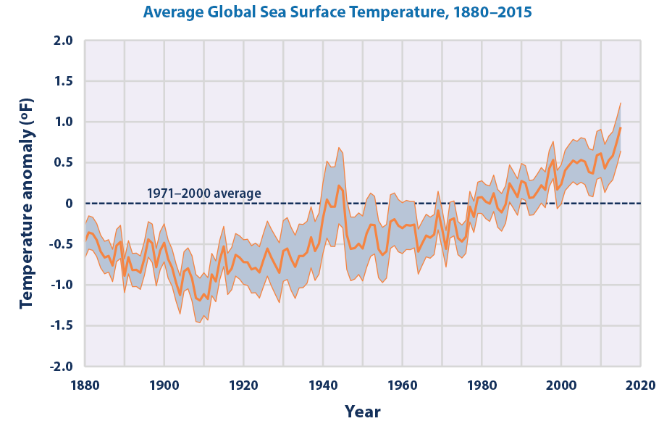
Figure 7: This graph shows how the average surface temperature of the world’s oceans has changed since 1880. It uses the 1971 to 2000 average as a baseline for depicting change. Choosing a different baseline period would not change the shape of the data over time. The shaded band shows the range of uncertainty in the data, based on the number of measurements collected and the precision of the methods used (Credit: NOAA (National Oceanic and Atmospheric Administration). 2016. Extended reconstructed sea surface temperature (ERSST.v4). National Centers for Environmental Information. Accessed March 2016. www.ncdc.noaa.gov/data-access/marineocean-data/extended-reconstructed-sea-surface-temperature-ersst, https://www.epa.gov/climate-indicators/climate-change-indicators-sea-surface-temperature).
Suitable remote sensing campaigns can even analyse the spatial distribution of the warm-up process. Since the insolation (solar luminosity variations, orbital variations) does not change with the rates measured, natural causes can be excluded.
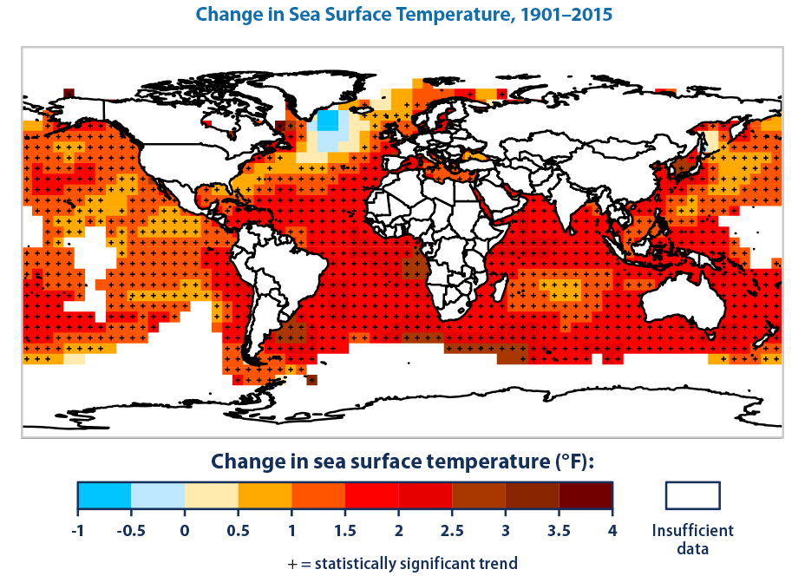
Figure 8: This map shows how average sea surface temperature around the world changed between 1901 and 2015. It is based on a combination of direct measurements and satellite measurements. A black “+” symbol in a square indicates that the trend shown is statistically significant. White areas indicate lack of data to calculate reliable long-term trends (Credits: IPCC (Intergovernmental Panel on Climate Change). 2013. Climate change 2013: The physical science basis. Working Group I contribution to the IPCC Fifth Assessment Report. Cambridge, United Kingdom: Cambridge University Press. www.ipcc.ch/report/ar5/wg1, NOAA (National Oceanic and Atmospheric Administration). 2016. NOAA Merged Land Ocean Global Surface Temperature Analysis (NOAAGlobalTemp): Global gridded 5° x 5° data. National Centers for Environmental Information. Accessed June 2016. www.ncdc.noaa.gov/data-access/marineocean-data/noaa-global-surface-temperature-noaaglobaltemp, https://www.epa.gov/climate-indicators/climate-change-indicators-sea-surface-temperature).

