Worksheet: The Climate in Numbers and Graphs

Purpose of this activity
You will determine the climatic conditions of a city using a graphical tool called a ‘climate chart’. It represents the long-term climatic conditions of a given location. You will work like a scientist to collect and calculate the data you need to fill the chart. Finally, you may even have the opportunity to derive your own local climate chart and compare it to your experience with the weather that is typical of your location.

Questions and discussion
If you knew the current temperature and amount of rainfall, would you be able to determine the season of the year?

What does it mean when we say that generally, summer is warmer than winter?

With this in mind, how would you characterise seasons in terms of weather phenomena?

Can you describe different types of climate? What are the climatic differences between, e.g. London and southern Spain?

If London is characterised as being ‘rainy’, does it mean that it rains every day?

Activity 1: The averaged weather
Materials needed:
- Pencil
- Computers with spreadsheet software (MS Excel), if available
- Excel file astroedu1620-The Climate in Numbers and Graphs-Tables.xlsx (if computers are used)
- Pocket calculators (assumed to be private or school property)

You will characterise the climatic conditions of a specific location, that is, the Jena Observatory in Germany. In the end, you will need a list of representative temperatures and precipitation for each month of the year. The values will be the 30-year averages of the individual weather data obtained for each day. In several steps, you will learn how to transform weather data obtained on a daily basis into data that tell you something about the climate of that location.
Throughout this activity, you will have to calculate averages and sums of individual values of real weather data. Depending on the set-up of this activity, you will either use pocket calculators to derive the solutions manually or employ spreadsheet software, e.g. Microsoft Excel.

Manual calculations
If you will be using a pocket calculator, you will have to use the equations for calculating averages as mentioned in the background information.

Using spreadsheet software
If you are using a computer with spreadsheet software like Microsoft Excel installed, you can use the file astroedu1620-The Climate in Numbers and Graphs-Tables.xlsx for the subsequent calculations. In this case, you can apply the statistical functions AVERAGE() and SUM().

Task 1: Representative weather data for June 2010
Table 1 provides daily mean temperatures and accumulated precipitation (rain) for June 2010. You can also find it in the Excel file in a sheet labelled ‘Task 1’, if provided.
What would be the typical temperature in June 2010? How would you calculate it?

In order to calculate representative weather data for that month, you have to derive the monthly mean temperature and monthly total precipitation.
Discuss with your classmates how to do this.

Table 1: Weather data obtained at the Jena Observatory from June 2010, including daily mean temperatures and accumulated precipitation.
Day | Temperature (°C) | Precipitation (mm)
1 | 11.2 | 5.2
2 | 12.3 | 1.9
3 | 17.3 | 0
4 | 16.3 | 0
5 | 19.1 | 0
6 | 22.1 | 0.3
7 | 19.5 | 0.3
8 | 20.2 | 0
9 | 23.7 | 0.1
10 | 24.1 | 0
11 | 22.6 | 1.2
12 | 17.7 | 1.2
13 | 15.5 | 0
14 | 15.3 | 0
15 | 16.2 | 0
16 | 15.4 | 0
17 | 17.4 | 0
18 | 17.5 | 0
19 | 13.3 | 0.1
20 | 13.5 | 0
21 | 13.0 | 0
22 | 14.6 | 0
23 | 16.8 | 0
24 | 19.7 | 0
25 | 20.1 | 0
26 | 19.5 | 0
27 | 19.6 | 0
28 | 21.4 | 0
29 | 22.9 | 0
30 | 23.2 | 0
After the calculations (manually or with computer support), compare your results with your classmates. Make sure that you all have the same (correct) result. Then, add it to Table 2, which is needed for the next step.

Task 2: Representative weather data for June any year between 1981 and 2010
In this step, you will learn how to calculate representative 30-year averaged climatic data from the average weather data derived in the previous step.
Discuss with your classmates the following questions:
How can you judge whether the result from the previous task is representative for June in any given year?

What are the highest and lowest values of the temperature and precipitation?

What would be the typical temperature in June of any given year? How would you calculate it?

Table 2 provides annual mean temperatures and accumulated precipitation for June in any given year between 1981 and 2010. You can find it also in the Excel file as a sheet labelled ‘Task 2’, if provided.
Table 2: Averaged weather data in the month of June obtained at the Jena Observatory from 1981 until 2010, including the monthly mean values of temperature and precipitation.
Year | Temperature (°C) | Precipitation (mm)
1981 | 17.2 | 62
1982 | 17.9 | 48
1983 | 17.4 | 66
1984 | 15.3 | 89
1985 | 14.9 | 60
1986 | 16.6 | 62
1987 | 15.4 | 104
1988 | 16.4 | 57
1989 | 16.6 | 57
1990 | 16.8 | 118
1991 | 15.3 | 80
1992 | 18.4 | 39
1993 | 16.9 | 87
1994 | 17.7 | 73
1995 | 15.4 | 75
1996 | 16.6 | 34
1997 | 16.9 | 50
1998 | 18.0 | 62
1999 | 16.3 | 67
2000 | 18.4 | 37
2001 | 15.5 | 61
2002 | 18.4 | 45
2003 | 20.4 | 55
2004 | 16.5 | 46
2005 | 17.1 | 39
2006 | 17.7 | 39
2007 | 19.0 | 73
2008 | 18.3 | 43
2009 | 15.6 | 56
2010
Now calculate the mean temperature and mean precipitation measured for the month of June between 1981 and 2010. This time, we need the average precipitation because we are interested in the typical total rainfall in June. In this step, we are not interested in the total rainfall measured over 30 years.
Discuss with your classmates how to do this.
After the calculations (manually or with computer support), compare your results with your classmates’ findings. Make sure that you all have the same (correct) result. Then add it to Table 3, which is needed in the next step.
Table 3: Climate data based on weather data obtained at the Jena Observatory and averaged over 30 years.
Month | Temperature (°C) | Precipitation (mm)
January | 2.1 | 35
February | 2.2 | 34
March | 5.5 | 46
April | 9.4 | 45
May | 14.2 | 60
June
July | 19.2 | 77
August | 18.5 | 65
September | 14.3 | 48
October | 10.0 | 38
November | 5.3 | 53
December | 2.4 | 46

Task 3: Representative annual climate data
Before moving on to the next activity, i.e. constructing the climate chart, you first have to derive general representative climatic data that provide information about the conditions to expect throughout the year. For this, you calculate the long-term annual mean temperature and total precipitation from Table 3. This table is also available as the ‘Task 3’ sheet in the Excel file, if provided.
Complete the sentence below.

For the Jena Observatory, the annual mean temperature is ______ °C and the annual total precipitation is _____ mm.

Activity 2: Climate charts
Materials needed:
- Millimetre paper
- Pencils (black, blue, red and yellow)
- Ruler
Climate charts are a useful tool to quickly grasp the basic climatic conditions for any given location. Figure 5 (background information) presents an example of such a climate chart constructed for the city of Rome, Italy. Study its concept, which is provided in the background information.
Discuss the features of climate charts with your classmates using the example of Rome. In particular, try to answer the following questions.
What do the blue and red curves represent?

Which are the months with the lowest and highest temperatures?

What are the seasons connected to those temperatures?

On which hemisphere do we experience summer/winter during these months?

Which are the months with the lowest/highest precipitation?

When does the blue curve (precipitation) fall below the red curve (temperature)?

Why do you think this area is coloured yellow?

What does this mean for the climatic conditions? When throughout the year is it humid or dry in Rome?

Constructing the climate chart
You will now apply the knowledge about climate charts to the example from activity 1 above. For the header of the climate chart, you still need the details of the location of the Jena Observatory.
Name: Jena Observatory (Germany)
Latitude: 50.9251° N
Longitude: 11.583° E
Altitude: 155 m
Then, use Table 3 and construct the climate chart following the instructions below.
- Take the millimetre paper and draw the coordinate system for the climate chart. Use the one for Rome as a template. Make sure to leave some room for the header.
- Make sure the scales reflect the values.
- The scale for the precipitation must show values that are twice the numbers in the temperature scale in the opposite axis.
- Add a header that lists the following items: name of the city and country, altitude, latitude, longitude, annual mean temperature, annual total precipitation
- Begin with the temperature: add a red dot for each temperature value in the twelve months.
- Connect the dots with a smooth red line.
- Do the same for the precipitation but use blue. Here, the dots should be connected with straight lines.
- If the blue line is above the red line, fill the area in between with blue vertical lines.
- If the blue line is below the red line, colour this area yellow.
Discuss the results like you did for the Rome example. Ask the students how the climate of Jena compares to Rome.

Activity 3: Derive your local climate chart (for advanced students only)
Weather data are available for almost any location and area around the world. Use the links below to find the suitable weather station from which you can derive the climate data that are needed to construct your local climate chart.
USA:
https://www.ncdc.noaa.gov/cdo-web/datatools/normals
This tool permits easy access to 30-year averages between 1981 and 2010 for 9,800 weather stations in the USA. On this page, select ‘Monthly Normals’ and choose from the menu of federal states below. From the newly generates list, select the station that is nearest to your location. This produces a graph and a table. Remember that you need both temperature and precipitation data, which are not always available for all the stations.
Clicking on ‘View Station Details’ provides information needed for the header of the climate chart.
From the table, note the values for precipitation and average temperature. They have to be converted from inches into millimetres and from °F into °C. This can, for example, be done at
https://www.metric-conversions.org

UK:
http://www.metoffice.gov.uk/public/weather/climate-historic/#?tab=climateHistoric
This page provides access to historic and current weather data for about 35 weather stations across the UK. It also provides instructions on how to load the data into MS Excel for subsequent statistical analysis.
Select the red dot that is nearest to your location. A window appears with the name of the station and its geographical coordinates. Click on ‘Historic station data’ to access the weather data. The linked file is a simple text file that has details on the weather station and lists the weather data averaged for every month of a given year. Among them is ‘rain’ in millimetres and the mean of the daily minimum and maximum temperatures. To get the mean temperature, just calculate the average of the two values. Then proceed as in Activity 2.

Germany:
ftp://ftp-cdc.dwd.de/pub/CDC/
For details, please refer to the Readme file provided in the FTP folder.

The suitable data are located at
ftp://ftp-cdc.dwd.de/pub/CDC/observations_germany/climate/monthly/kl/historical/
The file ‘KL_Monatswerte_Beschreibung_Stationen.txt’ lists the station id (needed to identify the data file), the duration of weather observations, the altitude in metres, geographical coordinates, the station name, and the federal state of each of the weather stations. The data are stored in the files labelled monatswerte_XXXXX_YYYYYYYY_ZZZZZZZZ_hist.zip.
Here, XXXXX is the station id, while YYYYYYYY and ZZZZZZZZ denote the temporal range of the data. Select the station with sufficient temporal coverage nearest to your location. The content of these files is explained in DESCRIPTION_...pdf at the top of the file list.
From the ZIP file, extract the file ‘produkt_monat_Monatswerte…txt’. From this file, you need the columns
- MESS_DATUM_BEGINN: begin of measurement
- MESS_DATUM_ENDE: end of measurement
- LUFTTEMPERATUR: mean air temperature in °C
- NIEDERSCHLAGSHOEHE: precipitation in mm
Then proceed as in activity 2 to get the annual mean temperatures and the annual total precipitation.
Compare the results with your own experience. Do the temperature and precipitation meet your expectations?

How do they compare to the other locations, e.g. Rome and Jena? Why do you think this might be? Please discuss your conclusions!

Background Information

Climate
Climate is defined as the long-term average of weather or atmospheric phenomena, often modified by seasonal variations. In order to make a statement about the climate, weather data have to be recorded over a long period, typically 20 or 30 years. This avoids confusion with short-term variations as shown in Error! Reference source not found..
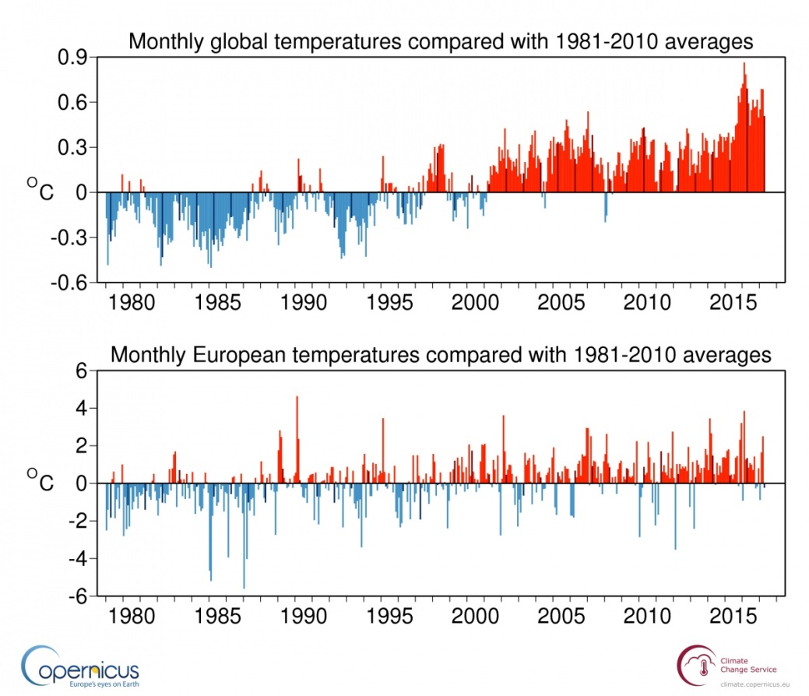
Figure 1: Monthly global mean and European mean surface air temperature anomalies relative to 1981–2010, from January 1979 to April 2017. The darker coloured bars denote the April values. Source: ERA-Interim. (Credit: ECMWF, Copernicus Climate Change Service, https://climate.copernicus.eu/resources/data-analysis/average-surface-air-temperature-analysis/
monthly-maps/april-2017)
The temperature changes throughout a day (Figure 2). In many regions on Earth, these changes can be rather large. In order to have a representative temperature value for a single day, the mean value or the average of the recorded values is calculated. The daily mean temperature changes from day to day, because of seasonal influences.
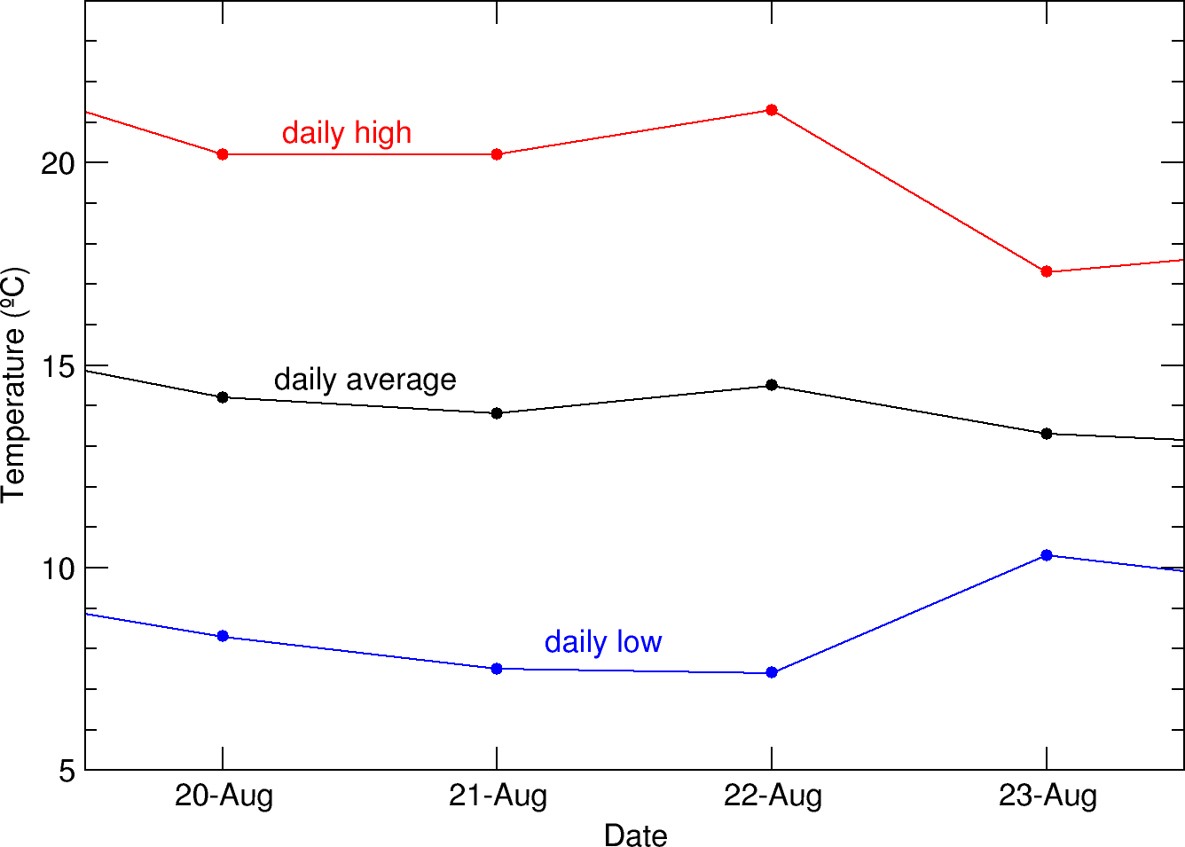
Figure 2: Daily temperature variation of the daily high, daily average and daily low temperatures (own work, based on data provided with this activity).
In addition, the Earth can be divided into climate zones, which have different ranges of temperatures and precipitation. These zones are produced by large-scale atmospheric interactions or geological features. Besides the previously mentioned temporal average, climate zones are defined via regional averages, which are coarsely aligned with the latitudes, mainly because of the variation of the incident angle of solar irradiation depending on latitude. Various schemes explain climate zones, but in general, there are four or five distinct zones:
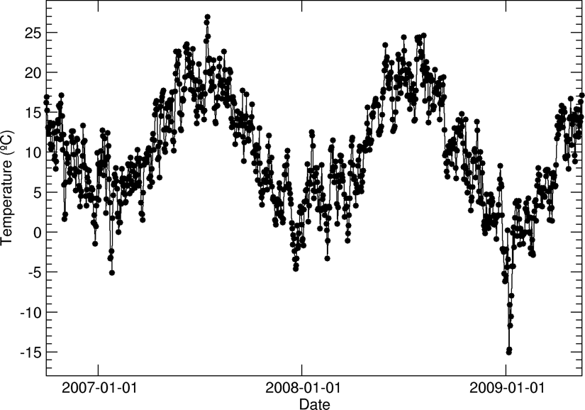
Figure 3: Seasonal variation in the daily mean temperature (own work, based on data provided with this activity).
Tropical zone (between latitudes 0° and 23.5°)
- little seasonal variation in insolation
- very warm throughout the year
- humid, high precipitation

Subtropics (between latitudes 23.5° and 40°)
- most intense insolation during the summer
- generally rather dry, little precipitation
- strong variation in temperatures between day and night (little protective cloud cover)
- rather cool and moist winters

Temperate zone (between latitudes 40° and 60°)
- low incident angle of insolation
- lower mean temperatures than those in the subtropics
- seasons and length of day differ through the year
- precipitation evenly distributed through the year, no or rare arid periods

Cold zone (between latitudes 60° and 90°)
- very low incident angle of insolation
- strong seasonal differences, little diurnal variation
- low temperatures
- amount of precipitation depends on geographical conditions

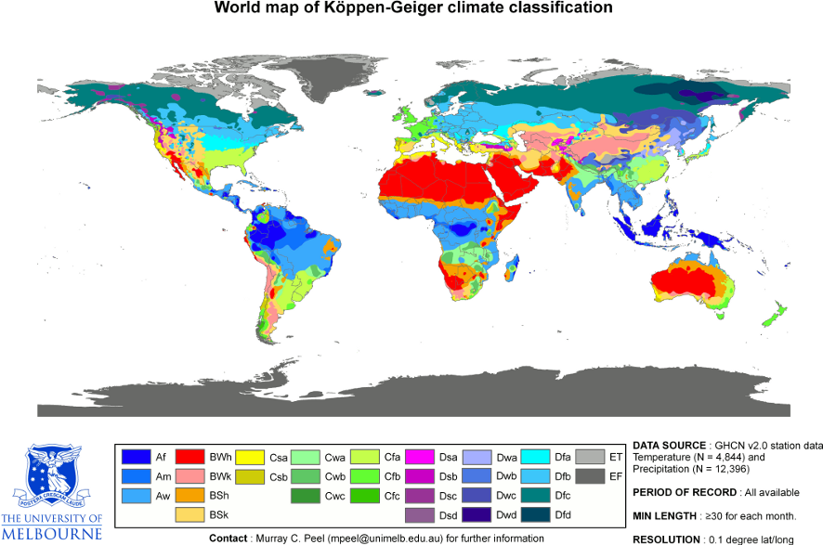
Figure 4: Detailed climatic zone map of the Earth showing five major climate zones (World_Koppen_Map.png: Peel, M. C., Finlayson, B. L., and McMahon, T. A. (University of Melbourne) derivative work: Br-Sc-94 (https://commons.wikimedia.org/wiki/File:Koppen_World_Map_(retouched_version).png), ‘Koppen World Map (retouched version)’, https://creativecommons.org/licenses/by-sa/3.0/legalcode)

Climate charts
A frequently applied tool to determine the basic climatic features of a given location is a climate chart, developed by Walter and Lieth. A climate chart is a graphical representation of the two main observables that characterise weather and climate: temperature and precipitation. The chart shows one representative value for either of the two quantities for each month. The temperature is the mean temperature in a given month, while the sum for the month is displayed for the precipitation.

Calculating the mean or average of a list of values is the simplest method to determine a representative number. While the individual numbers vary, the mean value tells us what number we can expect on average, provided the boundary conditions that govern its manifestation stay the same.

The example for Rome, Italy, is given below. The chart is based on the following list of values, which represent the long-term average of temperature and precipitation for each month.
Table 4: Long-term values of climatic data for Rome.
Month | Temperature (°C) | Precipitation (mm)
January | 6.9 | 76
February | 7.7 | 88
March | 10.8 | 77
April | 13.9 | 72
May | 18.1 | 63
June | 22.1 | 48
July | 24.7 | 14
August | 24.5 | 22
September | 21.1 | 70
October | 16.4 | 128
November | 11.7 | 116
December | 8.5 | 106

The resulting climate chart according to Walter and Lieth is given as follows:

Rome (Italy)
Altitude: 46 m
Latitude: 41°54’ N annual mean temperature: 15.5°C
Longitude: 12°29’ E annual total precipitation: 880 mm
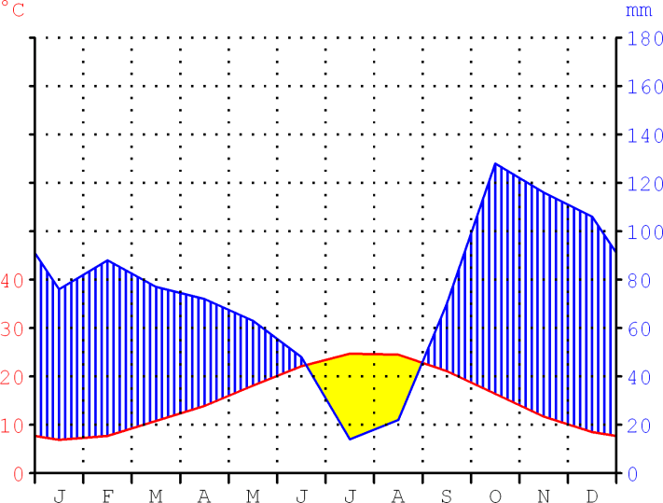
Figure 5: Climate chart for Rome, Italy. It illustrates the monthly mean temperatures and the corresponding monthly total precipitation throughout the year (own work based on Geoklima 2.1, https://creativecommons.org/licenses/by-sa/3.0/
legalcode)

The header of the chart for Rome lists some basic information about the location. Very often, it mentions the annual mean temperature and the summed precipitation amount throughout the year. The chart itself has two scales: the red one to the left displays the temperature in degrees Celsius and the blue one to the right provides the precipitation (rainfall) in millimetres. For very high values of precipitation, the scale above 100 mm is condensed to steps of 100 mm (not in this example). The horizontal scale at the bottom lists the months through the year, abbreviated with the first letter of its name.
The red curve depicts the evolution of temperature, averaged for a given month, as listed in the table above. The blue curve shows the evolution of precipitation as the sum calculated for a given month. The values are also listed in the table. The red scale belongs to the red curve and the blue scale to the blue curve.
In order to be able to derive climatic information from such a chart, the two scales must be adjusted so that 10°C corresponds to 20 mm of precipitation, both aligned to zero. With this strategy, humid periods are those where the curve of precipitation is above the temperature curve. In contrast, arid periods are whenever the temperature curve is above the one representing precipitation. Usually, these periods are indicated by colouring the areas between the two curves. Blue upright lines depict humid periods, while a dotted pattern or a filled yellow area represents arid periods. If the scale for precipitation above 100 mm is compacted, the area above this value is generally indicated by a filled blue area (not in this example).

Averaging, simple mean
An average value is defined as a number that is the minimum of the sum of differences between the average and the individual values. In an ideal world, this sum of differences is zero.

If T stands for a given value of a temperature measurement, we can indicate a series of measurements by adding an index, e.g. T₁, T₂ and T₃, which corresponds to the first, second and third values, respectively. In order to calculate the average of a series of measurements, one has to calculate the sum of the individual values and divide it by the number of measurements. With three temperature measurements, the average would be calculated as follows:

$$\overline{T}=\frac{T_{1}+T_{2}+T_{3}}{3}$$

Or in general
$$\overline{T}=\frac{T_{1}+T_{2}+T_{3}+…+T_{n}}{n}$$

$\overline{T}$ is the symbol for the temperature average, and $n$ is any given positive integer that corresponds to the number of measurements.

Jena is pronounced: [`je:na] or in English: yena

