The Quest for Longitude

Building instructions: The longitude clock
Items needed:
- Template printed on heavy paper or thin cardboard
- Instructions (this document)
- Crafting knife
- Scissors
- Glue
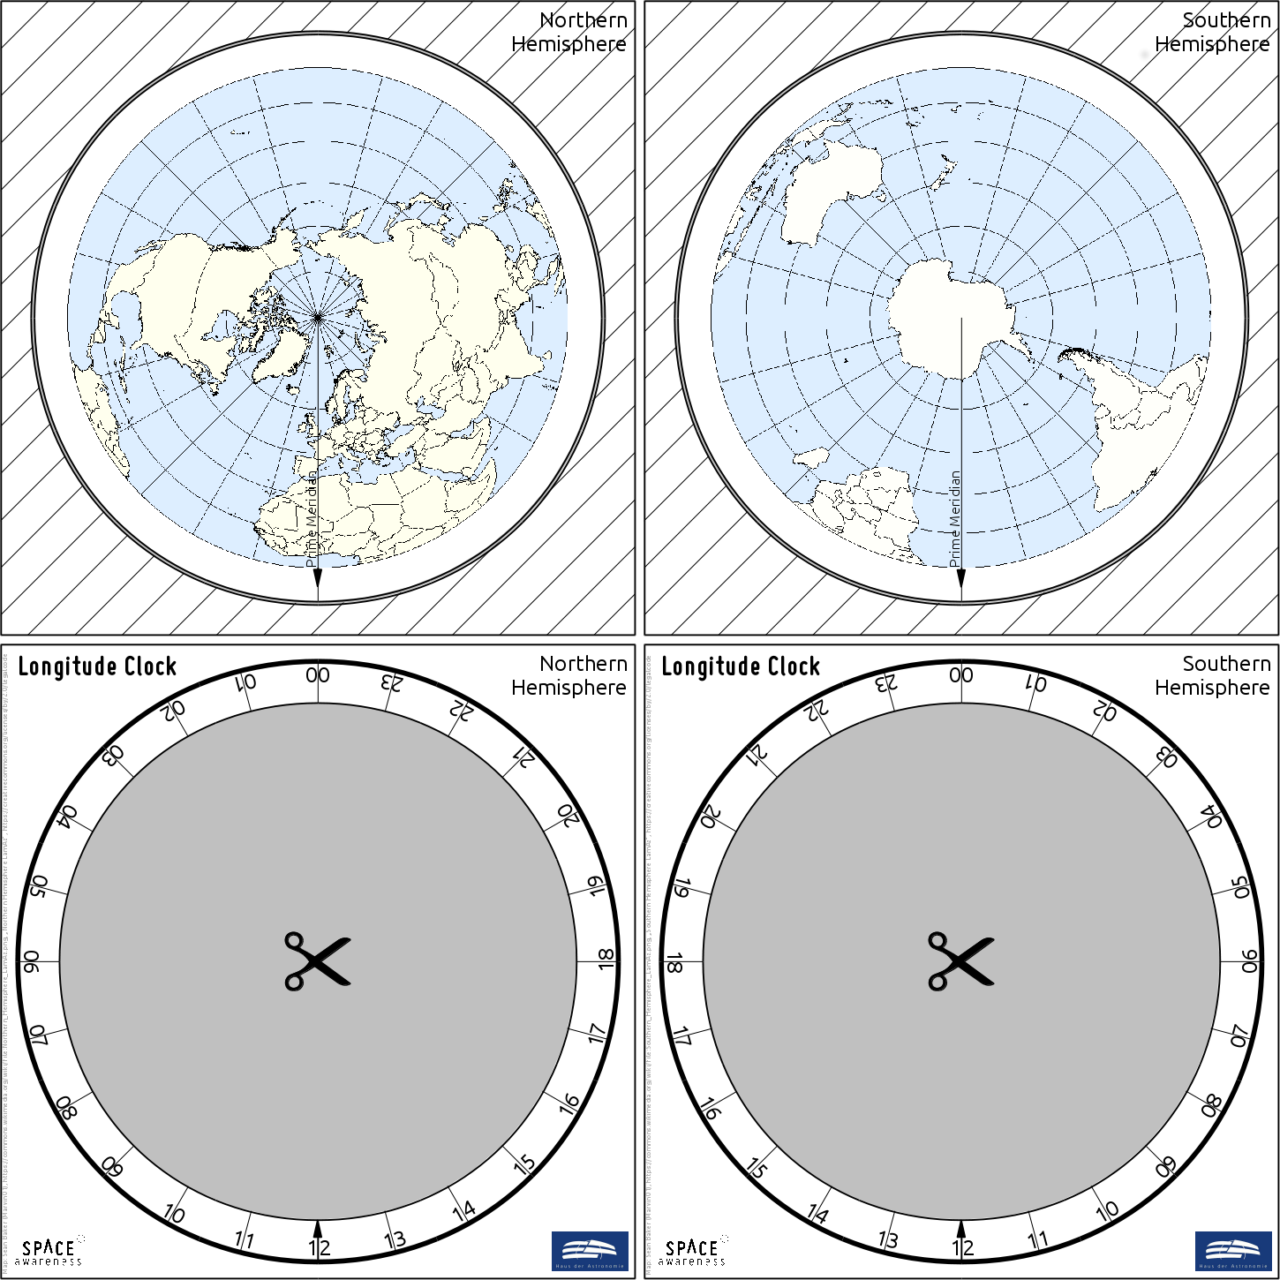
Figure 1: Template for building the longitude clock. A printable version is available as a separate file (own work).
The template of the longitude clock consists of four pages.
- Print the template on extra heavy paper or cardboard to provide stability.
- Cut out the square areas.
- Glue the squares with the maps back to back. Make sure the glue is well distributed and the arrow on the Prime Meridian points in the same direction on both sides.
- Cut out the grey area inside the face of the clock (labelled ‘Longitude Clock’).
- After the glue has dried, cut off the hatched area around the maps, but do not destroy the hatched part. It will be needed later.
- Remove the grey area in between the hatched area and the maps. You may cut into the black borders surrounding it. Scissors can be used to trim the edges.
- Glue the part with the hatched area to the back of one of the faces of the longitude clock. Make sure the glue is well distributed on the hatched side. Let it dry.
- Put the disk with the maps inside the hatched area and check that it rotates smoothly. If needed, trim the edge some more. Then remove the disk again.
- Put glue on the remaining visible side of the hatched page.
- Carefully, put the disk with the maps inside. It must not receive any glue. Be sure that the correct side of the map disk is facing up. Double-check with the labelling of the clock face.
- Place the back of the remaining face of the longitude clock on the glued hatched part.
- Let it dry and check that the disk rotates.

The Longitude Clock App
There is a Java application attached to this unit that works in the same way as the paper version of the longitude clock. After the software is started, the northern and southern hemispheres appear side by side. The time can be set by dragging with a computer mouse or typing. The software contains a readme file with further instructions.
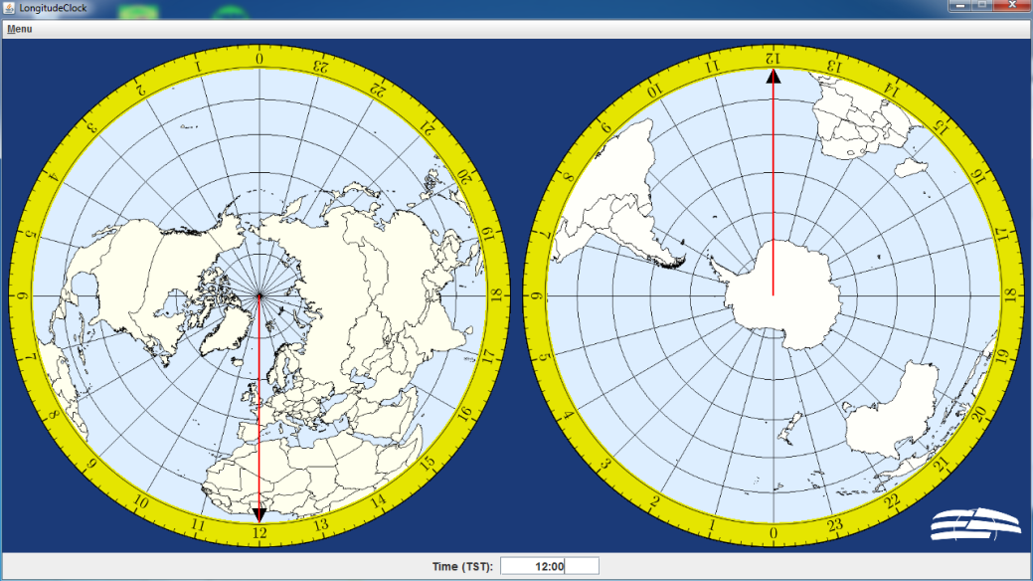
Figure 2: Screen shot of the longitude clock application.

Minimum requirements
- Java version 7 or higher
- Graphic board that supports at least OpenGL 3.3
When the application is started, the OpenGL version that is currently supported will be shown in a separate console.

Instructions
Unzip the file astroedu1646-LongitudeQuest-LongitudeClock.zip anywhere on a computer that has either Windows or Linux installed. A new folder called LongitudeClock is created. Go to that folder and run either the Windows or Linux launcher script. Detailed information about its usage is included.

Activity 1: Find the longitude
Materials needed:
- Worksheet
- Longitude clock
- Pencil
- Calculator
- Computer, if the longitude clock app is used

Latitude and longitude
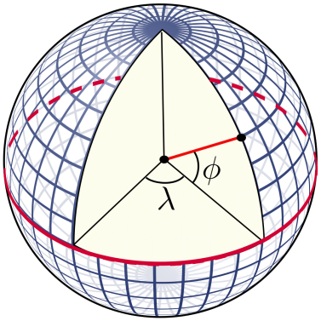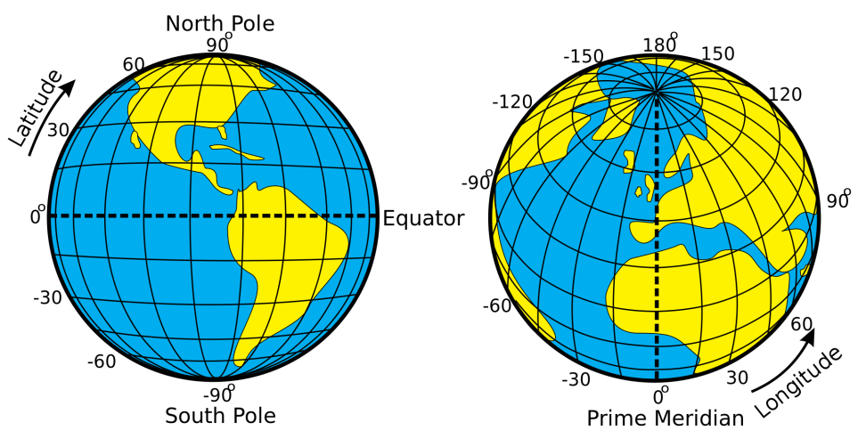
Figure 3: Illustration of how the latitudes and longitudes of the Earth are defined (Credits: Peter Mercator, djexplo, CC0).
Any location in an area is defined by two coordinates. The surface of a sphere is a curved area, but using coordinates like up and down does not make much sense, because the surface of a sphere has neither a beginning nor an ending. Instead, we can use spherical polar coordinates originating from the centre of the sphere, where the radius is fixed by its size (Figure 3). Two angular coordinates remain. Applied to the Earth, they are called the latitude and longitude. The Earth’s rotation provides the symmetry axis. The North Pole is defined as the point where the theoretical axis of rotation meets the surface of the sphere, and rotation is counter-clockwise when looking at the pole from above. The opposite point is the South Pole. The equator is defined as the great circle halfway between the two poles.

The latitudes are circles parallel to the equator. They are counted from 0° at the equator to ±90° at the poles. The longitudes are great circles connecting the two poles of the Earth. For a given position on Earth, the longitude going through the zenith, or the point directly above, is called the meridian. This is the line the Sun apparently crosses at local noon. The origin of longitudes is defined as the Prime Meridian, which passes Greenwich, where the Royal Observatory of England is located. From there, longitudes are counted from 0° to ±180°.

Example: Heidelberg in Germany is located at 49.4° North and 8.7° East.

Mean and True Solar Time
Figure 4 demonstrates the Earth’s rotation and its orbit around the Sun. The Sun illuminates the Earth, which leads to day and night. Within nearly 24 hours, the Earth rotates once around its own axis. As a result, the orientation relative to the sky at position 2 is the same as that at position 1.
In addition to rotating, the Earth also revolves around the Sun. At position 1, the Sun indicates local noon. This means that on the northern hemisphere, the Sun is due south. However, at position 2, i.e. after one full rotation, the Sun does not align with that point in the sky anymore, i.e. it indicates a time before local noon. In order to have the Sun at the same spot in the sky again (next local noon), the Earth has to revolve and rotate for a little longer (position 3). Thus, a solar day lasts a few minutes longer than the Earth takes to rotate around its own axis. A solar day takes almost exactly 24 hours.
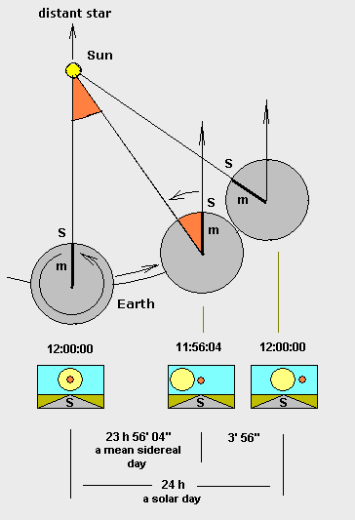
Figure 4: Illustration of the difference between solar and sidereal days (Credit: Francisco Javier Blanco González, https://commons.wikimedia.org/wiki/File:Tiempo_sidéreo.en.png, https://creativecommons.org/licenses/by-sa/2.5/ legalcode).
However, the orbital speed of the Earth around the Sun is not constant throughout the year. It is faster near the perihelion and slower near the aphelion.
Consequently, the solar day has different durations. This is reflected in the apparent solar time (AST) or true solar time (TST), which corresponds to the true apparent path of the Sun across the sky. Therefore, 12:00 noon TST is exactly when the Sun is due south.

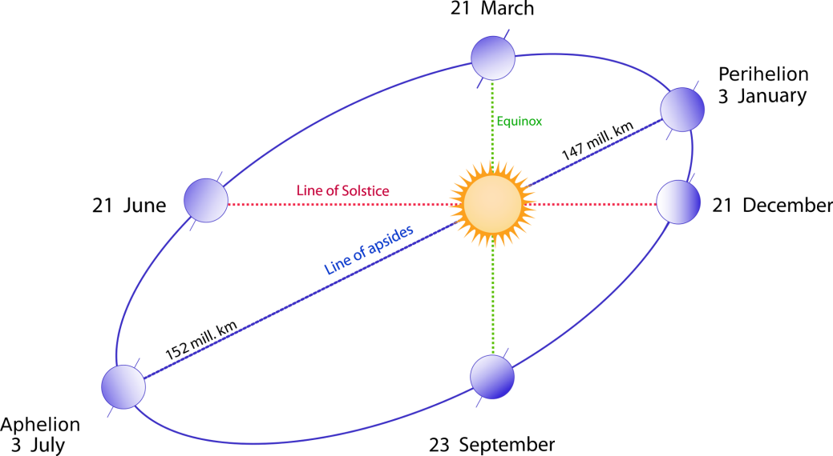
Figure 5: Schematic view of the Earth’s elliptical orbit around the Sun throughout a year. The position closest to the Sun is the perihelion, while the most distant point is the aphelion (Credits: following Duoduoduo’s advice, vector image: Gothika, https://commons.wikimedia.org/wiki/File:Seasons1.svg, ‘Seasons 1’, annotations updated by Markus Nielbock, https://creativecommons.org/licenses/by-sa/3.0/legalcode).
On average, the solar day lasts 24 hours, which corresponds to a full apparent revolution of the Sun in the sky, i.e. 360°. Based on this average, we can also assume that on average every day is equally long, i.e. the Sun returns to the same position exactly every 24 hours. We have seen that in reality this is not the case, but it simplifies measuring time. This timescale is called the mean solar time (MST). This means that the angular speed $ω$ of the Earth relative to the Sun’s apparent position for a solar day is on average 360° divided by 24 hours (h), or 15 degrees per hour:
$$ω=\frac{360°}{24 \text{h}}=15\frac{°}{\text{h}}$$

Determining longitude
With this rotational rate, one can determine longitude if both the time at the Prime Meridian and the local time are known. If one calculates the difference between these times, the longitude is derived by simply multiplying this number with 15.
This concept was already proposed by the ancient Greek mathematician Hipparchus, who lived in the 2nd century BCE.
Several methods have been tried and used in history to determine this time difference. Many involve the exact prediction of astronomical events that can be observed anywhere on Earth (eclipses, lunar distances to known bright stars, constellations of Galilean moons around Jupiter). Ships used to take along tables with the times at 0° longitude for such events. But they often turned out to be too complicated or difficult to observe on a rocking ship.
The breakthrough was achieved by John Harrison, an 18th century clockmaker, who managed to invent highly accurate clocks that would even work on ships. His fourth version, the H4, had the design of a large pocket watch and always showed along the local TST at Greenwich or, more precisely, at the Prime Meridian.
All the navigators had to do was determine their local time, which was usually done at local noon, when the Sun passes the local meridian. The time difference in hours between local noon and TST is
$$Δt=12 \text{h}-TST$$
The longitude corresponds to the angle for which the Earth had rotated between noon at the Prime Meridian and the local noon. Since a mean solar day lasts 24 hours, one hour corresponds to 15° in longitude. The local longitude in degrees is then given as follows:
$$λ=Δt∙15=\left(12 \text{h}-TST\right)∙15 \frac{°}{\text{h}}$$

Using the longitude clock
When navigating using a sextant and clock, the local time on board a ship is compared to the time measured at the Prime Meridian. For this purpose, ships used to carry along a highly accurate clock that was set to the time at 0° longitude, i.e. the time at the Greenwich Observatory. The measurements were usually made at local noon, i.e. when the Sun attains its highest elevation.
The Prime Meridian is indicated on the longitude clock. To determine longitude, simply turn the marker of the Prime Meridian to the time displayed by the clock, which is set to the time at 0° longitude. The local longitude is then indicated at the time marker of 12 o’clock (local noon). The longitudes are indicated in steps of 15° west and east of the Prime Meridian.
Note that for our exercises, we assume the clocks to show the true solar time, but we calculate assuming the mean duration of a solar day to be 24 hours.

Exercise
The table below contains five TST readings for local noon. Use the equations above to calculate the time differences and the resulting longitudes and fill in the blank table cells. Negative values indicate western longitudes while positive values represent eastern longitudes.
Each result is crosschecked using the longitude clock.
True solar time  at Greenwich (hh:mm) | $Δt$ (h) | $$λ (°)$$
08:00
23:00
18:00
00:00
14:30

Activity 2: Captain Cook’s second voyage
Materials needed:
- Worksheet
- Pencil
- Calculator
- Computer/tablet/smartphone with internet connection
Captain James Cook was an 18th century British explorer, navigator, cartographer and captain of the Royal Navy. He is famous for his three voyages to and through the Pacific Ocean. On his first voyage, Cook was the first to map the entire coastline of New Zealand and the eastern coast of Australia. He also made first contact with aboriginal tribes there. The spot of his first landing was later named Botany Bay, just south of present-day Sydney.
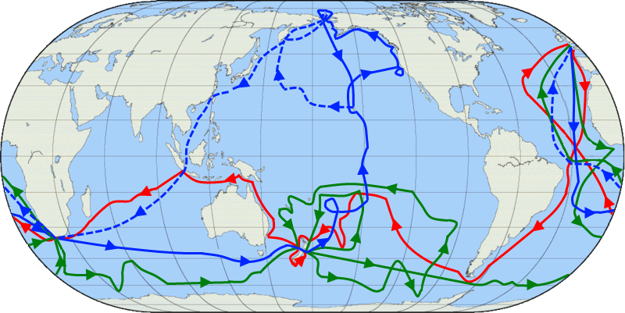
Figure 6: Map showing the three voyages of Captain James Cook, with the first in red, second in green and third in blue. The route of Cook’s crew following his death is shown as a dashed blue line (Credit: Jon Platek. Blank map by en:User:Reisio. https://commons.wikimedia.org/wiki/File:Cook_Three_Voyages_59.png, ‘Cook Three Voyages 59’, https://creativecommons.org/licenses/by-sa/3.0/legalcode).
However, it is Cook’s second voyage from 1772 to 1775 that interests us the most. On this journey, he took along a replica of John Harrison’s H4 watch to test its accuracy and its ability to determine longitude.

Exercise
In this exercise, you will assume the position of Captain Cook’s navigator. On the basis of the measurements indicated in the table below, you will determine the latitude and longitude for seven locations that were part of his second voyage.
The latitude can be calculated from any observable celestial object. If the position of this object in the sky is known, the angle between the horizon and that object, or the elevation, guides latitude determination. Celestial objects have coordinates of their own. What is important here is their angle with the equator. This angle is called declination and corresponds to the latitude on Earth. Only at the terrestrial poles, the equator aligns with the horizon.
The latitude $ϕ$ is calculated from the declination ($δ)$ and elevation ($η)$ using the following equation.
$$ϕ=±\left(90°-η\right)+δ$$
The plus sign in front of the bracket is chosen if the Sun attains its highest elevation to the south. It is minus if the Sun is to the north. The sign of $ϕ$ is positive for northern latitudes and negative for southern latitudes.
Unfortunately, the Sun changes its declination all the time. However, it can be calculated. For the seven measurements, its value has been included in the table below.
Table 1: List of navigational measurements made on Cook’s flagship, the HMS Resolution, on seven dates during his second voyage. The measurements were all obtained at local noon, i.e. at the highest elevation of the Sun on that day. The times were obtained from the K1 watch James Cook took with him.
Date | Solar  declination (°) | Sun  direction | Solar  elevation (°) | True Solar Time (hh:mm:ss)
13 July 1772 | 21.7 | South | 61.3 | 12:16:24
30 October 1772 | -14.1 | North | 70.2 | 10:46:24
17 May 1773 | 19.3 | North | 29.7 | 00:22:48
15 August 1773 | 14.0 | North | 58.5 | 02:01:36
30 January 1774 | -17.5 | North | 36.3 | 19:07:36
17 December 1774 | -23.4 | North | 60.0 | 17:05:14
30 July 1775 | 18.5 | South | 58.1 | 12:06:00

Story
Captain James Cook began his second voyage on 13 July 1772. His fleet consisted of two ships, the HMS Resolution and the HMS Adventure, the latter commanded by Captain Tobias Furneaux. Before setting sail, Cook took the first set of measurements.
After stopping in the Madeira and Cape Verde Islands, the expedition anchored on 30 October 1772 at their first major southern port. They navigated around the Cape of Good Hope and after manoeuvring the ships through pack ice, they reached the Antarctic Circle on 17 January 1773. Both ships rendezvoused on 17 May 1773. From there, they explored the Pacific, and on 15 August reached an island, where the first pacific islander ever to visit Europe embarked on the HMS Adventure.

The Adventure returned to England early, while Cook with the Resolution continued to roam the seas. After several attempts to venture south of the Antarctic Circle, he reached the most southern point on 30 January 1774, where ice blocked the passage. Cook continued to explore the Pacific but finally decided to steer a course home. Cook headed east and his crew sighted land on 17 December 1774. They spent Christmas in a bay that Cook later named Christmas Sound.

He continued exploring the South Atlantic and discovered South Georgia and the South Sandwich Islands. After a stopover in southern Africa, the ship returned home on 30 July 1775.
For seven of the destinations mentioned in this document, the table above lists measurements from which you should determine the latitude and longitude and add them to the table below.
For the longitudes, use the equations in Activity 1. The times listed in the map have to be converted into hours, with decimals representing the minutes and seconds.

Example
The first measurement is at Cook’s home port. It was taken on 13 July 1772 at 12:16:24. So, it is 12 hours, 16 minutes and 24 seconds. To convert this into hours with decimals, simply add up the following numbers:
12 hours
16/60 hours
24/3600 hours
The sum is rounded to 12.2733 hours.
Following the equation mentioned above, you get (rounded to the first decimal):
$$λ=\left(12 \text{h}-12.2733 \text{h}\right)∙15 \frac{°}{\text{h}}=-4.1°$$
Thus, the longitude is -4.1° or 4.1° west.
To get the latitude, calculate (northern hemisphere, i.e. the Sun is in the south):
$$ϕ=\left(90°-η\right)+δ=\left(90°-61.3°\right)+21.7°$$
Date | Latitude (°) | Longitude (°) | Location on map
13 July 1772
30 October 1772
17 May 1773
15 August 1773
30 January 1774
17 December 1774
30 July 1775
If possible, check a map in an atlas or via a service online where these positions are on Earth. In Google Maps, simply enter the latitude followed by the longitude, both separated by a comma.
Glossary

Aphelion
The point in the Earth’s orbit that is most distant from the Sun

Apparent movement
Movement of celestial objects, which is caused by the Earth’s rotation

Cardinal directions
Main directions, i.e. north, south, west, east

Culmination
Passing of the meridian by celestial objects. These objects attain their highest or lowest elevation there.

Diurnal
Concerning a period that is caused by the daily rotation of the Earth around its axis

Elevation
Angular distance between a celestial object and the horizon

Galilean moons
Four of more than 60 known moons of Jupiter (Io, Europa, Callisto and Ganymede) that Galileo Galilei discovered in 1610 with one of the first astronomical telescopes used in human history.

Great circle
A circle on a sphere whose radius is identical to the radius of the sphere

Mean solar time
Annual average of the duration the Sun takes to reach the same azimuthal direction (e.g. between noons), which is almost exactly 24 hours. The time measured according to these astronomical events is called the mean solar time. In general, this differs from the time displayed by common contemporary clocks.

Meridian
A line that connects north and south at the horizon via the zenith

Perihelion
The point in the Earth’s orbit that is closest to the Sun

Pole height
Elevation of a celestial pole. Its value is identical to the latitude of the observer on Earth.

Precession
As a spinning body rotates, the rotation axis often also moves in space. This is called ‘precession’. As a result, the rotation axis constantly changes its orientation and points to different points in space. The full cycle of the precession of the Earth’s axis takes roughly 26,000 years.

Sextant
Navigational tool invented during the 18th century used to measure the angular altitude of celestial objects to determine latitude

Spherical polar coordinates
The natural coordinate system of a flat plane is Cartesian and measures distances in two perpendicular directions (ahead, back, left, right). For a sphere, this is not very useful, because it has neither beginning nor ending. Instead, the fixed point is the centre of the sphere. When projected outside from the central position, any point on the surface of the sphere can be determined by two angles, one of which is related to the symmetry axis. This axis defines two poles. In addition, the radius represents the third dimension in space, whereby each point within a sphere can be determined. This defines the spherical polar coordinates. When defining points on the surface of a sphere, the radius stays constant.

Time zone
Before mass transportation across large distances by train became possible, each town had its own local time that followed the solar time. This situation became impractical, as time tables for trains had to consider the shifts in time between stations. Therefore, in the 1840s, a standard time that would be valid throughout Britain was decided on. Later, the concept was implemented all over the world, with 24 zones of local standard times, namely, the time zones. This is what we still use today.

True solar time (apparent solar time)
The duration of a true solar day – the period between two meridian passages of the Sun – changes throughout the year. This is caused by the eccentric orbit of the Earth around the Sun. While the rotational speed of the Earth itself remains constant, the orbital velocity around the Sun does not. Consequently, a true solar day can be off from the mean value of 24 hours between about 20 to 30 seconds. This leads to differences between the true and mean solar times of up to approximately 15 minutes in either direction. In this time frame, noon is when the Sun is exactly on the meridian, i.e. south in the northern hemisphere and north in the southern hemisphere.

Zenith
Point in the sky directly above

