TITAN

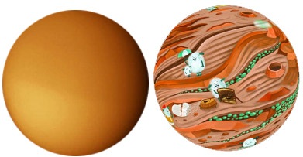

Titan is the largest moon of Saturn, the ringed planet. This is the only moon with a thick atmosphere. The material on Titan’s surface consists of water-ice; that is, its rocks are also made of ice. Titan’ interior is not hot now, so there are no active volcanoes on it. There are still a lot of changes happening to its surface, which is mainly caused by the methane cycle. There is no liquid water on Titan because the material of ice-rock is always in a state frozen to the hardness of rock at the cold surface (-180°C). The role of ground water on Earth is performed by ethane and methane on Titan. Methane on the Earth occurs only as a gas, as for example in the flame of a gas stove. There is also methane rain falling from Titan’s clouds; when it accumulates, it forms rivers, which run into polar lakes and seas. In the region of the equator, parallel bands of dark dunes line up and bury much of the surface. Titan’s landscapes are perhaps the most similar to the Earth within the solar system, but still it is a planet that operates very differently from ours. Space probe Huygens landed on its surface in 2005. It is the farthest world from the sun on which photos of its surface have ever been taken.

Body type: moon
Body composition: icy
Atmosphere: thick, orange, cold atmosphere, mostly Nitrogen
Liquid: methane, ethane
Weather: Surface temp. -175 °C all over the globe. C2H6 surface fog near lakes. Always completely hazy at high altitudes, blocking 99% of sunlight . Some clouds. Intense occasional methane showers at the equator over Xanadu and polar areas. Infrared rainbows.
Endogenic features: none
Exogenic features: rivers, lakes, valleys, “labyrinth terrain”, dunes
Cosmogenic features: few impact craters
Common features: dunes (equator), featureless plains (mid-latitudes), wet and dry lakes (poles)
Rare features: rivers, deltas, islands, rain features
Life limiting parameter: too cold
Nomenclature: Names from JRR Tolkien’s The Lord of the Rings, Isaac Asimov’s Foundation, Frank Herbert’s Dune series.
Highest point: Mithrim Montes in Xanadu, 3 km high. The water ice surface is eroded by rain and grains of dunes are redistributed by winds.
Age of the surface: variable, includes very old and very young surfaces. Lakes are actively forming and drying.

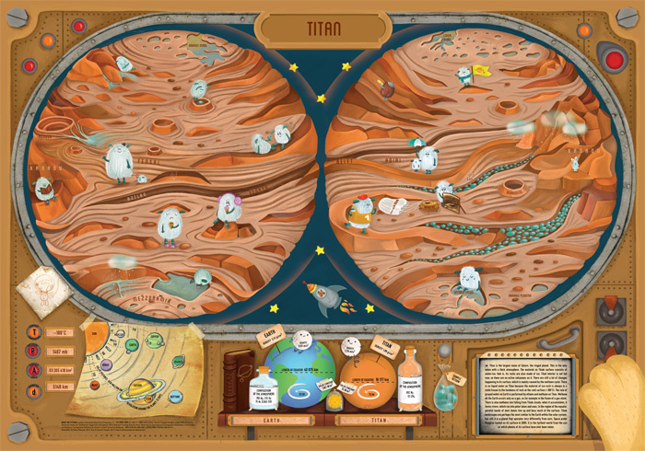

Titan map: (Illustrator: Panka Pásztohy) The least understood (at present) world is Titan, where large areas are yet to be mapped and interpreted. The map shows the surface as a perspective spherical landscape, where the various forms are open to interpretation. Ice pebbles fill some of the valleys, greatly enlarged in the map. Parallel lines along the equator represent longitudinal dunes. Lakes are all real features, except for one in which one creature is bathing. Clouds (over the poles and Xanadu) were indeed observed and likely made rain on the surface.
White hairy creatures interact with the surface. The physical parameters of the bodies are depicted in a “bookshelf,” which should look very appropriate when the map hangs on the wall of a children’s room.

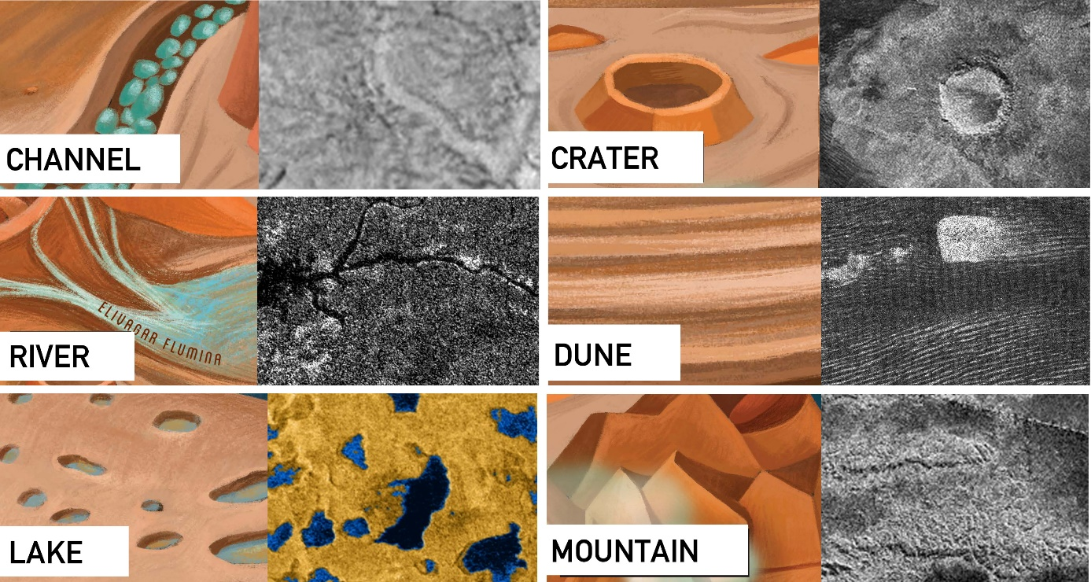

INSTRUCTIONS / TITAN
ACTIVITY 1
- Draw the Equator
- Mark the North Pole and South Pole in both hemispheres with letters N and S
- Write the name of the body
ACTIVITY 2 Read the handout, and underline words you don’t understand.
Graphic map. Using the map, draw a generalized (simplified) sketch map, showing the outlines of only the largest and most important features (draw several types of features, e.g., cracks and craters). You can use colors and/or lines.
- Exogenic (liquids)
  - Groups of Lakes at both poles (Kraken Mare, Ontario Lacus)
  - Rivers (... Fluctus)
- Aeolian (wind produced)
  - Long, subparallel dark dunes at the equator
- Other
  - Xanadu mountainous region

ACTIVITY 3 Your landing site. Where would you land? which place you find the most exciting for exploration? Find YOUR landing site. Mark it with a symbol. Name your landing site (s). Write down the names next to the symbol.
ACTIVITY 4 Names. After the graphic part is finished, create the nomenclature: write the names of the features you have drawn next to the feature itself. Write three names (you can add more later) onto the map. You can use different colors or letters for each feature type (e.g, capital letters for continents, red color for the lava channel etc. -- be consistent).
ACTIVITY 5 Make up a weather forecast for "tomorrow", based on the Weather information in the handout. Choose at least three places, and show weather data: display the min/max temperature in your unit (C or F) with LARGE numbers. Consider that on towards the poles it is colder. Next to the numbers, show the weather with a graphic symbol you design: clear (sunny), cloudy, rainy, foggy or any interesting, special weather phenomenon you learn from the handout. Find min/max temperature data on the map's control desk and additional information on the handout.
ACTIVITY 6 Design a flag for the planet or moon, and draw it on the map, based on the characteristics of the body (weather, color, geology etc).
ACTIVTY 7 Draw a map legend where YOUR symbols are explained on the map. You may group them by process (e.g., exogenic (atmospheric, aeolian), endogenic (volcanic, tectonic) and impact processes). Write down the title “LEGEND” and explain your symbols and indicate which feature it corresponds to.

