Seasons Around the World

What causes seasons on Earth?

Task 1 - Vertical or shallow angle

You have just been looking at the rays of light coming from the torch. Did it look like the drawing? Circle the correct answer.
The area of light is larger if you shine the torch vertically / at a shallow angle on the table.
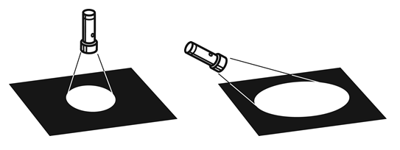

Task 2 - Hot or cold?

What do you need?
You need an orange or a ball, pens, 3 cocktail sticks or other markers, and sticker(s).

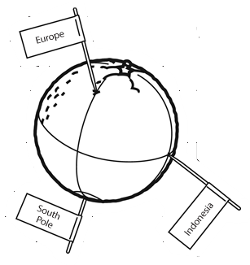
The orange (or the ball) represents the Earth with the North Pole on the top of the orange.
What are you going to do? Carry out this task with someone else.

- Draw the meridian circle: the circle links the North and South poles.
- Draw the Equator around the middle of the orange. The equator is perpendicular to the circle linking the North and South poles.
- Pin a cocktail stick in the bottom of the orange. Write South Pole on a sticker and attach it to the cocktail stick to recognize it later.
- Turn the orange a quarter to the left and pin a cocktail stick labeled Europe there. Pin a cocktail stick on the intersection of the vertical line and the equator, like the third cocktail stick in the drawing. This is Indonesia. Write Indonesia on a sticker and attach it on the cocktail stick to help you recognise it later.
- Hold the orange at a slight angle, like in the drawing below. Shine the torch on the cocktail stick showing where you live. Hold the torch 15 centimetres away from the orange.

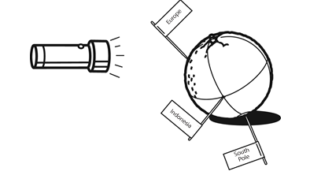
- Get your partner to draw a line around the area on the orange where the light is shining.
- Now shine the torch from 15 centimeters away from the side onto Indonesia.
- Get your partner to draw a line around the area on the orange where the light is shining now.
- Look at the two circles. Circle the correct answer.

The area lit up for Europe is larger / smaller than the area in Indonesia (on the Equator). CIRCLE the correct answer

- Below you can see four drawings. They show the position of the Earth in the different seasons.

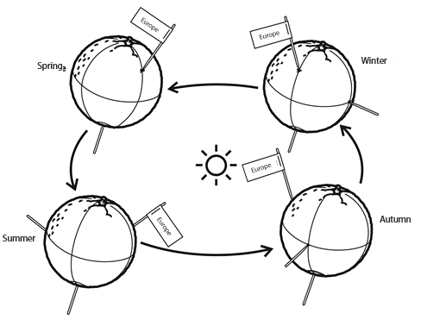
- Experiment shining the torch on your orange as shown in each of the drawings to see how the light falls on the surface. Turn the torch along with the orange.

- The rays of the Sun always fall at more of a right-angle / more diagonally where I live than on Indonesia. CIRCLE the correct answer
- In which season do we have the least sunlight here?
- In which season do we have the most sunlight here?

Task 3 - Seasons are not different everywhere

Now, can you answer the following questions?

- What is the connection between the Sun and the seasons?
- Why is there very little difference in the seasons in the countries on the Equator, such as Indonesia?

