Navigate like a Viking – use the Sun, not your phone!

Purpose of this activity
You will imagine yourself to be a 9th century Viking who has to use the Sun to navigate across the North Sea. You will build your own navigational tool, test its functionality and simulate a voyage from southern Scandinavia to Greenland. Imagine not getting lost in the wide ocean without any modern devices like GPS receivers installed in a smartphone. In addition, you will learn about the history of the Vikings, who built the most advanced ships of their times in Europe.

Introduction
Watch the following videos.
History Channel | The Vikings [New] HD (Duration: 1:28:22)
https://www.youtube.com/watch?v=6mkib3lYA2s

Vikings, The Founders of Europe (Duration: 50:32)
https://www.youtube.com/watch?v=jngPAIGrzJs

Building a Viking Ship (Duration: 1:46)
https://www.youtube.com/watch?v=78kpzwGmBxk

Questions
For how long has mankind used ships to cross the oceans?

What could the benefits of trying to explore the seas have been?

How do you find your way to school every day? What do you use to prevent yourself from getting lost?

In the absence of obvious landmarks, how did ancient sailors find their way on the open seas?

The Story of the Viking Galmi
This worksheet comes with a short story about a Viking called Galmi. Read it and answer the following questions.
What is Galmi’s job?

Why does he want to go on a raid?

Who is leading the crew of sailors that Galmi joins?

What is their destination? Would you know its modern name?

What propulsion devices do the longships have?

How do the Vikings protect themselves against heavy rainfall on the open seas?

How does Floki determine the course?

How does the crew know that the coast is near?

Does the longship need anchors to dock?

Activity: A Game of Shadows
With this activity, you will investigate the properties and usage of a Viking shadow board, which was used for navigation.
Materials needed for one experimental set-up:
- Cardboard (diameter at least 4 cm)
- Toothpick
- Earth globe (+ stable mounting, e.g. inflatable: https://goo.gl/gq1d5N, http://www.unawe.org/earthball)
- Compass (drawing tool)
- Lamp or spot light
- Scissors
- Cutter or sharp knife
- Glue
- Blu Tack (or similar)
You will either work in groups of two, or the teacher will set up the activity as a demonstration only.

Building a miniature shadow board
For this activity, you need a miniature version of a shadow board. Follow the instructions to make one for yourself.
- Use the compass to draw three concentric circles with radii of 1, 1.5 and 2 cm on a piece of cardboard.
- Cut out the disc along the circle with a radius of 2 cm.
- Cut a 2-cm-long piece from the toothpick.
- Run it through the centre of the cardboard disc and glue it. Make sure that it remains perpendicular to the surface of the disc. The two rings on the disc must be on the same side as the stick (Figure 1).
- Let the glue dry.
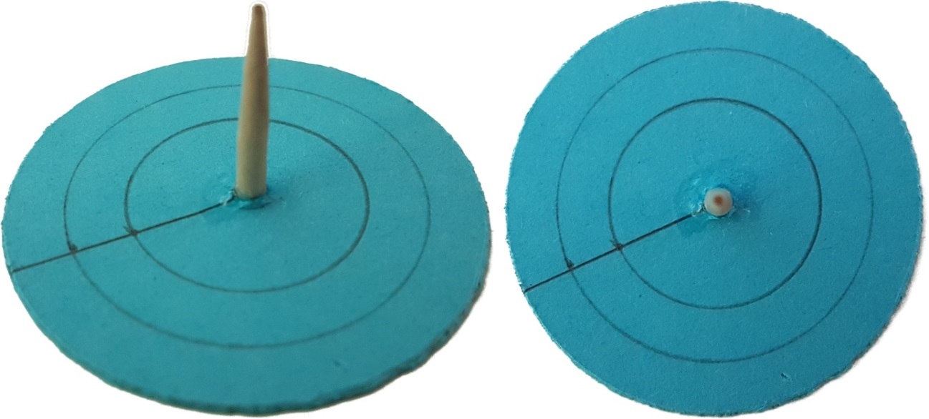
Figure 1: Miniature shadow board made of cardboard and a toothpick. Left: side view, right: top view (own work).

Part 1: Shadows
Put the shadow board on the desk. Before starting the experiments, answer the following questions:

When you illuminate the shadow board, how will the shadow cast by the stick behave when the position of the lamp is changed? What will be the direction of the shadow relative to the lamp?

How will the shadow change when you hold the lamp high or low?

Take a lamp and illuminate the shadow board. Change the position of the lamp relative to the board and observe how the shadow changes.
Compare your observations to your predictions. Did the shadow behave as you expected? Discuss this with your classmates:

Imagine that the lamp represents the Sun. Where does the shadow point to when the Sun is south (northern hemisphere)/north (southern hemisphere) of you?

How would you be able to find the south when observing the path of the Sun during the day?

Imagine that the lamp represents the Sun. Are the shadows longer in the winter or summer? Explain!

Part 2: Navigate
The Vikings travelled between Scandinavia and Greenland. Figure 9 shows that if the Vikings embarked at southern Norway and travelled along the 61st northern latitude, they would have ended up at the southern tip of Greenland. It is quite likely that at least during parts of such a voyage, they used the shadow board as a navigational tool.
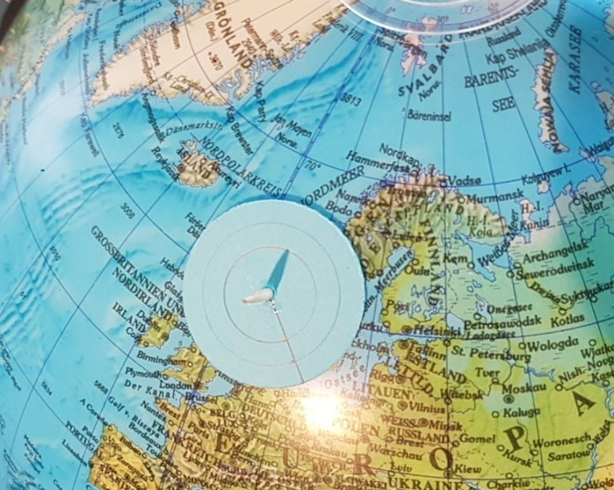
Figure 2: Starting position of the shadow board with the gnomon located at southern Norway (own work).
To simulate the point of embarkation, attach the miniature shadow board with Blu Tack on the globe at the southern tip of Norway (Figure 2). Since the Vikings predominantly sailed during summer, the angle between the axis of the globe and the connecting line to the lamp should be less than a right angle (90°, see Figure 3), although this is not very important for the purpose of this exercise. The easiest way to do this is to keep the north up.
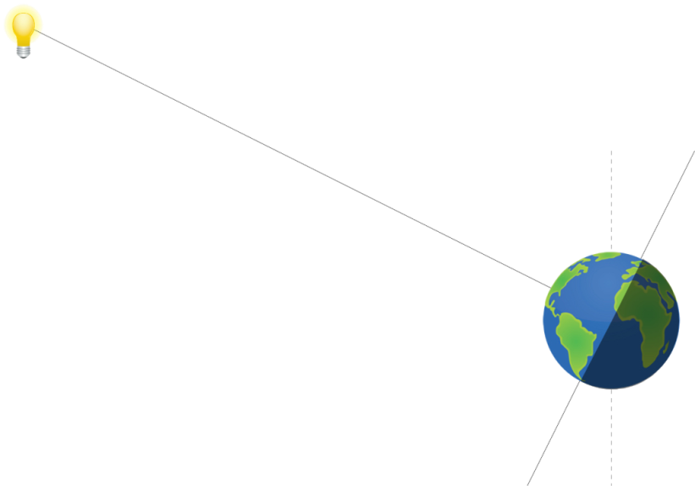
Figure 3: The lamp that represents the Sun illuminates the globe. Northern summer is achieved when the axis of the globe and the line connecting it with the lamp subtend an angle smaller than 90° (own work).
Important: Try to keep the orientation between the lamp and the Earth’s axis stable.
In the beginning, place the globe in a position such that the shadow on the shadow board points up, that is, to the North Pole. Adjust the distance between the globe and the lamp until the shadow touches one of the rings (inner ring in Figure 2).
What is the local time of the day, when the lamp (the Sun), the shadow board and the axis of the globe (Earth) are aligned? From the perspective of the shadow board on the Earth, where would the Sun be in the sky?

How would you be able to derive the cardinal directions from this measurement?

While maintaining the orientation of the globe, rotate it around its axis and watch how the shadow changes.
Tip: If an inflatable globe is used, its orientation can be fixed by mounting it on a bowl.
What time of the day corresponds to the configuration in which the shadow board is east of the previous orientation of the globe?

How does the shadow change?

When is the shadow the shortest?

Now, return to the initial configuration. Then change the latitude of the starting position by moving the shadow board north and south.
How does the shadow change?

You will now simulate a voyage to the southern tip of Greenland. During each measurement with the shadow board, adjust the globe such that it indicates local noon for the board.
Now put the shadow board at a position west along the current latitude. Rotate the globe until the shadow points north.
How did the Vikings know when the shadow pointed north? The answer is in the length of the shadow.

Repeat this procedure a few times until you reach the southern tip of Greenland. Make sure the tilt of the axis is kept constant.
Explain why the length of the shadow during local noon is always the same anywhere on the same latitude.

The Math of the Shadow Board
(optional, for higher terms; trigonometric functions needed)
The length of a shadow can be calculated if its latitude on Earth is known. To make the calculations simple, we assume the following:
- The Sun is above the equator (equinox).
- The radius of the Earth is negligible in comparison to its distance from the Sun.
- It is local noon at the location of the shadow board.
- The local horizon at the position of the shadow board is flat.
Figure 4: Sketch that represents the illumination of a gnomon by the Sun at a certain latitude on the Earth. For simplicity, the Sun is assumed to be located above the equator (equinox). Local noon is assumed (own work).
To calculate the length of the shadow, we have to look at the configuration of the Sun and the Earth with respect to each other. It is shown in Figure 4. There is a gnomon (i.e. the shadow board) extending from the surface of the Earth that casts a shadow when illuminated by the Sun.
In this sketch, the rays of light originate at the centre of the Sun. Since the radius of the Earth is small in comparison to its distance from the Sun, the rays of light hitting the equator and the gnomon can be considered to be parallel to each other.
The teacher will help you to produce a sketch that contains the most crucial elements of the geometry of the shadow board on the Earth’s surface.
Our local coordinate system that extends to the horizon is a tangent that touches the surface of the Earth. When viewed from the side, this area appears like a line that touches the circumference of the Earth – a circle.
What is the angle between a tangent and a line connecting it to the centre of the circle?

Can you identify the right-angled triangle that is formed by the gnomon and the shadow cast on the plane?

The height of the gnomon is h and the length of the shadow is ℓ.
What is the trigonometric function that describes the relation between ℓ and h?

If h = 10 cm, what is the length of the shadow ℓ at latitudes of φ = 40° and 60°?

Conclusions
Why does the shortest shadow during the day point north (northern hemisphere)?

What time was it when the Sun was in the south (northern hemisphere)?

Why does the clock show a time other than 1200 h at local noon when the Sun attains its highest elevation?

The length of the shadow at local noon changes throughout the year. Why?

Background information

Latitude and longitude
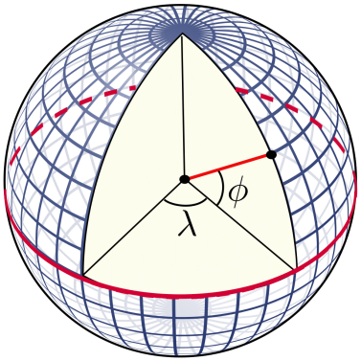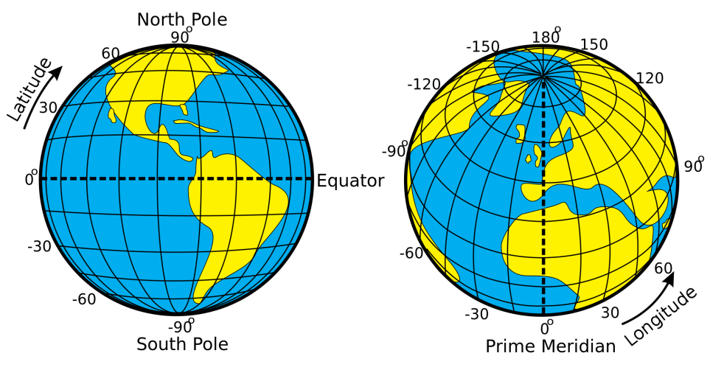
Figure 5: Illustration of how the latitudes and longitudes of the Earth are defined (Credits: Peter Mercator, djexplo, CC0).
Any location in an area is defined by two coordinates. The surface of a sphere is a curved area, and using directions like up and down is not useful, because the surface of a sphere has neither a beginning nor an ending. Instead, we can use spherical polar coordinates originating from the centre of the sphere, which has a fixed radius (Figure 5). Two angular coordinates remain, which for the Earth are called the latitude and the longitude. The North Pole is defined as the point where the theoretical axis of rotation coincides with the surface of the sphere, and the Earth rotates in a counter-clockwise direction when the pole is viewed from above. The opposite point is the South Pole. The equator is defined as the great circle halfway between the poles.
The latitudes are circles parallel to the equator. They are counted from 0° at the equator to ±90° at the poles. The longitudes are great circles connecting the two poles of the Earth. For a given position on Earth, the longitude going through the zenith, which is the point directly above, is called the meridian. This is the line that the Sun apparently crosses at local noon. The origin of this coordinate is defined as the meridian of Greenwich, where the Royal Observatory of England is located. From there, longitudes are counted from 0° to +180° (eastward) and -180° (westward).

Elevation of the poles (pole height)
If we project the terrestrial coordinate system of latitudes and longitudes in the sky, we get the celestial equatorial coordinate system. The Earth’s equator becomes the celestial equator and the geographical poles are extrapolated to build the celestial poles. If we were to take a photograph of the northern sky with a long exposure, we would see from the trails of the stars that they all revolve about a common point, which is the northern celestial pole (Figure 6).
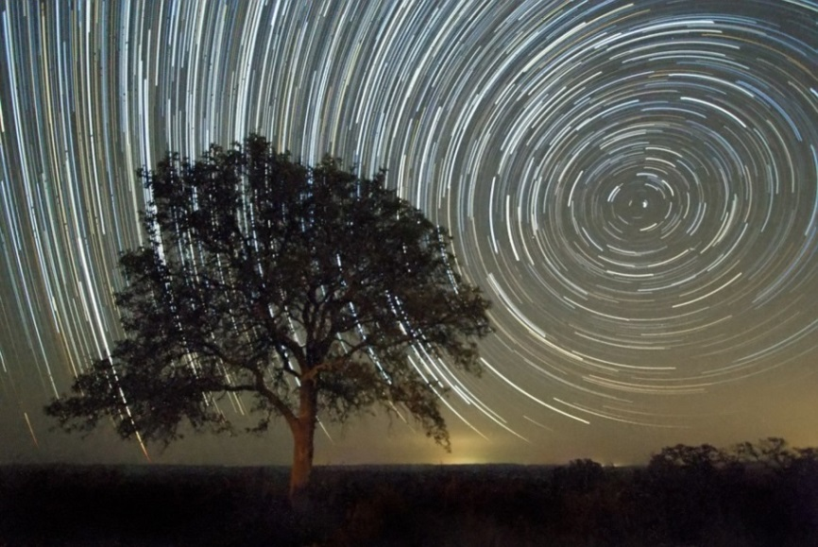
Figure 6: Trails of stars at the sky after an exposure time of approximately 2 hours (Credit: Ralph Arvesen, Live Oak star trails, https://www.flickr.com/photos/rarvesen/9494908143, https://creativecommons.org/
licenses/by/2.0/legalcode)
In the northern hemisphere, there is a moderately bright star near the celestial pole, which is the North Star or Polaris. If we stood exactly at the geographical North Pole, Polaris would always be directly overhead. We can say that its elevation would be (almost) 90°. This information introduces the horizontal coordinate system (Figure 7), which is a natural reference we use every day. We, the observers, are the origin of that coordinate system located on a flat plane, whose edge is the horizon. The sky is imagined as a hemisphere above. The angle between an object in the sky and the horizon is the altitude or elevation. The direction within the plane is given as an angle between 0° and 360°, the azimuth, which is usually measured clockwise from the north. In navigation, this is also called the bearing. The meridian is the line that connects north and south at the horizon and passes the zenith.
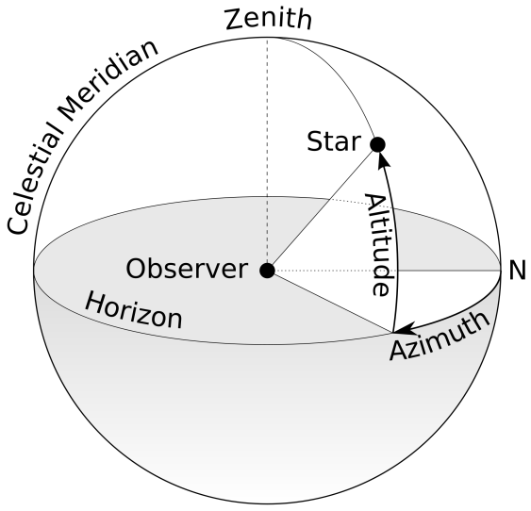
Figure 7: Illustration of the horizontal coordinate system. The observer is the origin of the coordinates assigned as the azimuth and altitude or elevation (Credit: TW Carlson, https://commons.wikimedia.org/wiki/File:Azimuth-Altitude_schematic.svg, ‘Azimuth-Altitude schematic’, https://creativecommons.org/licenses/by-sa/3.0/
legalcode).
For any other position on Earth, the celestial pole or Polaris would appear at an elevation less than 90°. At the equator, it would just appear at the horizon, that is, at an elevation of 0°. The correlation between the latitude (North Pole = 90°, Equator = 0°) and the elevation of Polaris is no coincidence. Figure 4 combines all three mentioned coordinate systems. For a given observer at any latitude on Earth, the local horizontal coordinate system touches the terrestrial spherical polar coordinate system at a single tangent point. The sketch demonstrates that the elevation of the celestial north pole, also called the pole height, is exactly the northern latitude of the observer on Earth.
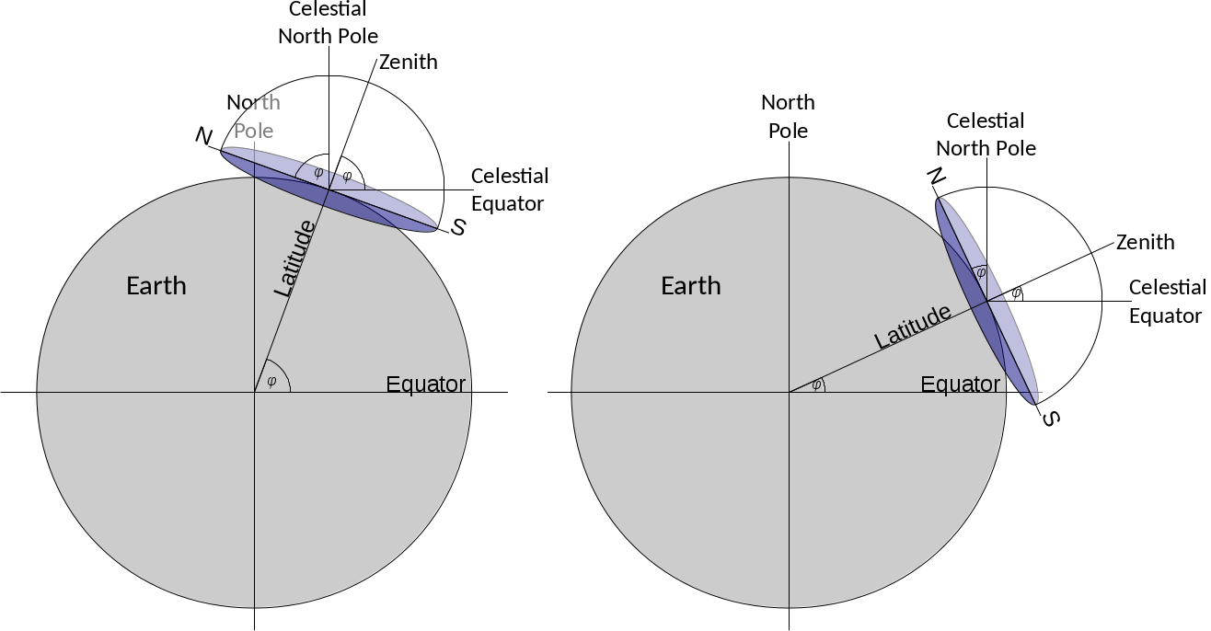
Figure 8: When combining the three coordinate systems (terrestrial spherical, celestial equatorial and local horizontal), it becomes clear that the latitude of the observer is exactly the elevation of the celestial pole, also known as the pole height (Credit: M. Nielbock, own work).
Early navigation
Early seafaring peoples often navigated along coastlines before sophisticated navigational skills were developed and tools were invented. Sailing directions helped to identify coastal landmarks (Hertel, 1990). To some extent, their knowledge about winds and currents helped them to cross short distances, e.g. in the Mediterranean.
Soon, navigators realised that celestial objects, especially stars, can be used to maintain the course of a ship. Such skills have been mentioned in early literature like Homer’s Odyssey, which is believed to date back to the 8th century BCE. There are accounts of ancient Phoenicians who were able to even leave the Mediterranean and ventured on voyages to the British coast and even several hundred miles south along the African coast (Johnson & Nurminen, 2009). A very notable and well-documented long-distance voyage has been mentioned by ancient authors and scholars like Strabo, Pliny and Diodorus of Sicily. It is the voyage of Pytheas, a Greek astronomer, geographer and explorer from Marseille who, around 300 BCE, apparently left the Mediterranean by passing Gibraltar and carried on north until the British Isles and beyond the Arctic Circle, where he possibly reached Iceland or the Faroe Islands, which he called Thule (Baker & Baker, 1997). Pytheas used a gnomon or sundial, which allowed him to determine his latitude and measure the time during his voyage (Nansen, 1911).

Sailing along a latitude
In ancient times, the technique of sailing along a parallel (of the equator) or latitude was based on observing circumpolar stars. The concept of latitudes in the sense of angular distances from the equator was probably not known. However, it was soon realised that when looking at the night sky, some stars within a certain radius around the celestial poles never set; these are circumpolar stars. When sailing north or south, sailors observe that the celestial pole changes, too, and with it, the circumpolar radius. Therefore, whenever navigators see the same star culminating, i.e. transiting the meridian, at the same elevation, they stay on the ‘latitude’. For them, it was sufficient to realise the connection between the elevation of stars and their course. Navigators had navigational documents that listed seaports together with the elevation of known stars. In order to reach the port, they simply sailed north or south until they reached the corresponding latitude and then continued west or east.
Nowadays, the easiest way to determine one’s latitude on Earth is to measure the elevation of the North Star, Polaris, as a proxy for the true celestial North Pole. In our era, Polaris is less than a degree off. However, 1000 years ago, it was 8° away from the pole.
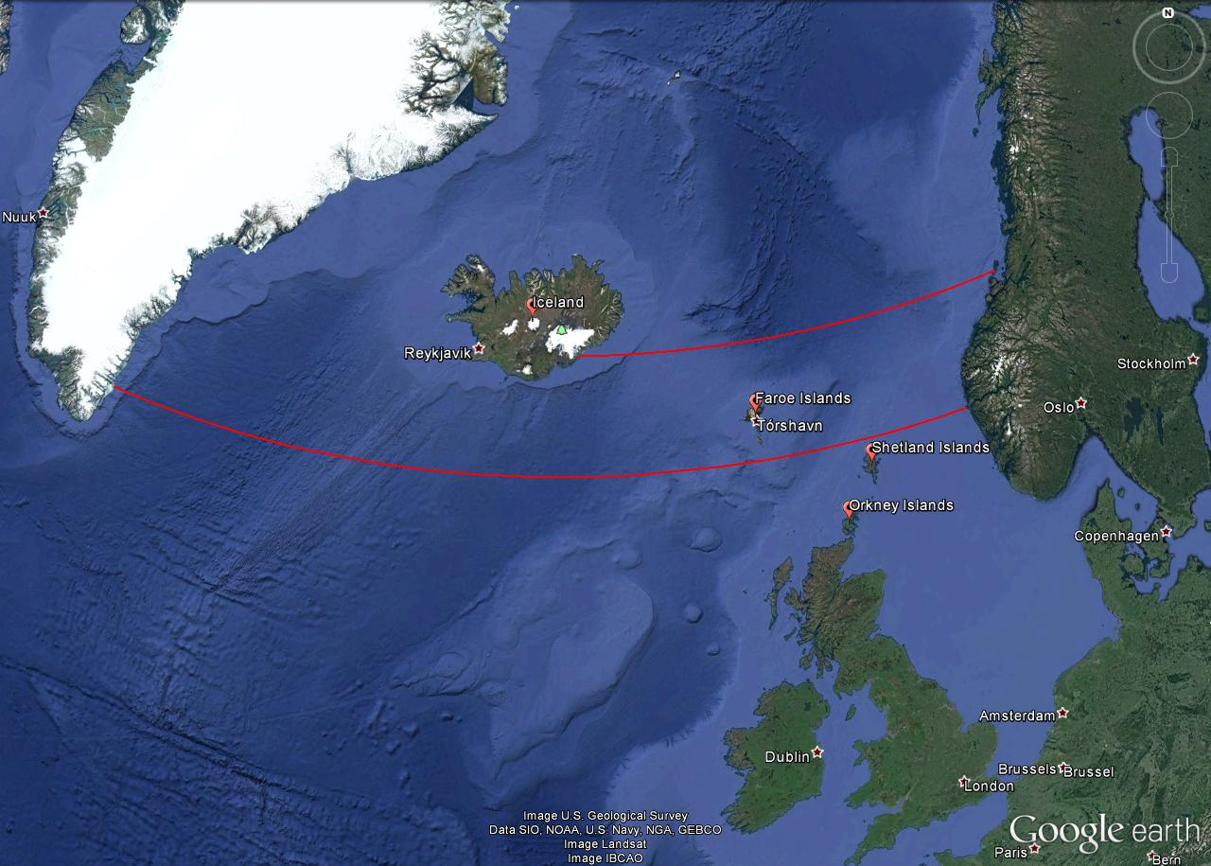
Figure 9: Vikings probably used the technique of sailing along the latitude to reach destinations west of Scandinavia (red lines). Iceland is on the 64th northern latitude and 680 nautical miles away from Norway’s coast. The voyage to Greenland along the 61st northern latitude passes the Shetland and Faroe Islands. A stopover in Iceland is a viable alternative.
However, using Polaris to determine the north direction and one’s own latitude only works when it is dark enough to see the 2 mag bright star. On a clear day, this is only possible during nautical or astronomical twilight, that is, when the Sun has set and its centre is over 6° below the horizon. However, at latitudes higher than 61° north, the Sun remains well above such low (negative) elevations, especially around the summer solstice. This is the realm north of the Shetland Islands, that is, near the Faroe Islands and Iceland. Hence, observing Polaris becomes rather difficult in the summer, which is the preferred season for sailing. For latitudes north of the Arctic Circle, where sea ice can block passages during the winter, the Sun never sets for a certain period during the summer. Therefore, other techniques were needed for navigation.
The Vikings
The Vikings were Northern Germanic tribes who were known for their seamanship, influential culture and wide trade network. And they were feared for the raids and pillages they executed with roaring brutality. However, contrary to common urban legends, the Vikings were not the filthy, savage barbarians that wore horned helmets when going into battle. Instead, they seemed to be well groomed, and bathed at least once a week (Berg Petersen, 2012). The Vikings originated in the coastal regions around western and southern Scandinavia as well as Denmark. During their explorations, they settled in Iceland, Greenland, Newfoundland, Normandy and the British Isles. However, they ventured as far as Northern America, all around Europe, the Black Sea and the Caspian Sea (Figure 10).
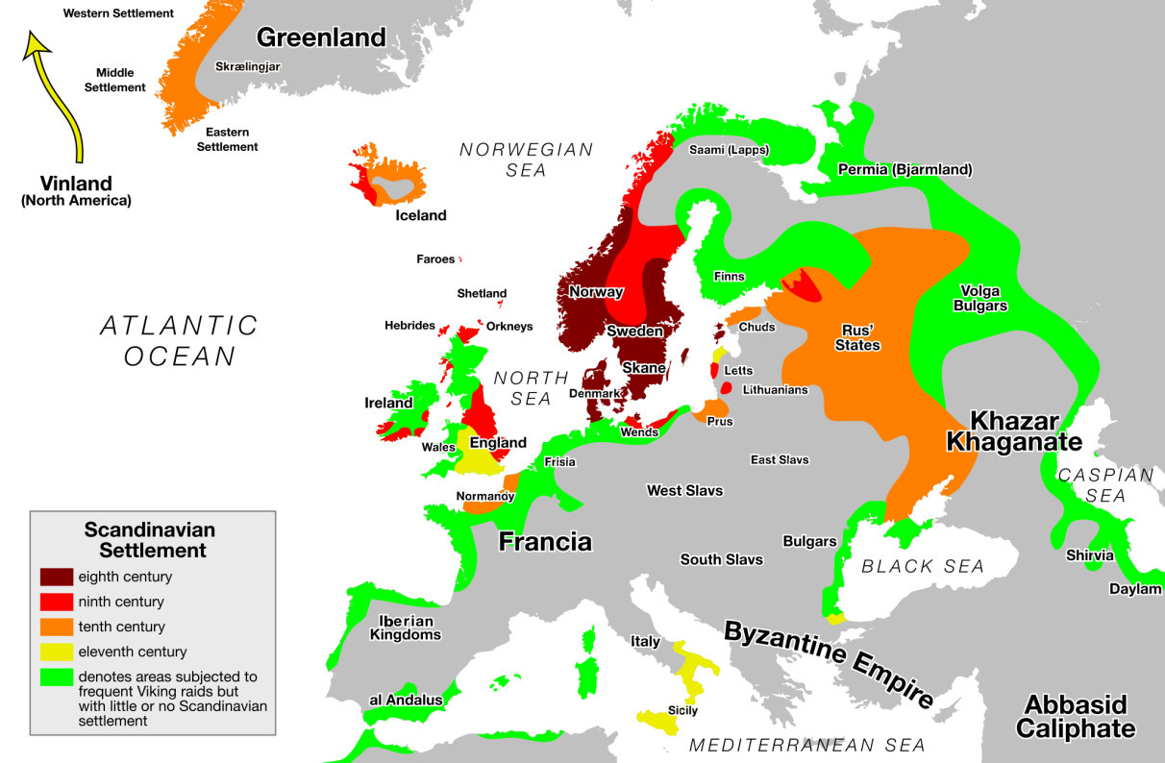
Figure 10: Map of Viking expansion between the 8th and 11th centuries. Their origins are the Norwegian coast and southern Sweden as well as Denmark (Credit: Max Naylor, https://commons.wikimedia.org/wiki/
File:Viking_Expansion.svg, public domain).
The beginning of the Viking Era is commonly dated as 793 CE, with their raid of the Christian monastery of Lindisfarne in Northumbria, England. However, the Gallo-Roman historian St. Gregory of Tours reports on an earlier attack by a Danish king named Chlochilaicus on Austrasia, the homeland of the Merovingian Franks, around 520 CE. It is believed that this Danish king may be identical to the mythical character of Hygelac in the Beowulf poem. The Viking Era ended with the Battle of Hastings between the English and the Norman-French, who were descendants of the Vikings, and the destruction and abandonment of Hedeby, an important Viking settlement and trading post, in 1066. As it marked the Norman conquest of Britain, the Battle of Hastings was such an important turning point in British history that it was documented with vivid pictures in the Bayeux Tapestry (Figure 1111), which was made in the 1070s but remains in excellent shape even now .
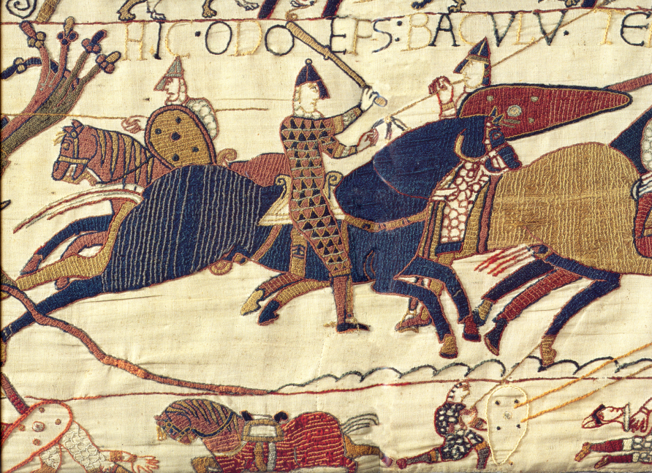
Figure 11: A segment of the Bayeux Tapestry depicting Odo, Bishop of Bayeux and half-brother to William the Conqueror, rallying the Norman troops during the Battle of Hastings in 1066. The Bayeux Tapestry is a 70-metre long embroidered cloth depicting the Battle of Hastings and the events leading up to the Norman Conquest of England. It was probably commissioned by Odo himself (https://commons.wikimedia.org/wiki/
File:Odo_bayeux_tapestry.png, public domain).
Viking navigation
The Vikings were famous for their longships, which were multi-purpose ships that could be used on rivers, shallow coastal waters and oceans. These ships were used for trade, exploration and warfare. Depending on their size, they could carry from a dozen up to 80 sailors. Because of their shallow draught, many of them did not need a harbour to make landfall and could simply be beached. Viking longships were usually decorated with carved ornaments. Propulsion was provided by sails or oars which could achieve speeds of 15 to 20 knots.
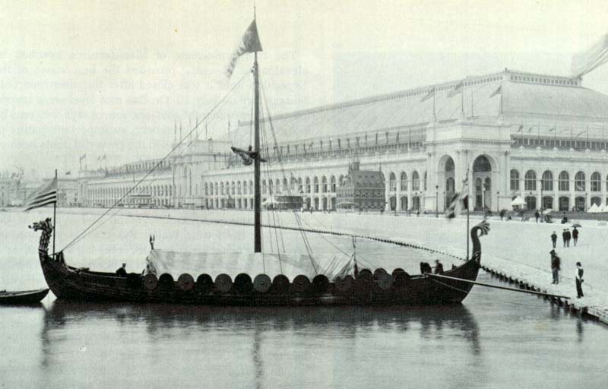
Figure 12: The ‘Viking’, a replica of the Gokstad Viking ship, at the Chicago World Fair 1893. With a crew of 11, it crossed the Atlantic and reached Chicago within 2 months (public domain).
Assuming an average speed of 5 knots, crossing the Northern Sea would have been possible within one or two days. Longer trips, e.g. from Norway to Iceland, would have been achieved within five to seven days.
The Viking sailors were very experienced in interpreting the signs provided by nature. They were able to read the migratory routes of birds and whales as well as interpret the smells and sounds that the wind carried from distant shores. The Vikings probably did not have any sea charts, but they used chants and rhymes that contained sailing information, as mentioned in the medieval Hauksbók chronicle, and were passed on from generation to generation. For instance, the route from southern Norway to Greenland passes the Shetland Islands and Iceland. Sighting of these lands could be used to correct the course, which perfectly coincides with staying on latitude 61° north. Therefore, the Vikings must have had the skills to follow this latitude.
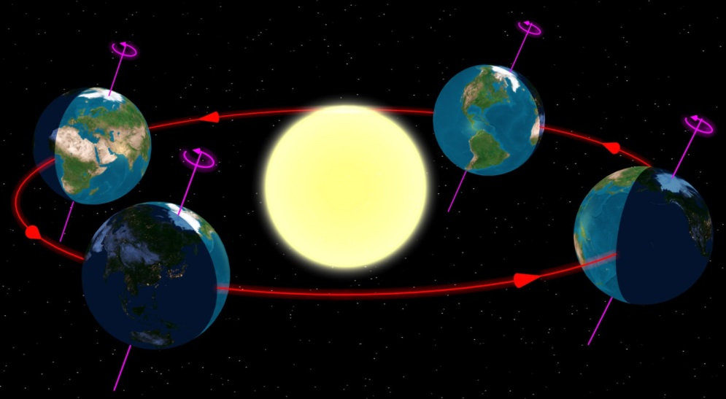
Figure 13: Illumination of the northern and southern hemispheres of the Earth during its orbit around the Sun (Credit: Tau'olunga, https://en.wikipedia.org/wiki/File:North_season.jpg, CC 0).
As mentioned before, the Sun played an important role in identifying a ship’s course. The difficulty with the Sun compared to the stars is that the Sun changes its declination, that is, the elevation above the equator, during the course of a year. The reason for this is that the Earth revolves around the Sun on a tilted axis.
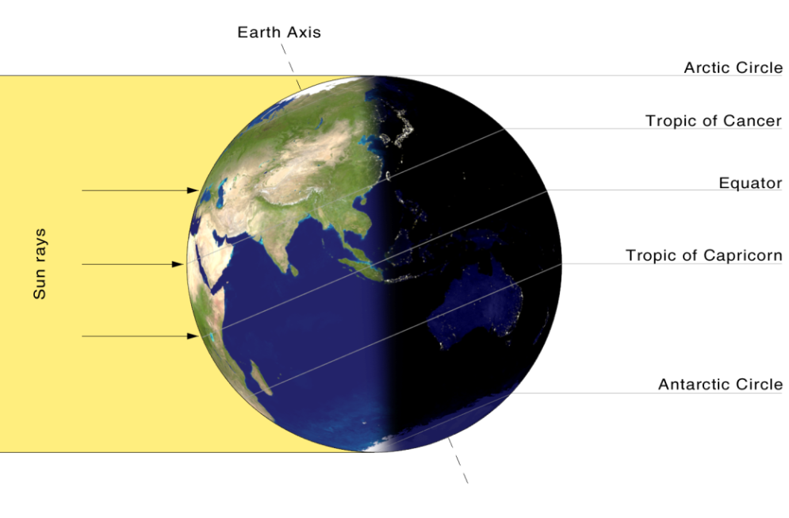
Figure 14: On the summer solstice, the Sun is directly above the Tropic of Cancer. Its apparent position changes during the year (Credit: Przemyslaw ‘Blueshade’ Idzkiewicz (https://commons.wikimedia.org/wiki/File:Earth-lighting-summer-solstice_EN.png), ‘Earth-lighting-summer-solstice EN’, https://creativecommons.org/
licenses/by-sa/2.0/legalcode).
In the summer, the northern hemisphere faces the Sun, while during the winter, the southern hemisphere faces the Sun. The range under which the Sun appears in the zenith is the latitudes between 23.4° north, the Tropic of Cancer, and 23.4° South, the Tropic of Capricorn. For any given location on Earth, the Sun’s elevation while it transits the meridian – the line that connects North and South at the horizon through the zenith – changes by the sameangular range, i.e. ±23.4° around the celestial equator.
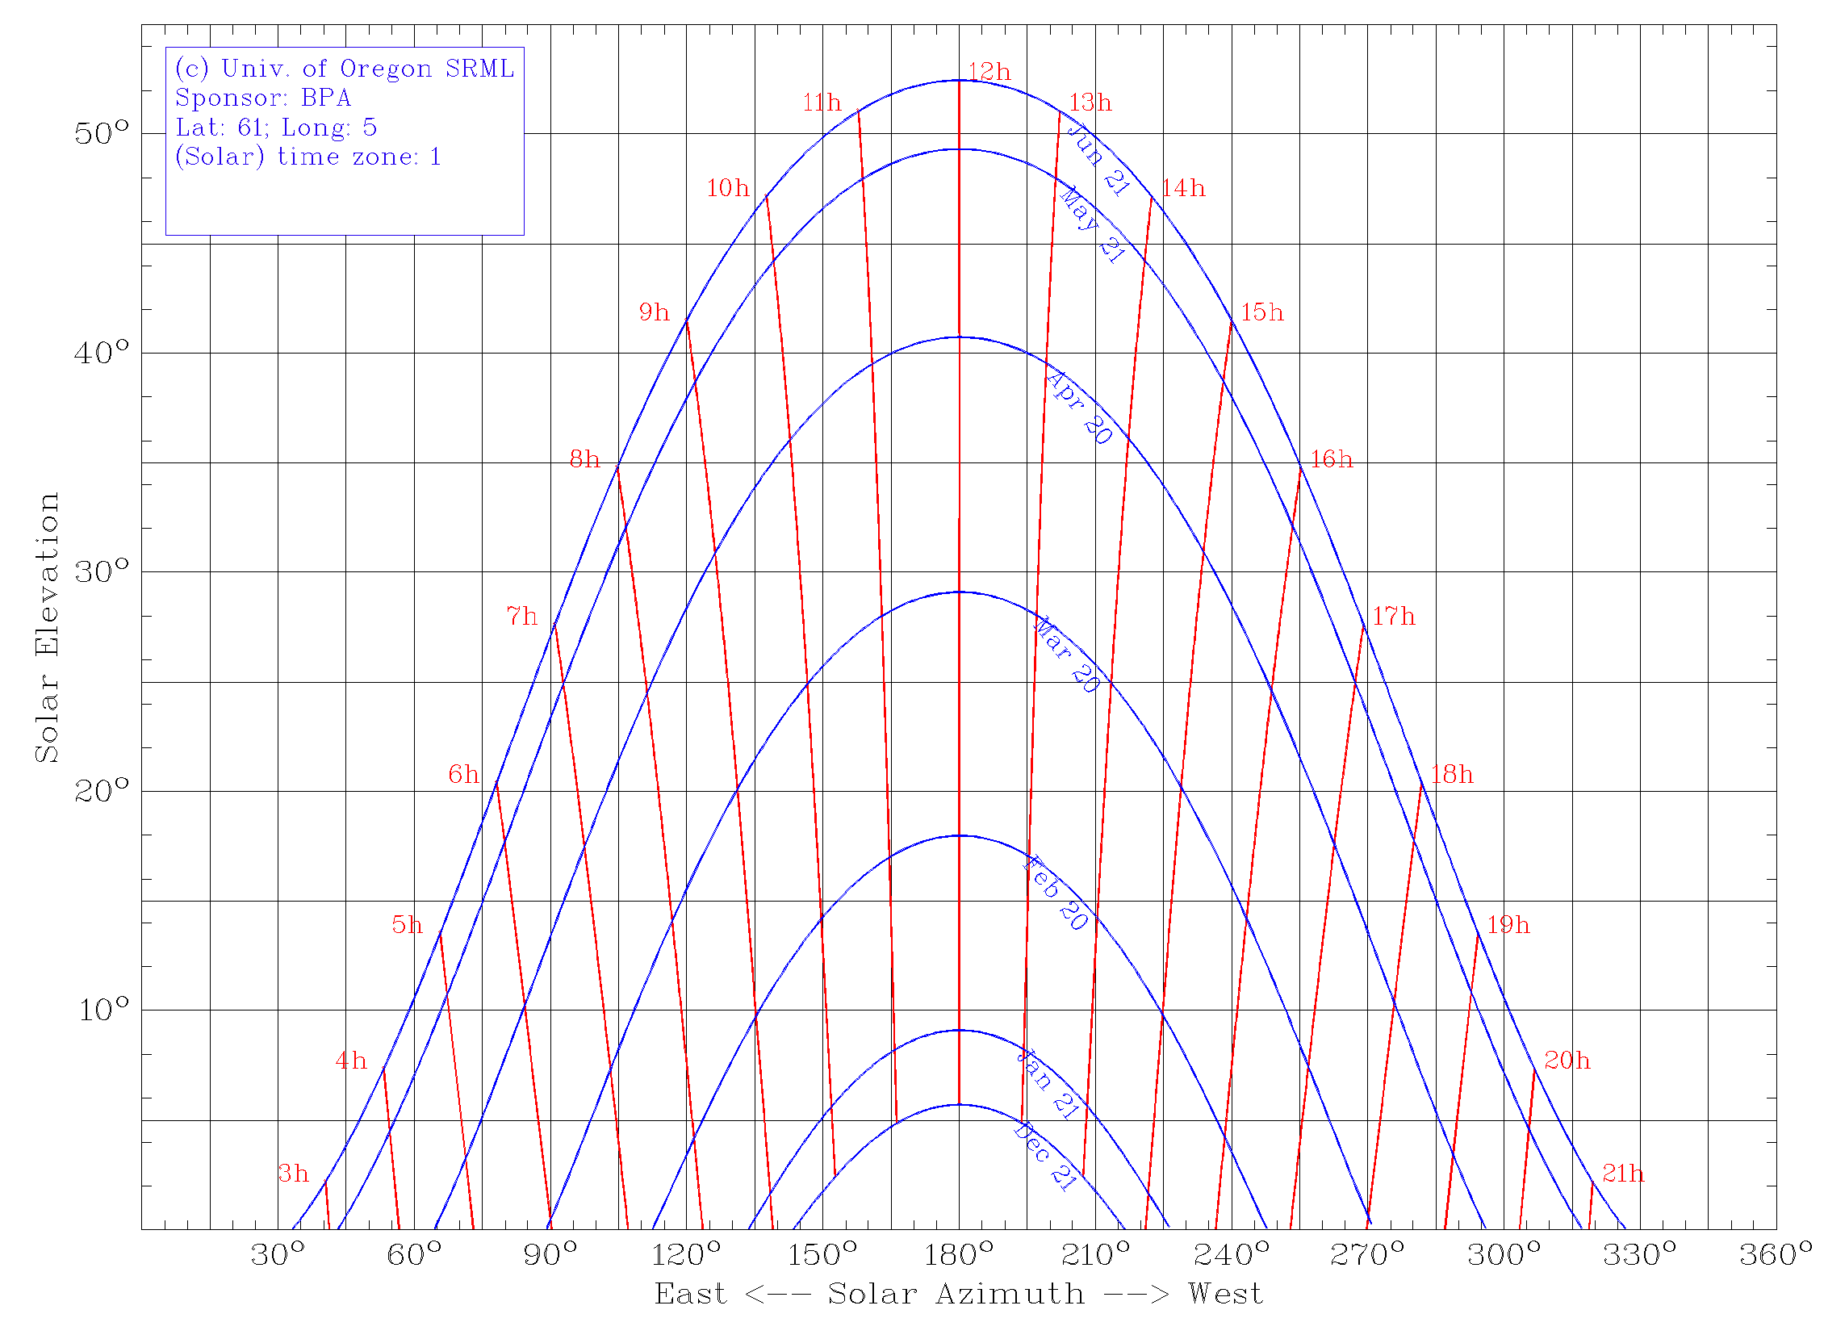
Figure 15: The diurnal and annual elevation of the Sun above the horizon for a latitude of 61° north (Credit: Created using the Sun chart path program of the University of Oregon, USA, http://solardat.uoregon.edu/
SunChartProgram.html).
For a latitude of 61° north, the elevation of the Sun above the horizon is shown in Figure 11. South is at the centre at an azimuth of 180°. Through the year, the elevation of the Sun at local noon changes by almost 47°. However, the rate of change is not constant. We can assume a variation in the solar declination of up to 1° per voyage to be acceptable for navigational purposes.
If this variation between two consecutive days is accounted for, the Sun could be used to determine the latitude at any time of the year. This would mean that within two days, the declination of the Sun – or its elevation at noon – never changes by more than 1°. This corresponds to a deviation of 8 km after travelling for 240 sea miles. As has already been pointed out, two days are sufficient for voyages through the Northern Sea. For journeys that last five to seven days, the permissible period in which the Sun can be used for navigation in the northern hemisphere is between the end of May and the beginning of July. This time period is adequate to travel from southern Norway to Iceland. The corresponding drift due to the changing solar elevation amounts to 25 km or less. For longer travels, e.g. to Greenland, the course can be adjusted using landmarks on the way, for instance, when passing the Shetland Islands, the Faroe Islands and Iceland. Is there evidence for navigational tools that the Vikings used that were based on the Sun?

The sun shadow board
Sailing along the latitude was probably facilitated by a device called solskuggerfjøl (‘sun shadow board’ Figure 16). Eighteenth century sailors from the Faroe Islands have been seen using a wooden disk of up to 30 cm in diameter with engraved concentric rings and a central gnomon whose height could be adjusted (Tjgaard, 2011). This board was placed inside a bucket of water to cancel out the ship’s movements. It is quite likely that this device was already in use during the Viking age.
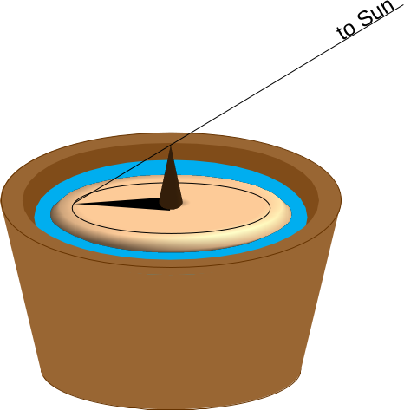
Figure 16: Sketch of the Viking sun shadow board (Credit: M. Nielbock, own work).
If we assume a negligible change in the Sun’s declination, the shadow of the gnomon at noon can be calibrated to any latitude by aligning its tip with a circle. When read during noon on subsequent days, the tip of the shadow should again touch the same circle. If the shadow is shorter, the position is too far south; if it is longer, it is too far north.

The sun compass
The magnetic compass was not known of in Europe during the Viking age. And it would have been quite useless for them anyway, because the magnetic field of the Earth is far from homogeneous. The phenomenon by which the magnetic poles do not align well with the geographical ones is called ‘magnetic declination’. In addition, magnetic field lines are strongly curved. And both properties of the magnetic field change with time (Figure 17). Measuring campaigns like the one using ESA’s SWARM satellites constantly monitor the magnetic field.

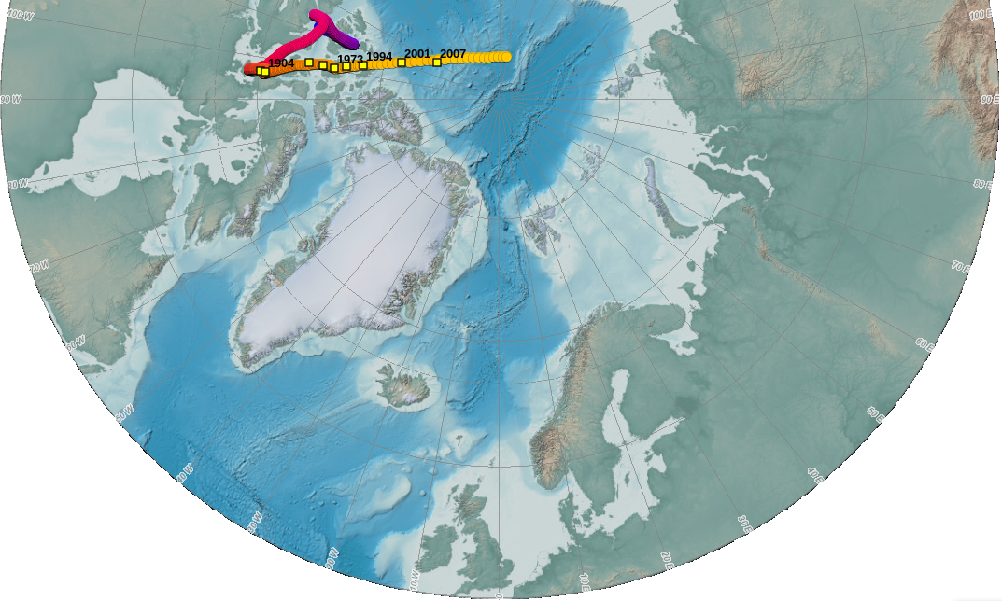
Figure 17: Change in the magnetic North Pole and its position relative to Scandinavia (Created with the NOAA Historical Magnetic Declination Viewer, http://maps.ngdc.noaa.gov/viewers/historical_declination/).
Thus, especially at high latitudes, the Vikings would have lost their way using a magnetic compass more often than they would have found the correct course. But it seems that they were able to find the cardinal directions using the Sun instead.
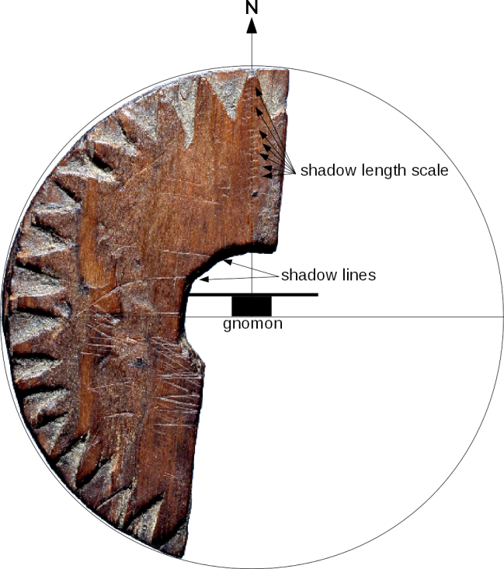
Figure 18: Image of the original wooden disk fragment found in Uunartoq, Greenland. The annotations denote the elements required for its possible use as a sun compass (Bernáth et al., 2013). When the shadow is aligned with the shadow lines, north is up. Incisions in that direction allow one to measure the shadow length (Credit: Lennart Larsen, Danish National Museum, http://samlinger.natmus.dk/DO/10775, ‘Trædisk_Grønland’, background of photograph removed and annotations added by Markus Nielbock, https://creativecommons.org/licenses/by-sa/2.0/legalcode).
In 1948, fragments of a small wooden disk were found during historic excavations of the abandoned monastery of Uunartoq in southwest Greenland (Figure 18). In the following decades, people started to believe that it was a navigational tool to determine the cardinal directions using the Sun. However, even to date, there are doubts that it truly served that purpose. Nonetheless, remarkable scientific analyses demonstrate that in fact this disk could have been a combination of a sundial, a compass and a sun shadow board.
Incised lines have been identified as the paths of the shadow cast by a central gnomon during the days of equinox and summer solstice at a latitude of 61° north. These lines hypothetically helped to determine local noon, when the Sun attains its highest elevation when crossing the meridian. This moment is the time when the device should be used. At local noon, the central gnomon produces a shadow that points north. Similar to the sun shadow board mentioned above, incisions on the wooden board toward the northern direction can be used to determine possible deviations from the course along a predefined latitude.

Local time and time zones
The shadow of the gnomon is the shortest and points north whenever the Sun is exactly south (northern hemisphere). This is what defines local noon. Since the Earth rotates continuously, the apparent position of the Sun changes as well. This means that at any given point in time, local noon is actually defined for one longitude only. However, clocks show a different time. Among other effects, this is due to daylight saving time during the summer and the time zones (Figure 19). Here, noon occurs simultaneously at many longitudes. However, it is obvious that the Sun cannot transit the meridian at all those places at the same time. Therefore, the times provided by common clocks are detached from the ‘natural’ local time a sundial shows.
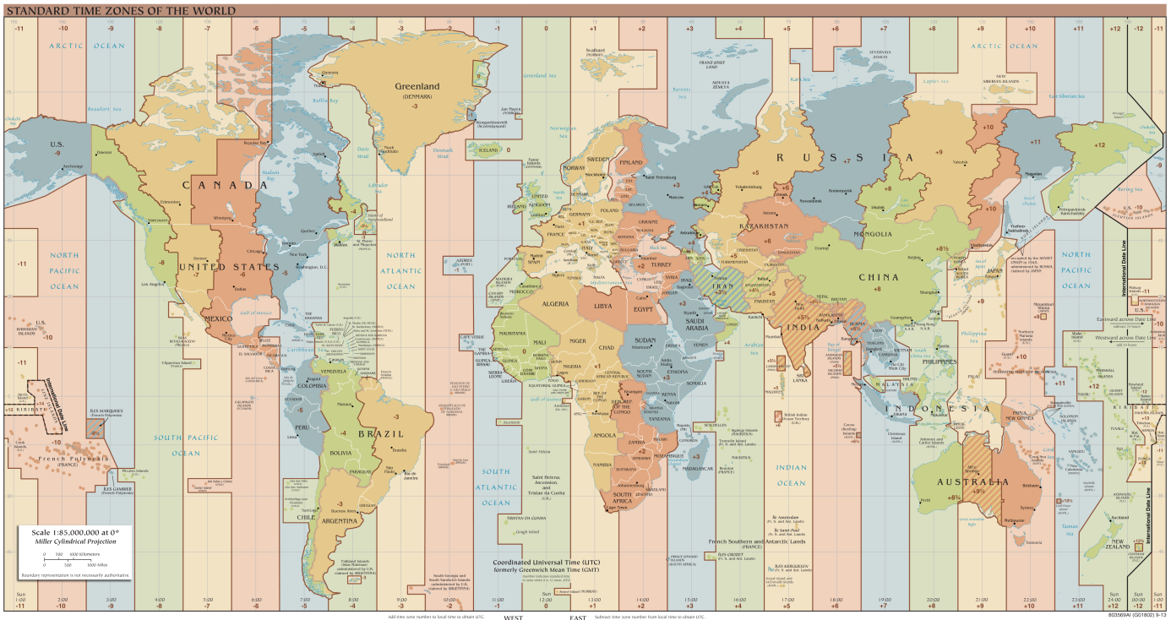
Figure 19: World time zones. Instead of the local time that is based on the apparent course of the Sun in the sky and valid for single longitudes only, the common clocks show a time based on time zones which applies to many longitudes simultaneously (Credit: TimeZonesBoy, https://commons.wikimedia.org/wiki/
File:Standard_World_Time_Zones.png, https://creativecommons.org/licenses/by-sa/4.0/legalcode).

Glossary

Apparent movement
Movement of celestial objects which, in fact, is caused by the rotation of the Earth

Cardinal directions
Main directions, i.e. north, south, west and east

Circumpolar
Property of celestial objects that never set below the horizon

Culmination
Passing the meridian of celestial objects. These objects attain their highest or lowest elevation there.

Diurnal
Concerning a period that is caused by the daily rotation of the Earth around its axis

Elevation
Angular distance between a celestial object and the horizon

Equinox
This is the configuration in which the Sun apparently crosses the equator. This happens twice a year. On these dates, the Sun is exactly at the zenith at the Earth’s equator. These two dates define the beginning of spring and autumn.

Gnomon
Any object that casts a shadow

Great circle
A circle on a sphere whose radius is identical to the radius of the sphere

Meridian
A line that connects north and south at the horizon via the zenith

Pole height
Elevation of a celestial pole. Its value is identical to the latitude of the observer on Earth.

Precession
As a spinning body rotates in space, its rotation axis often also moves in space. This is called precession. As a result, the rotation axis constantly changes its orientation and points to different points in space. The full cycle of the precession of the Earth’s axis takes roughly 26,000 years.

Spherical polar coordinates
The natural coordinate system of a flat plane is Cartesian and measures distances in two perpendicular directions (ahead, back, left, right). For a sphere, this is not very useful, because it has neither beginning nor ending. Instead, the fixed point is the centre of the sphere. When projected outside from the central position, any point on the surface of the sphere can be determined by two angles, one of which is related to the symmetry axis. This axis defines two poles. In addition, the radius represents the third dimension of space and allows ones to locate each point within a sphere. This defines the spherical polar coordinates. The radius stays constant and can therefore define points on the surface of a sphere.

Sundial
A stick that projects a shadow cast by the Sun. The orientation and length of the shadow enable the determination of time and latitude.

Zenith
Point in the sky directly above

