Worksheet: The Engine of Life

Purpose of this activity
In this activity, you will investigate the fundamental conditions that support life on planets like Earth and Mars. In particular, you will explore the importance of the distance to the Sun. You will also examine planetary systems other than the Solar System. For example, you will determine which of the planets discovered near a star may potentially possess liquid water and thus be candidates for hosting extra-terrestrial life.

Questions
Is there life on Mars?

Is there liquid water on Mars?

Why are these two things related?

What does it take to support life on other planets?

What conditions are needed to keep water liquid?

What provides the Earth and other planets with the heat needed to keep water liquid?

What happens to water if it is very cold or very hot?

Activity 1: Engine of Life
Materials needed:
- Strong lamp, floodlight
- Dimmer to regulate the brightness
- Folding rule or yardstick
- Photovoltaic cell with attached electric motor or fan (ensure that the power the cell generates is adequate to drive the motor)
This experiment demonstrate how illumination changes with distance from the light source.
The voltaic cell supplies the necessary voltage for the motor to run.
Set up the experiment according to Figure 1. A coloured cardboard disc attached to the rotation axis improves the visualisation. If a fan is used, the wings may be painted.
Plug the lamp into the dimmer and the dimmer into the socket.
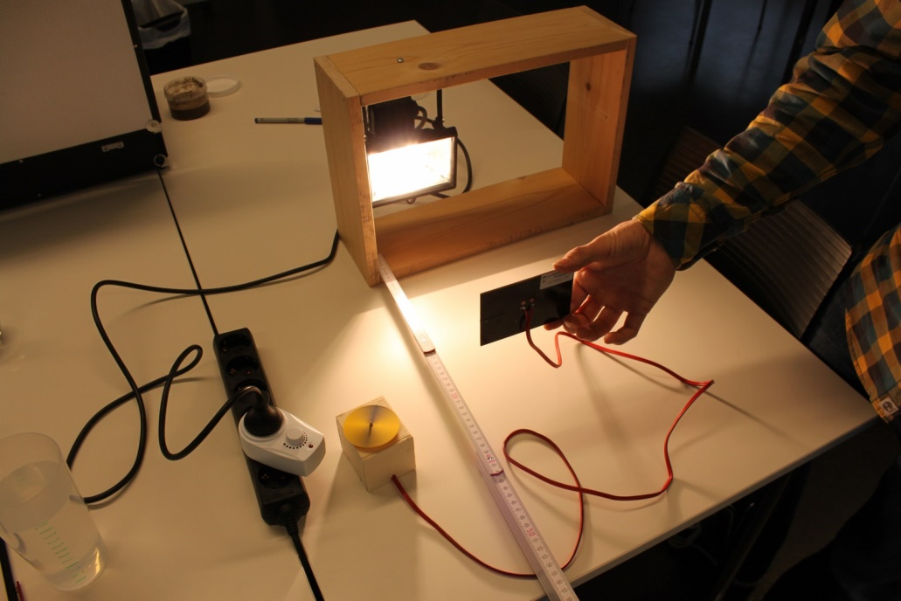
Figure 1: Experimental set-up (own work).
Discuss with your classmates how the motor will behave if the cell is held at different distances from the lamp.

Procedure
- Switch on the lamp.
- Hold the photovoltaic cell at a distance from the lamp. The motor should not move.
- Approach the lamp slowly and determine the distance at which the electric motor starts moving.
- Repeat this procedure for different brightness settings of the lamp by using the dimmer.
Write down your observations. Describe the results you get when varying the brightness of the lamp.

Comparing this experiment to the configuration of the Solar System, life-sustaining conditions (those under which the motor runs) are possible because the Earth (photovoltaic cell) is close enough to the Sun (lamp). The point at which the motor starts running is the outer edge of the habitable zone. What does this experiment tell us about exoplanets in other planetary systems with different stars that are supposed to harbour life?

For ages 14 and higher:
What happens to the motor when the cell is very close to the lamp?

Can we expect planets sustaining life to be at any distance inside the inner edge of the habitable zone?

Activity 2: The Habitable Zone of Kepler-62
Materials needed:
- Pencils (regular and coloured)
- Compass (drawing tool)
- Millimetre paper
- Ruler
- Calculator
- Computer with internet access (can be only one operated by the teacher)
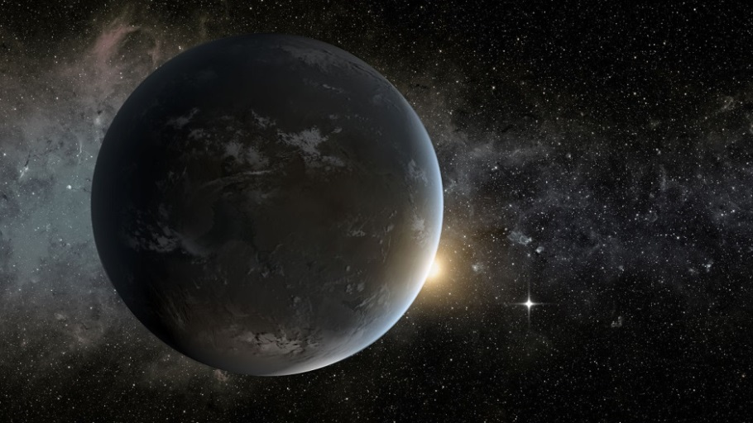
Figure 2: Artistic impression of the Kepler-62f exoplanet (NASA Ames/JPL-Caltech).
Kepler-62 is a star that is a little cooler and smaller than the Sun. It is part of the constellation Lyra. In 2014, it was discovered by the Kepler Space Telescope with five planets orbiting it. The details about Kepler-62 are summarised in Table 1.
Table 1: Properties of the star Kepler-62.
Property | Value
Name | Kepler-62
Distance | ca. 368 pc
Spectral Type | K2V
Luminosity | 0.21 L
Radius | 0.64 R
Mass | 0.69 M
Surface temperature | 4925 K
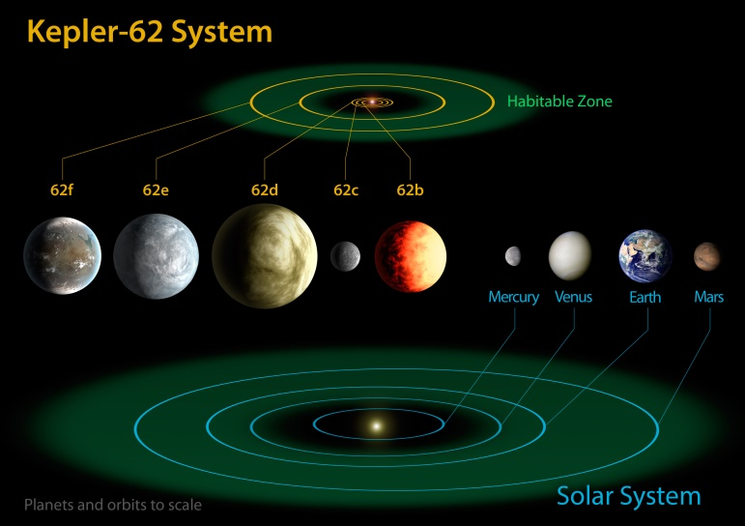
Figure 3: Comparison between the Solar System and the Kepler-62 planetary system (NASA Ames/JPL-Caltech).
Some of the five exoplanets are suspected to be Earth-like. The main properties of the five planets are provided in Table 2. All planetary orbits are nearly circular and listed in astronomical units (AU). This is the mean distance between the Sun and the Earth.
Table 2: Properties of the five exoplanets of the Kepler-62 system.
Name | Orbital radius (AU) | Mass  (Earth masses)
Kepler-62b | 0.0553 | ca. 2.1
Kepler-62c | 0.093 | ca. 0.1
Kepler-62d | 0.120 | ca. 5.5
Kepler-62e | 0.427 | ca. 4.5
Kepler-62f | 0.712 | ca. 2.8

Tasks (Drawing a scaled model)
Determine or discuss a suitable scale that allows you to put the entire system on a sheet of paper.

The model will show the planetary system from a bird’s eye view. Use the compass to draw the scaled circular orbits around the assumed position of the host star Kepler-62.

In the next step, you will add the habitable zone. First, you can apply the simple equation
$$d_{\text{HZ}}\left(\text{AU}\right)=\sqrt{\frac{L_{*}}{L_{⊙}},}$$
which only depends on the luminosity of the star. Note that this equation tells you where an Earth-like planet would be located around a Sun-like star of lower luminosity. Use Table 1 to calculate the distance of the habitable zone from Kepler-62.
Calculating the proper boundaries of habitable zones can be tricky and needs sophisticated models. There is an online tool at
http://depts.washington.edu/naivpl/sites/default/files/hz.shtml
that performs the calculations when the luminosity and surface temperature of the star are provided (This can be done by the teacher instead of handing out computers for all the students.). All you have to do is enter the surface temperature T_{eff} and the luminosity of the star in the upper two fields as shown in Figure 4. Note that after entering a value, you have to click in the field again.
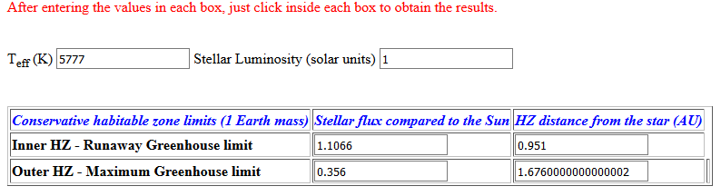
Figure 4: Screen shot of the online tool to calculate the dimensions of a habitable zone. The example above shows the values of the Sun. Important: After inserting the values, you have to click in the field to submit the entry (http://depts.washington.edu/naivpl/sites/default/files/hz.shtml).

Use the values of Kepler-62 from Table 1 (T_{eff} is the surface temperature). Use the result labelled as ‘Conservative habitable zone limits (1 Earth mass)’ and ‘HZ distance from the star (AU)’. Add the distances for the inner and outer edges of the habitable zone to the table below and calculate the scaled radii.
Table 3: Orbital parameters of the Kepler-62 planetary system (The scaled values are optimised for a sheet of A4 paper with a width of 18 cm.).
Name | Orbital radius (AU) | Scaled radius (cm)
Kepler-62b | 0.0553
Kepler-62c | 0.093
Kepler-62d | 0.120
Kepler-62e | 0.427
Kepler-62f | 0.712
Habitable Zone (inner)
Habitable Zone (outer)

How well does the simple distance of the habitable zone agree with the model calculation?

Can you think of a reason why the simple solution is so close to the extreme value of the modelled solution? In which way do the two approaches differ?

How does the missing parameter influence the radiation characteristics of Kepler-62?

Now add the inner and outer edges of the habitable zone to the scaled model of the planetary system.
You can colour the area between the inner and outer edges of the habitable zone. Green would be appropriate.
Which of the planets are inside the habitable zone?

Background Information

The Circumstellar Habitable Zone
The most important ingredient to sustain life as we know it is liquid water. Therefore, if scientists want to find planets or other celestial bodies where life may be present, they first want to know if water exists in liquid form there. This, for instance, is also one of the major goals of explorations and investigations of places in the Solar System other than Earth, e.g. Mars.
The presence of liquid water depends on environmental conditions like air temperature and atmospheric pressure. The main driver of the surface temperatures of planets is their distance from the central star they orbit. The temperatures are just right only in a small window so that water does not completely evaporate or freeze. These conditions are modified by local influences like the density of the atmosphere and the composition of potential greenhouse gases. This defines a range around a given star in which liquid water could be present. This range is defined as the ‘habitable zone’. If a planet is found orbiting in this zone, it may potentially possess water in the liquid form and thus sustain life as we know it. In the Solar System, Earth occupies the habitable zone. Some models also place Mars in this zone.

There is no guarantee that any planet orbiting within the habitable zone actually possesses notable amounts of liquid water or harbours life, because the conditions on any given planet can be very different. Other boundary conditions that may help to sustain life are energy sources (light, chemical) and magnetic fields to protect from ionising particle radiation.

Did or does Mars support life?
Mars is half the size of the Earth. Its reddish colour is caused by iron oxide (rust), and it has a very thin atmosphere, which mainly consists of carbon dioxide. One of its special features is its many extinct volcanoes, which reach heights of up to 22,000 metres! Like Earth, it also has seasons as its rotation axis is inclined. Theoretically, if the habitable zone of the Solar System is considered, Mars has the potential to be conducive to life.

To date, there is no indication that Mars is or was inhabited. However, there is strong evidence that this planet has harboured liquid water on its surface for a long time. The most common explanation for its current state is that Mars has lost its atmosphere because of which most of the water has either evaporated into space or is still present as ice deposits below the surface. Mars is so small that its gravitational force is rather low; therefore, it can barely hold its atmosphere. In addition, the lack of a magnetic field made it easy for solar wind to deplete the early Martian atmosphere. However, there is some evidence that at least for some time and in a few exceptional regions, there may have been liquid water on its surface. A high salinity helps keep water liquid even at temperatures below the freezing point of pure water (see Article 1 attached to this activity).

Scientists hope that some form of life could have survived within the ice sheets below the Martian surface. The European Mars programme ExoMars, to be launched in 2020, will investigate this very hypothesis using a robotic laboratory. It will be able to drill below the Martian surface and probe it for chemical and biological activity.
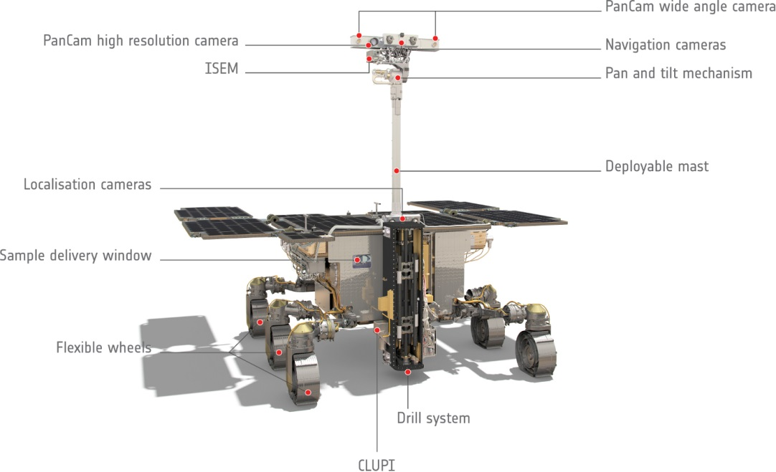
Figure 5: Computer model of the ExoMars rover to be launched in 2020 (ESA/ATG medialab, http://exploration.esa.int/
mars/58885-exomars-rover-front-view-annotated/, http://www.esa.int/spaceinimages/ESA_Multimedia/Copyright_
Notice_Images).

Other locations in the Solar System
During recent years, scientists have entertained the idea that there are other places in the Solar System that might be habitable although they are not within the Sun’s habitable zone. In particular, icy moons such as Europa and Enceladus of the gas planets Jupiter and Saturn, respectively, are interesting from this aspect. Observations made during Solar System exploration missions like NASA’s Cassini have found evidence of subsurface oceans of liquid water below their thick ice shields (see Article 2 attached to this activity). There is strong evidence that there are hydrothermal vents on the ocean floor of Enceladus (see Article 3 attached to this activity). Similar findings have been made in the terrestrial deep sea on Earth. These vents are colonised with life that feeds on hydrogen released from below.
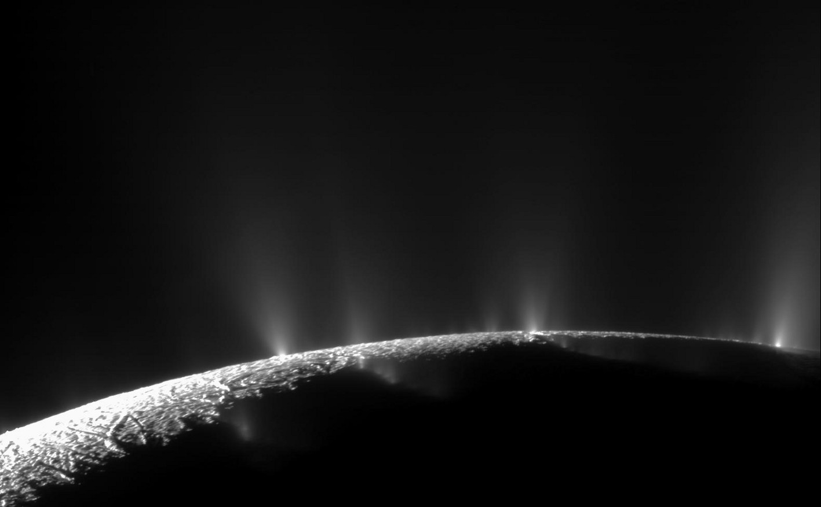
Figure 6: A dramatic plume sprays water ice and vapour from the south polar region of Saturn's moon Enceladus. Cassini's first hint of this plume came during the spacecraft's first close flyby of the icy moon on 17 February 2005 (NASA/JPL/Space Science Institute, https://photojournal.jpl.nasa.gov/catalog/PIA11688).

A simple formula for the habitable zone
With the Earth as the template of a habitable planet, one can calculate the distance from any given star where the conditions would be comparable. This distance is proportional to the luminosity of the star.
$$d_{\text{HZ}}\left(\text{AU}\right)=\sqrt{\frac{L_{*}}{L_{⊙}}}$$
Here, $L_{*}$ is the luminosity of the star and $L_{⊙}$ is the solar luminosity. The distance $d_{\text{HZ}}$ may then represent the location of the habitable zone. Its width depends on what temperatures to expect at the inner and outer edges. There are complex models to predict habitability that even include planetary properties like atmospheric conditions and mass. Therefore, the habitable zone is not really a well-defined range within a planetary system but depends on many properties that allow water to be present in its liquid form.
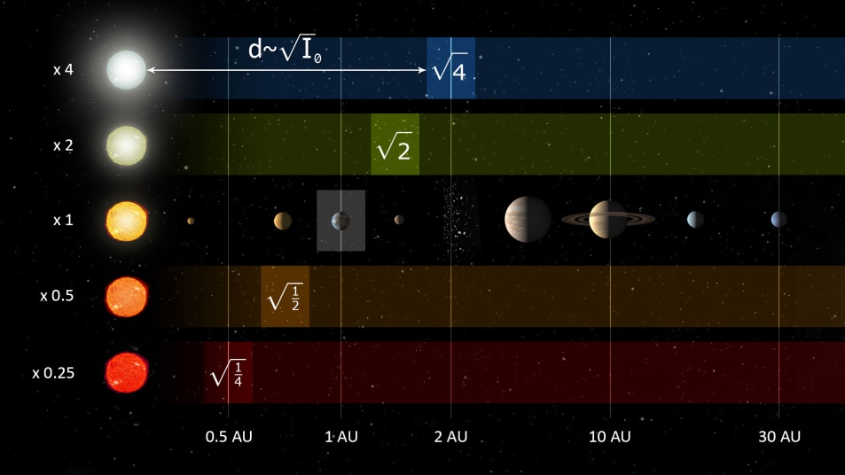
Figure 7: Distances in AU (astronomical units, i.e. the mean distance between the Sun and the Earth) of habitable zones for stars of varying luminosity (Derpedde, https://de.wikipedia.org/wiki/Datei:Solarsystemau_habit.jpg, ‘Solarsystemau habit’, https://creativecommons.org/licenses/by-sa/3.0/legalcode).

Exoplanets
Planets that orbit stars other than the Sun are called ‘extrasolar planets’ or briefly, ‘exoplanets’. The first exoplanet hosted by a Sun-like star was discovered in 1995 by a Swiss team led by Michel Mayor and Didier Queloz from the University of Geneva. This planet, named 51 Pegasi b, is anything but an Earth-like planet as it revolves around its host star at a distance of only 0.05 AU, i.e. 5% of the mean distance between the Sun and the Earth. Note that even the planet closest to the Sun, Mercury, orbits it at a mean distance of 0.5 AU, i.e. 10 times farther away than 51 Pegasi b is from its host star. In addition, it is a gas giant similar to Jupiter and Saturn. To date (July 2017), we know of 3627 exoplanets, of which 2718 are planetary systems.
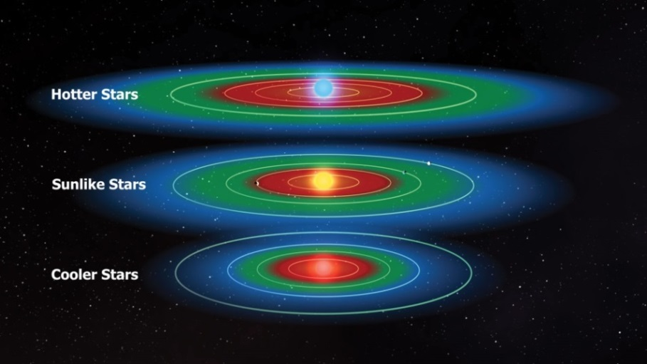
Figure 8: The circumstellar habitable zones of three stars that differ in size, luminosity and surface temperature (NASA/Kepler Mission/D. Berry, http://aasnova.org/2016/02/24/where-to-look-for-habitability/).
Figure 8 shows the circumstellar habitable zone (in green) for stars of different temperatures and luminosities. The star in the middle corresponds to stars similar to the Sun. Hotter stars usually have a large and wide habitable zone, while cooler stars can only provide small and narrow habitable zones. In the blue area, it is too cold for liquid water, and in the red area, it is too hot.
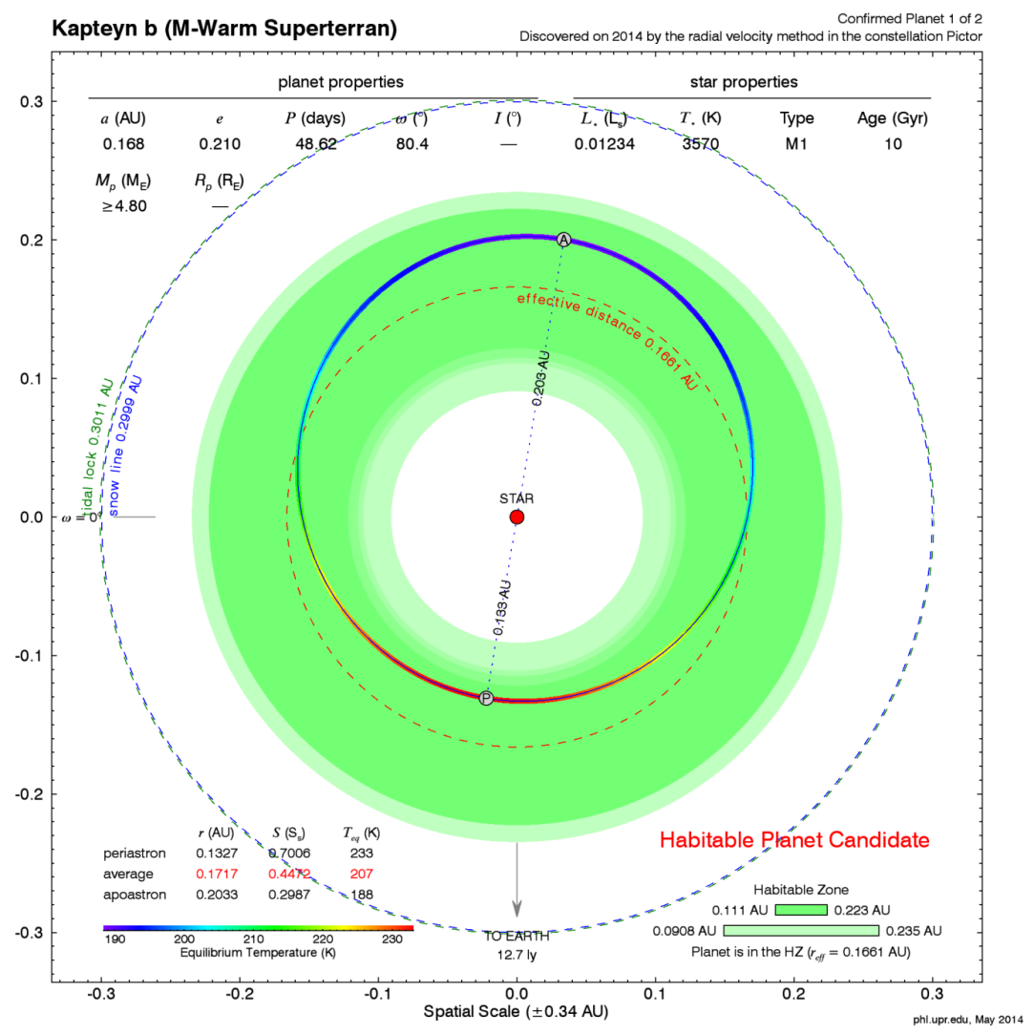
Figure 9: Habitable zone (green) around the star HD 33793. The orbit of the extrasolar planet Kapteyn b is indicated (PHL/UCP Arecibo, http://phl.upr.edu/press-releases/kapteyn, https://creativecommons.org/licenses/by-nc-sa/3.0/legalcode, based on: Anglada-Escudé et al. 2014, MNRAS, 443, L89).
Figure 9 shows an example of an exoplanet around the star HD 33793, also known as Kapteyn’s star. The star has a surface temperature of about 3570 K. This is about half of the surface temperature of the Sun, which is 5778 K. Thus, the habitable zone (indicated in green) is located at a distance between 0.11 and 0.22 AU.
Because of the lower luminosity of this star, the habitable zone is smaller and narrower. When comparing the habitable zones of the Sun and HD 33793 (Figure 10), we find that they considerably differ. The former is both wider and farther away from the Sun.
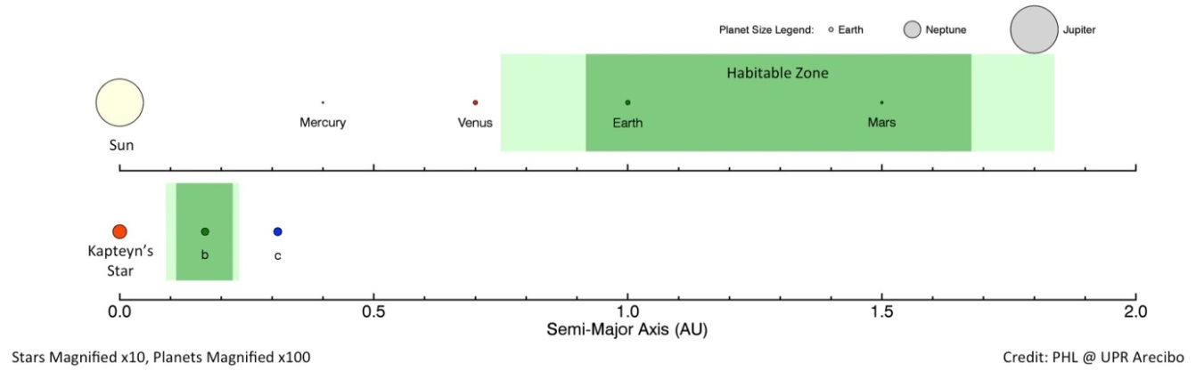
Figure 10: Comparison of the habitable zones (green) of the star HD 33793 and the Sun. (PHL/UCP Arecibo, http://phl.upr.edu/press-releases/kapteyn, https://creativecommons.org/licenses/by-nc-sa/3.0/legalcode, based on: Anglada-Escudé et al. 2014, MNRAS, 443, L89).
The exoplanet Kapteyn b with a mass that is about 5 times that of the Earth is located well within the habitable zone and therefore is interesting for further research on habitability.

http://www.exoplanets.eu

