The Engine of Life – Supplemental Background Information

Thermal radiation of solid bodies
Any given body with a temperature above absolute zero, i.e. $T>0 K$ radiates. According to Planck’s radiation law (ideally, for a black body), the distribution of frequencies of the emitted spectrum depends on the temperature.
$$U\left(ν,T\right)=\frac{8πhν^{3}}{c^{3}}⋅\frac{1}{e^{\frac{hν}{kT}}-1}$$
Integrating overall frequencies leads to the Boltzmann’s radiation law, which describes the total emitted power. In reality, black bodies only exist up to a certain degree of approximation. Therefore, Kirchhoff’s radiation law regarding the radiation power of any given body can be applied:
$$L_{Ων}\left(β,φ,ν,T\right)=L_{Ων}^{o}(ν,T)⋅a_{ν}^{'}(β,φ,ν,T)$$
This means that the radiation power $L_{Ων}\left(β,φ,ν,T\right)$ of a given body is as high as the total radiation power of a black body $L_{Ων}^{o}\left(ν,T\right)$ having the same temperature and same absorptivity $a_{ν}^{'}(β,φ,ν,T)$. The spectral radiance and absorptivity may also depend on the angle of incident radiation. Thus, according to Kirchhoff’s law, the radiation power of any given body is directly proportional to the radiation power of a black body of the same temperature.
Further, Kirchhoff’s radiation law leads to the conclusion that with a given temperature, a body with good heat absorption also releases heat well.

Boltzmann’s Law
Boltzmann’s law describes the emitted power of a black body radiating isotropically in all directions. For the total radiation power of a black body the following equation applies:
$$P=σ⋅A⋅T^{4}$$
$A$ is the area of the radiating cross section of the body and $σ$ is the Stefan Boltzmann’s constant, a natural constant with the value of:
$$σ=\frac{2π^{5}k_{B}^{4}}{15h^{3}c^{2}}=\left(5,670 367±0,000 013\right)⋅{10}^{-8}\frac{W}{m^{2}K^{4}}$$
Together with Kirchhoff’s Radiation Law the Stefan Boltzmann’s Radiation Law for any given body results to
$$P=ε\left(T\right)⋅σ⋅A⋅T^{4}$$
with a temperature dependent emissivity $ε(T)$.
The emissivity is a parameter that reflects the properties of the radiating substance and surface. For a given temperature, surfaces with different emissivity appear differently bright. As a result, the thermic radiation is also stronger.
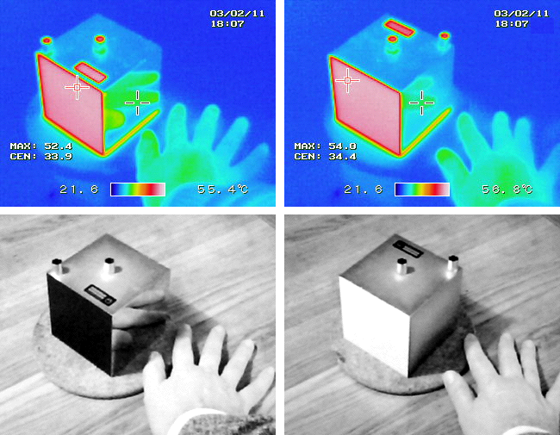
Figure 1: Photographs of Leslie's cube. The colour photographs are taken using an infrared camera; the black and white photographs underneath are taken with an ordinary camera. All faces of the cube are at the same temperature of about 55 °C. The face of the cube that has been painted has a large emissivity, which is indicated by the reddish colour in the infrared photograph. The polished face of the aluminium cube has a low emissivity indicated by the blue colour, and the reflected image of the warm hand is clear (Pieter Kuiper, https://commons.wikimedia.org/wiki/
File:LesliesCube.png, public domain).

Radiation balance
A body that absorbs energy in form of radiation warms up as long as the energy emitted is as high as the energy that is absorbed. This means that body is in thermal equilibrium. This scenario can applied to the Earth that receives electromagnetic radiation of the Sun with a flux density (solar constant) of:
$$E_{0}=1367\frac{W}{m^{2}}$$
If the Earth is in thermal equilibrium, the energy emitted must be as high as the energy absorbed. It is important that only half of the earth is irradiated at the same time. As part of the sunlight hits the surface in an angle not perpendicular, only an area as big as the cross section of the Earth is illuminated. Thus, the energy absorbed by the Earth is:
$$P=E_{0}⋅π⋅r_{e}^{2}≈1.74⋅{10}^{17} W$$
The energy emitted by the Earth can be calculated with Stefan Boltzmann’s law. Here it is important that the complete surface radiates.
$$P=σ⋅A⋅T^{4}$$
With this, the temperature can be calculated, if the Earth did not have an atmosphere.
$$T=\sqrt[4]{\frac{P}{σ⋅A}}=\sqrt[4]{\frac{P}{σ⋅4⋅π⋅r_{e}^{2}}}≈279 K$$

A model for circumstellar habitable zone
In the following, a simple model for characterising the circumstellar habitable zone has to be found. It is purely based on the assumption of thermal equilibrium. The total radiative power emitted by the Sun (luminosity) is derived from the solar constant, the surface of a sphere and the distance between the Sun and the Earth. Since the sun radiates in all directions isotropically, we can assume that the solar constant is valid for any point on such a sphere. We find:
$$L=P_{s}=E_{0}⋅4πr_{se}^{2}≈3,845⋅{10}^{26} W$$
The solar constant for any given distance $r$ is:
$$E_{0}\left(r\right)=\frac{L}{4πr^{2}}=E_{0}⋅\frac{r_{se}^{2}}{r^{2}}$$
This demonstrates that – as expected – the received flux density of a constant radiation source depends on the inverse square of the distance. Following the applied logic of the thermal equilibrium the effective temperature of a planet with the radius $r_{p}$ results to:
$$E_{0}\left(r\right)⋅π⋅r_{p}^{2}=σ⋅A⋅T^{4}$$
$$E_{0}\left(r\right)⋅π⋅r_{p}^{2}=σ⋅4⋅π⋅r_{p}^{2}⋅T^{4}$$
$$T^{4}=\frac{E_{0}\left(r\right)}{4⋅σ}=\frac{E_{0}⋅\frac{r_{se}^{2}}{r^{2}}}{4⋅σ}$$
$$T=\sqrt[4]{\frac{E_{0}⋅r_{se}^{2}}{4⋅σ⋅r^{2}}}=α⋅\frac{1}{\sqrt{r}}$$
With the constant
$$α=\sqrt[4]{\frac{E_{0}⋅r_{se}^{2}}{4⋅σ}}$$
which for the Sun yields:
$$α=1.08∙{10}^{8}\frac{{\text{m}}^{0.5}}{\text{K}}=278.58\frac{{\text{AU}}^{0.5}}{\text{K}}$$
By selecting realistic limitations for the average temperature of a planet, the limits for a circumstellar habitable zone can be determined.

