Worksheet: The Big Meltdown

Purpose of the activity
With this activity, you explore how ice contributes to the rising sea levels on melting. With a simple experiment, you will investigate the difference between ice floating on water and land ice, like that seen in glaciers. In the end, you will be able to realise that only one of the two forms of ice actually causes the water level to rise.

Activity: Melting the ice
List of material:
- Large transparent bowl
- Ice
- Large stone or a similar item that serves as a platform (about half the size of the bowl)
- Water
- Overhead marker
- Strong lamp

Questions
How do you melt ice?

Where on Earth can you find ice?

Imagine that all that ice melts. What would happen to the water levels?

What would happen to the coastal areas on Earth when the sea levels rise?

When you look at maps, what is the main difference between the northern and southern polar regions?

Which of them is the Arctic, and which is Antarctica?

Experimental set-up 1
Follow the instructions:
- The stone or the platform is placed into the bowl.
- The bowl is filled with water such that the platform protrudes out from the water.
- The water level is marked on the bowl with an overhead marker.
- The lamp is positioned so that it illuminates the bowl.
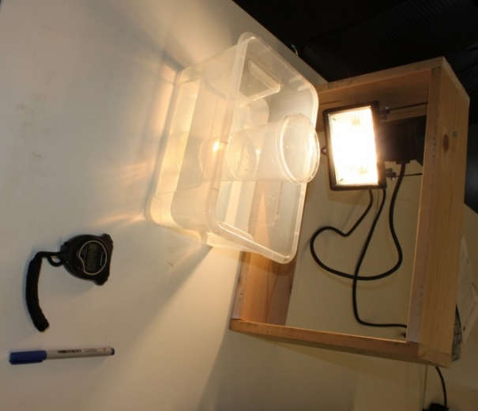
Figure 1: Experimental set-up. A plastic cup filled with water is used as a platform that carries the ice (own work).
In our model, there is a stone with its top above the water surface and covered with ice. What would be the corresponding situation on Earth?

Experimental Procedure Part 1
Follow the instructions:
- Ice is placed on the platform, and the lamp is switched on.
- Wait until the ice has melted.
Write down your observations during the first part of the experiment. Pay attention to the water level.

What happened to the water level? Explain the observation.

Experimental set-up 2
Follow the instructions:
- The platform is removed from the bowl.
- Again, the water level is indicated on the bowl with an overhead marker.
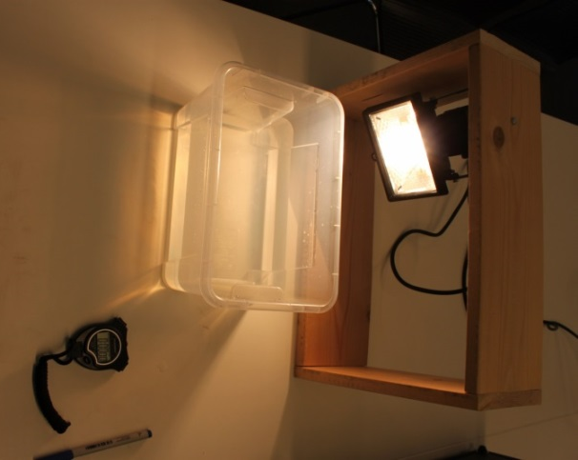
Figure 2: Experimental set-up for the second part. The platform has been removed (own work).
In the second model, the ice is floating on water. What would be the corresponding situation on Earth?

Experimental Procedure Part 2
Follow the instructions:
- The ice is put into the water, and the lamp is switched on again.
- Wait again until the ice has melted.
Write down your observations during the second part of the experiment. Pay attention to the water level.

What happened to the water level? Explain the observation.

When reconsidering the experiment, which of the two forms of ice contributes to the rising sea levels? Land ice or/and floating ice?

What is the impact on the oceans when the land ice melts and the resulting water runs into the sea?

How would you be able to witness such a rise?

Background Information

Sea surface altimetry
One of the most serious consequences of the ongoing climate change on Earth is the rise in sea levels, which poses a threat to many coastal areas. Monitoring sea levels used to be a quite difficult task. Even until a few decades ago, this could only be done via direct measurements and probes on open seas. However, with the advent of Earth-observing satellites and radar altimetry missions, it became possible to monitor sea levels very efficiently and effectively. While in-situ measurements only provide a very local perspective of a given probe, and the resolution of the global network is rather low, satellite measurements allow observing the Earth with high redundancy and frequency as well as at a high spatial resolution.
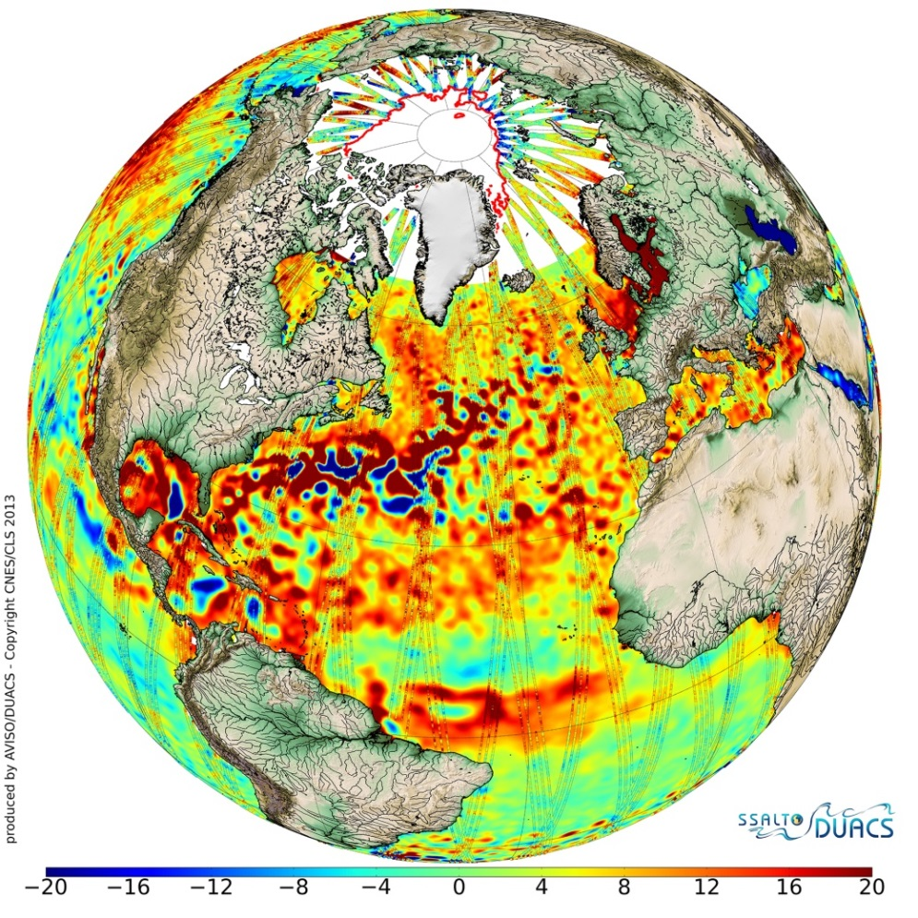
Figure 3: Average sea-surface topography for 2013 as mapped by CryoSat combined with data from other missions. Red represents higher sea levels (up to 20 mm above average) while blue represents lower sea-level areas (down to –20 mm). The perturbations seen in the Northern Atlantic are caused by the warm Gulf Stream current (ESA/CNES/CLS, http://www.esa.int/spaceinimages/Images/2014/06/2013_sea-surface_topography).
Known satellites with altimetry capabilities include CryoSat and Jason 2/3. The most recent addition is Sentinel 3, a flagship of the European Copernicus Earth observing programme that offers unprecedented spatial resolution.
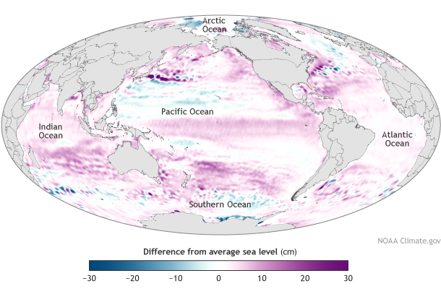
Figure 4: Sea level in 2014 compared to the global average at the mid-point of the 1993-2013 time series (NOAA Climate.gov map, adapted from Figure 3.25a in State of the Climate in 2014 report, https://www.climate.gov/news-features/understanding-climate/2014-state-climate-sea-level).

Oceans are on the rise
By combining such data obtained at different acquisition times, a general trend of the sea level evolution can be derived. When analysing all the data at hand, it is obvious that sea levels have been rising during the last one-and-a-half centuries (Figure 5).
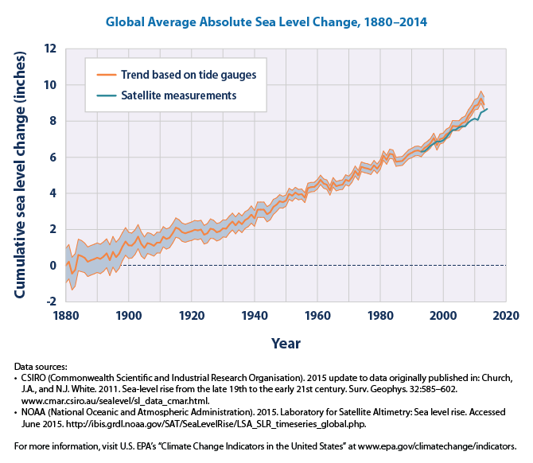
Figure 5: This graph shows cumulative changes in the sea level of the world’s oceans since 1880, based on a combination of long-term tide gauge measurements and recent satellite measurements. This figure shows the average absolute sea level change in inches (1 inch = 25.4 mm), which refers to the height of the ocean surface, regardless of whether the land nearby is rising or falling. Satellite data are based solely on the measured sea level, while the long-term tide gauge data include a small correction factor because the size and shape of the oceans are changing slowly over time. (On average, the ocean floor has been gradually sinking since the last Ice Age peak, 20,000 years ago.) The shaded band shows the likely range of values, based on the number of measurements collected and the precision of the methods used (United States Environmental Protection Agency, https://www3.epa.gov/climatechange/science/indicators/oceans/sea-level.html).
In summary, the current scientific results show that from 1993 until 2014, the ocean levels have been rising at a rate of up to 2.9 ± 0.4 mm per year. That is 6 cm within 20 years. And the rate seems to be increasing. The major contributor to the rising oceans is the land ice that melts because of global warming. This already has had a measurable impact on the coastal regions worldwide. A higher sea level appears to increase the numbers of floods, as depicted in Figure 6.
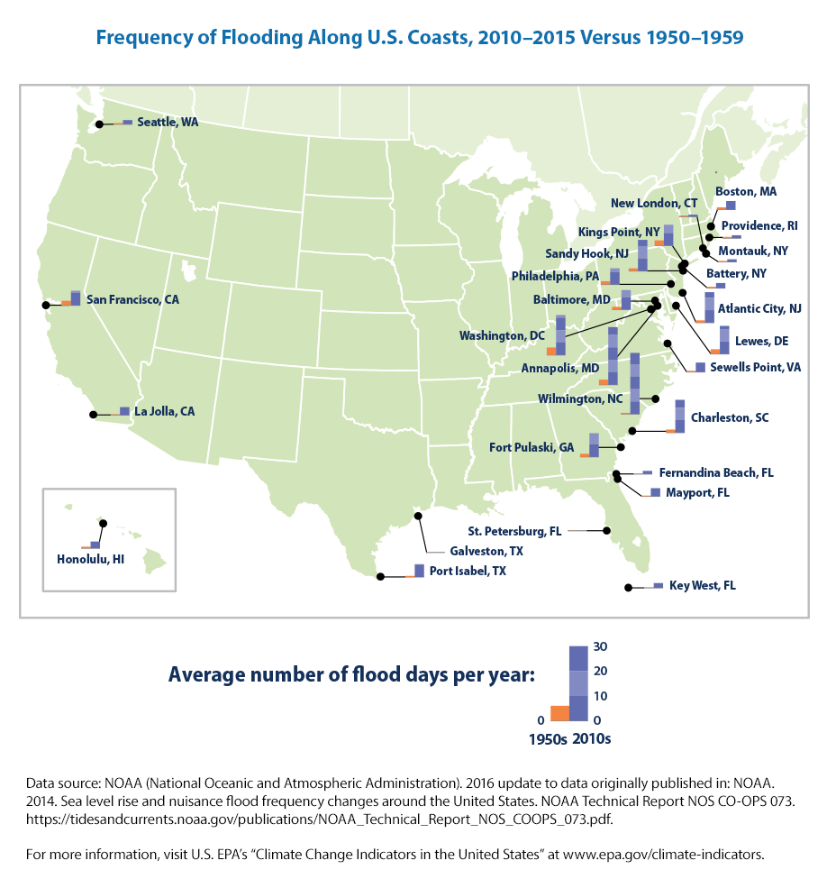
Figure 6: This map shows the average number of days per year in which coastal waters rose above the local threshold for minor flooding at 27 sites along U.S. coasts. Each small bar graph compares the first decade of widespread measurements (the 1950s in orange) with the most recent decade (the 2010s in purple) (United States Environmental Protection Agency, https://www.epa.gov/climate-indicators/climate-change-indicators-coastal-flooding).

Sea ice and land ice
Contrary to the Arctic, where the ice is just a sheet floating on the Arctic Sea, on the Antarctic, the largest ice masses are found on land. According to the Principle of Archimedes, the floating ice masses in the Arctic displace water equal to their own weight, so the melting of floating ice does not influence the sea levels. On the other hand, melting land ice such as on Greenland or in the Antarctic contributes to the rise in the ocean levels. Radar altimetry satellites like CryoSat-2 help to monitor the thickness of ice sheets, both on land and floating at sea (Figure 7).
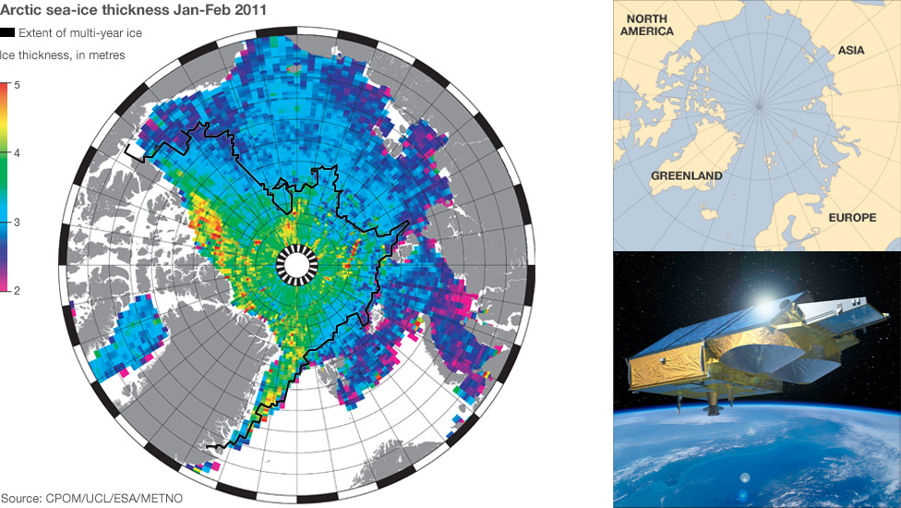
Figure 7: A colour-coded altitude map of the Arctic ice cover based on measurements from the CryoSat-2 satellite (BBC News, 21 June 2011; CPOM/UCL/ESA).

The buoyancy principle of Archimedes
Archimedes, possibly the greatest ancient mathematician and scientist from Syracuse, discovered the buoyancy principle, which is named after him. In simple words, it states that a body immersed in a fluid experiences a buoyant force equal to the weight of the fluid it displaces.
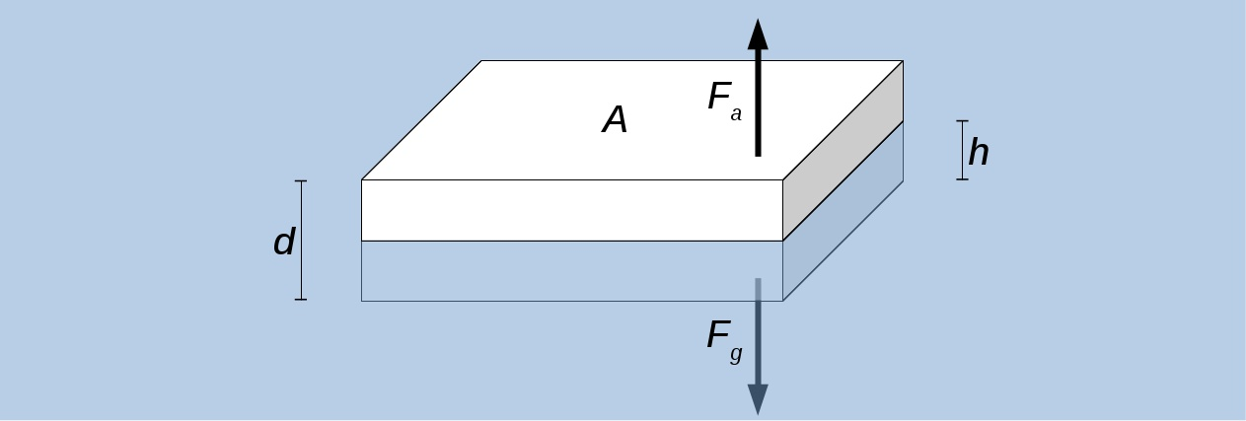
Figure 8: A sketch that illustrates the key parameters of a floating body and the equilibrium between its weight and the buoyant force, which is equal to the weight of the displaced liquid.
If, for instance, one wants to calculate the ratio of the depth of an ice sheet that is immersed in sea water, the following ansatz can be made.
$$F_{g}=F_{a}$$

With:
$$\begin{matrix}F_{g}=m_{\text{ice}}∙g \\ F_{a}=m_{w}∙g\end{matrix}$$
Here, $m_{\text{ice}}$ and $m_{w}$ represent the mass of the ice sheet and the mass of the displaced water, respectively. The ice sheet may have a thickness of $d$, a surface area of $A$, and it may be immersed by the depth $h$. From this, one can derive the volumes of the ice sheet $V_{\text{ice}}=A∙d$ and of the displaced water$V_{w}=A∙h$. This leads to:
$$m_{\text{ice}}=m_{w}⇔ρ_{\text{ice}}V_{\text{ice}}=ρ_{w}V_{w}⇔ρ_{\text{ice}}∙A∙d=ρ_{w}∙A∙h⇔ρ_{\text{ice}}d=ρ_{w}h$$
$$⇒\frac{h}{d}=\frac{ρ_{\text{ice}}}{ρ_{\text{w}}}$$
Even frozen sea ice is practically fresh water and is almost salt free. Therefore, the density of normal water ice applies. Liquid sea water contains on average 3.5% salt, which increases its density to $ρ_{w}≈1020\frac{\text{kg}}{{\text{m}}^{3}}$.
$$⇒\frac{h}{d}=\frac{920\frac{\text{kg}}{{\text{m}}^{3}}}{1020\frac{\text{kg}}{{\text{m}}^{3}}}=0.9$$
This means that 90% of the ice sheet is below sea water.

