Transforming water into acid… and back
Purpose of the activity
You will explore the interaction of carbon dioxide with water. A chemical reaction produces carbonic acid. When it happens in the oceans, this acid influences the life in the oceans and everything that depends on it.

Introduction
After some introduction from the teacher, try to answer the following questions.
What substances do you know that contain carbon?

Do you know solid, liquid or gaseous substances that contain carbon?

What is simplest gas that contains carbon and that is a product of combustion or organic decay? You even exhale it when breathing.

The atmosphere of the Earth contains carbon dioxide whose level is constantly rising.
What happens when carbon dioxide gets dissolved in water, as it happens with the oceans on Earth?

This is what we will find out with the next activity. It turns into an acid.
What do acids do?

Activity 1: Transforming water into acid
Materials needed:
- Distilled or demineralised water
- Transparent cup or glass
- Straw
- Universal pH indicator according to McCrumb and the corresponding pH scale
- As an alternative: pH indicator made from red cabbage
https://www.youtube.com/watch?v=oG-pNRVHsc4
https://www.youtube.com/watch?v=OMXMlWybv8A
Follow the individual tasks step by step. Do not to swallow the liquid!

Step 1: Pour some water in the glass.
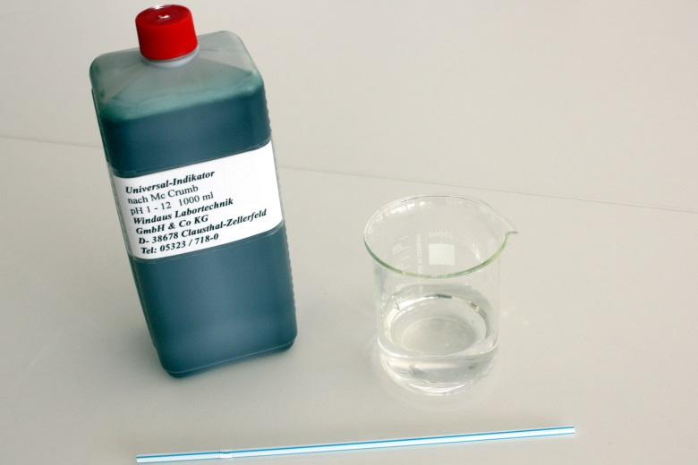
Figure 1: Items required for the first part of the activity.

Step 2: Add a few drops of the indicator until the solution turns green.
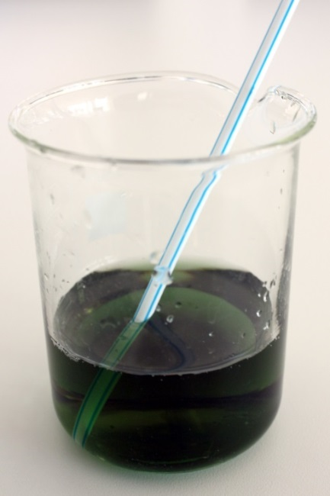
Figure 2: The colour of the water after adding some pH indicator.
What is the pH value?
Is the liquid acidic or basic?

Step 3: Use the straw and blow gently into the solution.
Be careful not to spill the solution. Continue until the colour of the indicator stops changing.
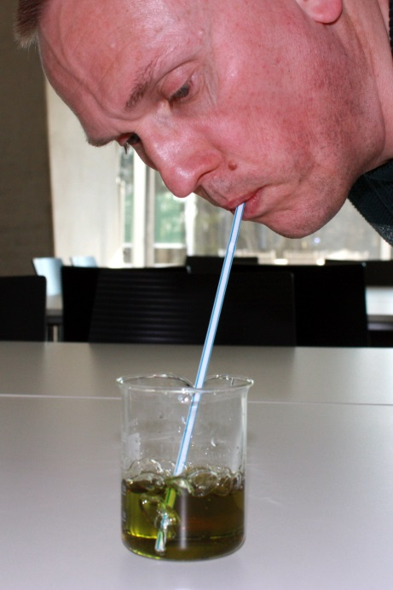
Figure 3: Blow air into the solution using a straw.

Step 4: Compare the final colour with the pH table of the indicator.
Determine the pH value.
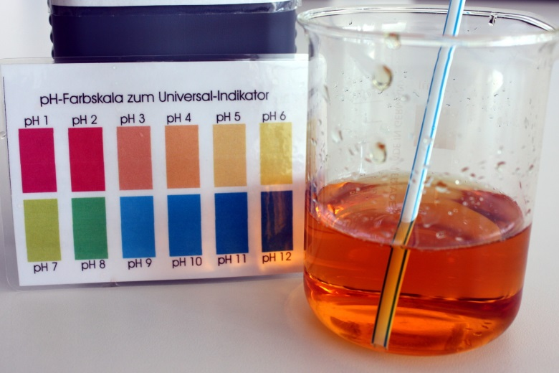
Figure 4: After blowing for several minutes, the colour stops changing. The final pH value can be measured by comparing the colour with the corresponding table.
What is the pH value you reached? Did the water become acidic or basic?

What do acids do with other substances?

Watch the following videos:
The Other Carbon Dioxide Problem (Duration: 3:57)
https://youtu.be/9EaLRcVdTbM
Sea Change: The Pacific’s perilous turn (Duration: 9:03)
https://goo.gl/Hu5y4q
What happens to marine creatures with exoskeletons made of limestone (mussels, clams, snails) when the water becomes more acidic?

Activity 2: Turning acid back to water
Do you know how to neutralise the solution again? Remember that sparkling mineral water and sodas also contain dissolved carbon dioxide.

What happens to the soda, if it is kept at room temperature for a while?

The following experiment might be carried out as a demonstration by the teacher. If the teacher decides that you can carry out the experiment on your own, take the heater and turn it on.
Put the glass with the acidic solution on the heater.
After heating it for several minutes, the liquid starts to change colours. Avoid boiling!
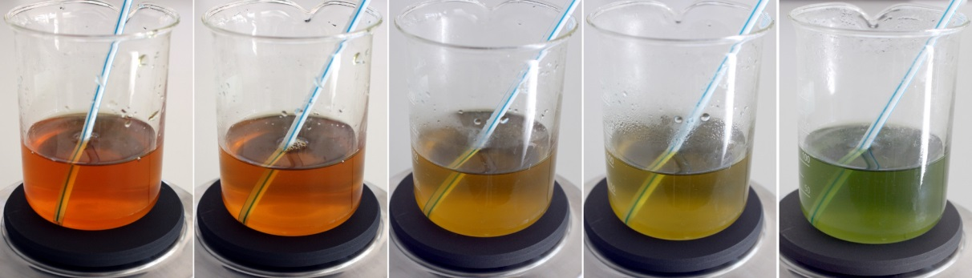
Figure 5: On heating the acidic liquid, the colour starts to change.
What is the pH value you have reached?

Explain why heating the acidic water neutralises it.

Now imagine the oceans.
What happens to the temperature of ocean water when it is transported from polar to equatorial regions?

Which waters can store more carbon dioxide? Polar or equatorial? Remember the analogy of the soda at room temperature.

What happens to the carbon dioxide dissolved in the ocean water on heating?

Now imagine the oceans being heated by global warming. What happens to the carbon dioxide stored in the water?

Background information

The carbon cycle
The Earth is a dynamic system that exchanges energy and materials between different spheres and outer space. One of the important circulation systems is the carbon cycle.
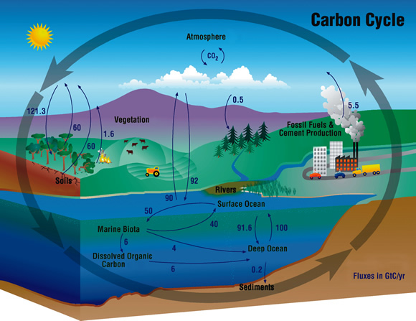
Figure 6: The annual flux of CO₂ in GigaTons (Gt) or billions of tons between each of the Earth's reservoirs. Each reservoir serves as both a source of and a sink for carbon, as indicated by opposing arrows. The carbon released by burning fossil fuels is an unbalanced contribution to the global carbon budget. Its contribution has increased from 5.5 Gt to 7-8 Gt between 2003 and 2007 (NASA/AIRS, https://www.flickr.com/photos/atmospheric-infrared-sounder/8265010034, https://creativecommons.org/licenses/by/2.0/legalcode)
Carbon is altered chemically and its compounds attain different physical states. Usually, the exchange of carbon between the lithosphere, the hydrosphere, the biosphere and the atmosphere is maintained in a delicate and naturally balanced equilibrium, with carbon sources and carbon sinks being in constant interaction. Sinks and sources are defined as subsystems that capture carbon or release it into the atmosphere where they act as greenhouse gases like carbon dioxide or methane.
However, human activities constantly increase the imbalance in carbon sources, leading to a growing concentration of carbon-based greenhouse gases. As Figure 8 illustrates, the amount of atmospheric CO₂ has increased dramatically since the beginning of the 20th century. The growth rate is unprecedented for the recent several hundred thousand years. There is a broad consensus among climatologists that this contributes significantly to the global warming seen today.
Table 1: Natural and artificial carbon sources and sinks.
Carbon sources | Carbon sinks
Volcanos | Oceans and lakes
Organic decay | Vegetation by photosynthesis
Natural forest/bush fires | Reforestation
Fossil fuel production and combustion | Precipitation
Deforestation by fire clearing | Industrial production of atmospheric gases
Waste incineration | Carbon capture and storage methods
Gas hydrates
Waters
Livestock
Rice farming
Manure management
Waste management
Industrial manufacturing

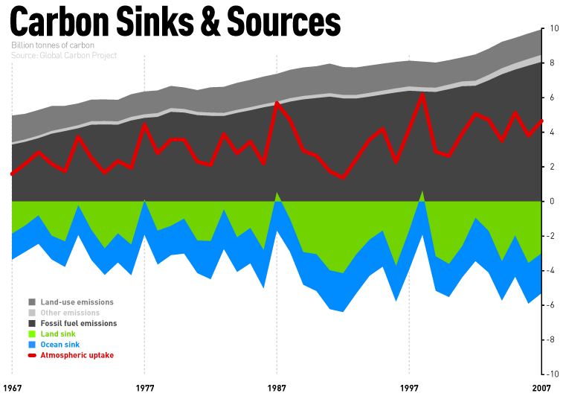
Figure 7: Evolution of the budget of carbon sinks and sources (climatesafety, https://www.flickr.com/
photos/climatesafety/4745854611, https://creativecommons.org/licenses/by-nc/2.0/legalcode).

Carbon dioxide concentrations can be measured both by sensors on ground and with dedicated Earth observation probes from space by remote sensing. Successful space programmes for monitoring greenhouse gases globally are Europe’s Envisat, Japan’s GoSat as well as NASA’s OCO-2 satellite. Europe’s Copernicus programme with its Sentinel satellites will also help understand the effects of increasing levels of greenhouse gases released into the atmosphere.
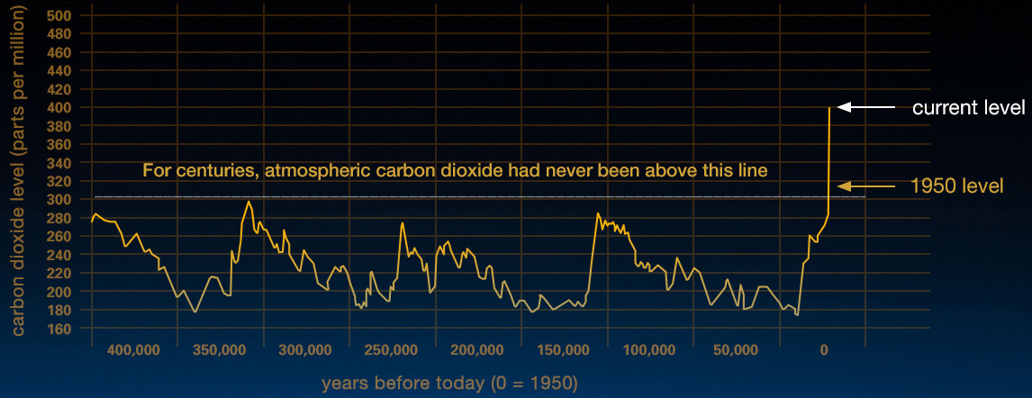
Figure 8: This graph, based on the comparison of atmospheric samples contained in ice cores and more recent direct measurements, provides evidence that atmospheric CO₂ has increased since the Industrial Revolution until February 2016. (Vostok ice core data/J.R. Petit et al.; NOAA Mauna Loa CO₂ record/NASA/JPL, http://climate.nasa.gov/evidence/, public domain).

The pH value
The pH value is a measure of the strength of acids. Its value represents the concentration of free hydron (${\text{H}}^{+}$) or hydronium (${\text{H}}_{3}{\text{O}}^{+}$) ions. The value is defined as:
$$p\text{H}= -{\text{log}}_{10}\left(\frac{c({\text{H}}_{3}{\text{O}}^{+})}{\frac{\text{mol}}{\text{l}}}\right)$$
The concentration of hydronium ions $c({\text{H}}_{3}{\text{O}}^{+})$ is given in units of moles per litre. The mole is a standard unit for the amount of a given substance. pH indicators change their colour depending on the pH value of the solution. This helps measure the pH value.

Oceans as a carbon sink
Up to 30-40% of manmade carbon dioxide is captured in oceans, rivers and lakes. The gas efficiently dissolves in water. Therefore, oceans are a very powerful and significant carbon sink.

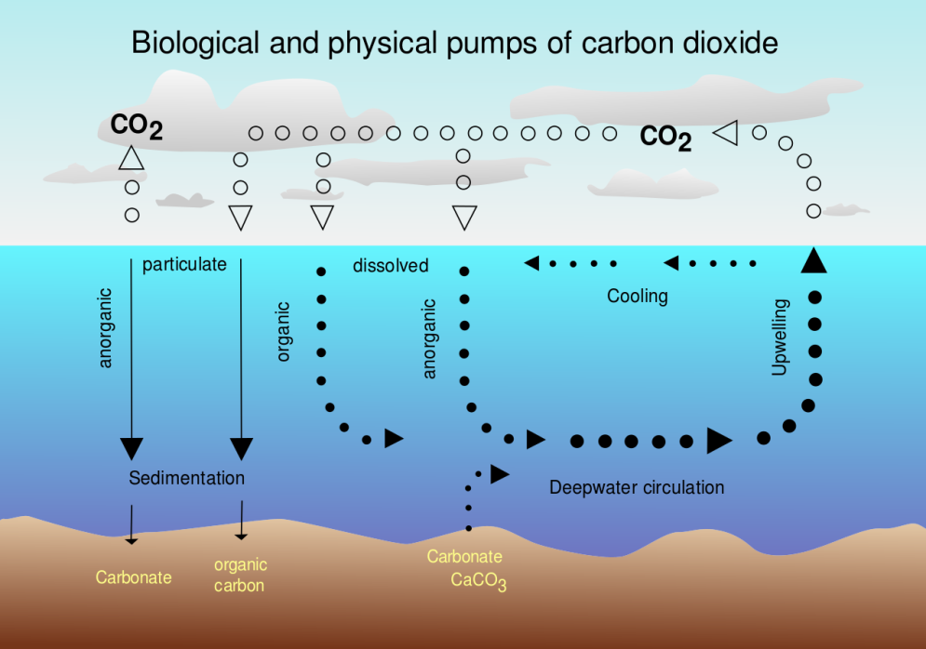
Figure 9: Air-sea exchange of carbon dioxide (McSush (modified), Hannes Grobe (original), https://commons.wikimedia.org/wiki/File:CO2_pump_hg.svg, https://creativecommons.org/licenses/by-sa/2.5/legalcode).
Although the ability of water to capture and store CO₂ helps in reducing greenhouse gases, it comes at a high price. The dissolution of ${\text{CO}}_{2}$ in water changes its chemistry. As a result, the water becomes more acidic. The acidification and its consequences can be split up into three chemical reactions. First, carbon dioxide and water form carbonic acid.
$${\text{CO}}_{2}+{\text{H}}_{2}\text{O → }{\text{H}}_{2}{\text{CO}}_{3}$$
The acid is immediately split up into its ions, one of which is the hydron ion, which also reacts to form the hydronium ion ${\text{H}}_{3}{\text{O}}^{+}$. The free hydron or hydronium ions are characteristic of an acid. This is reflected in the definition of the pH value (see above).
$${\text{H}}_{2}{\text{CO}}_{3} →{\text{H}}^{+}+{\text{HCO}}_{3}^{-}$$
The acidic solution reacts with carbonate ions that are abundant in ocean water. They are the building blocks e.g. for the exoskeletons of shellfish like snails, mussels as well as corals.
$${\text{H}}^{+}+{\text{CO}}_{3}^{2-}→{\text{HCO}}_{3}^{-}$$
These reactions occur at the surface of waters like the oceans. As a result, the formation of carbonate compounds like lime is hindered, or in extreme cases, existing exoskeletons can even get dissolved. The net equation of the reaction chain is shown in Figure 10.
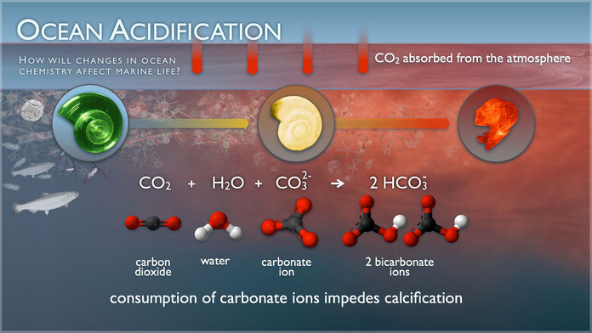
Figure 10: Illustration of how CO₂ dissolved in water consumes carbonate ions. It impedes calcification or even may lead to decalcification of sea shells (NOAA PMEL Carbon program, NAOO public domain).
Although the salinity of sea water mitigates the effect of acidification, the tendency remains. Apart from in-situ sample measurements, new technologies are available to determine the ocean pH levels on a global scale using remote sensing from Earth observation satellites (Figure 11).
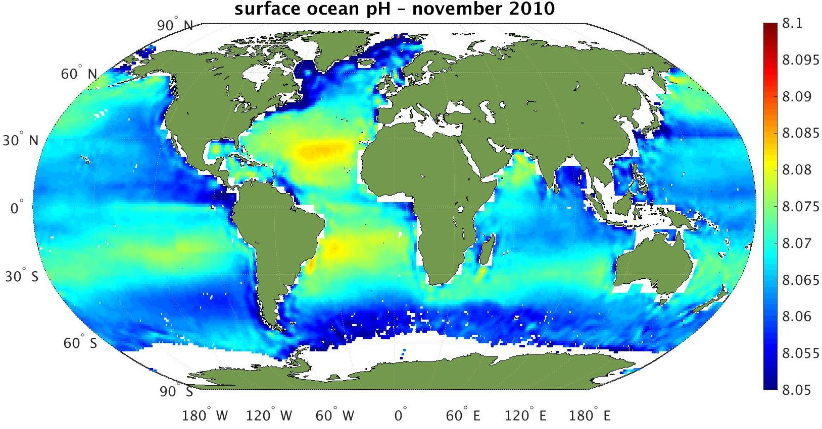
Figure 11: This map shows the first estimates of surface ocean pH using salinity data from ESA’s SMOS with satellite sea-surface temperature measurements and additional auxiliary data. There is a spatial variation of the pH across the globe. Cold waters near the poles tend to be more acidic because of the ability of cold water to better dissolve carbon dioxide than warm water (ESA/R. Sabia, http://www.esa.int/spaceinimages/
Images/2015/01/Surface_ocean_pH, https://creativecommons.org/licenses/by-sa/3.0/igo/legalcode).
Such maps also indicate that polar regions are more strongly affected by acidification than others. This is because cold water can better dissolve CO₂ than warm water. Wide range water currents are known to connect the oceans of the world. As a consequence, water is exchanged between latitudes, and so acidic, i.e. CO₂ rich, water is transported from the poles to the equator regions. The water gets heated up on its way and releases part of the stored CO₂. Therefore, oceans can also be regarded as a regionally confined carbon source.
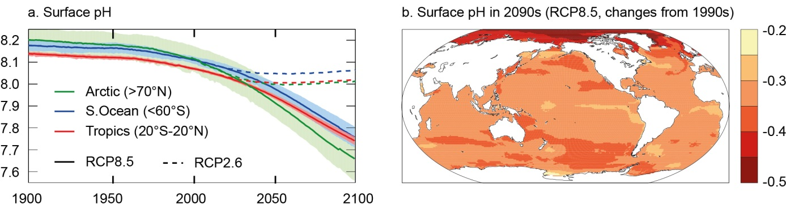
Figure 12: Past and projected evolution of oceanic surface pH levels. The models were calculated for the most optimistic (RCP2.6, Representative Concentration Pathways) and the most pessimistic scenarios (RCP8.5) for the evolution of atmospheric CO₂. (a) Time-series of surface pH shown as the mean (solid line) and range of models (filled), given as area-weighted averages over the Arctic Ocean (green), the tropical oceans (red) and the Southern Ocean (blue). (b) Map of the median model’s change in surface pH from 1990 to 2090 (IPCC Report, 2013, Working Group I, Chp. 6, p. 532).
This influence of water temperatures has also been confirmed by data models that capture the past and projected evolution of global pH levels, as shown in the climate reports of the IPCC (Intergovernmental Panel on Climate Change, see Figure 12). All projections show a stronger acidification of the polar regions than other regions on Earth.

The impact of acidification on marine life
The growing acidification of the oceans and coastal regions endangers the delicate equilibrium of marine life. Several species grow exoskeletons with carbonatic structures (corals, sea snails, mussels, etc.). These carbonates, mostly limestone, dissolve under the influence of carbonic acid. For example, sea snails, also known as sea butterflies, are one of the victims of acidification (Figure 13). Their shell becomes more fragile, which for them is a life-threatening situation. Experiments have shown that such creatures lose most of their shells after exposure to acidification levels expected in the near future. Since they are the basis of an entire food chain, their extinction may have a tremendous impact on a large portion of marine life.
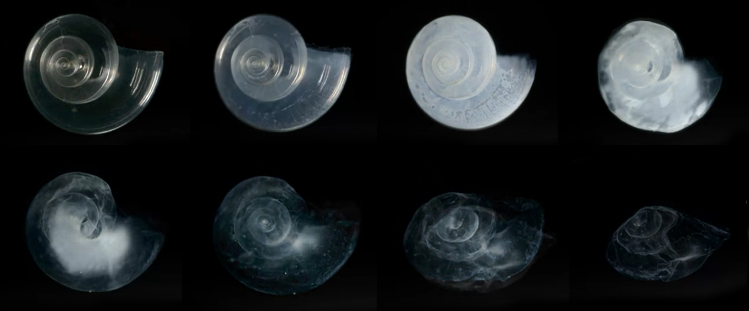
Figure 13: In laboratory experiments, the shell of this sea snail dissolved over the course of 45 days in seawater adjusted to an ocean chemistry projected for the year 2100 (Credit: NOAA Environmental Visualization Laboratory (EVL), https://commons.wikimedia.org/wiki/File:Pterapod_shell_dissolved_in_seawater_ adjusted_to_an_ ocean _chemistry_projected_for_the_year_2100.jpg, public domain).
Another example is microscopic, single-cell algae called coccolithophores (Figure 14). They form shells that consist of calcium carbonate scales. After they die, they sink to the sea floor. This process removes carbon from the global carbon cycle. If the formation of the carbonate shell is impeded, this carbon sink becomes less effective.

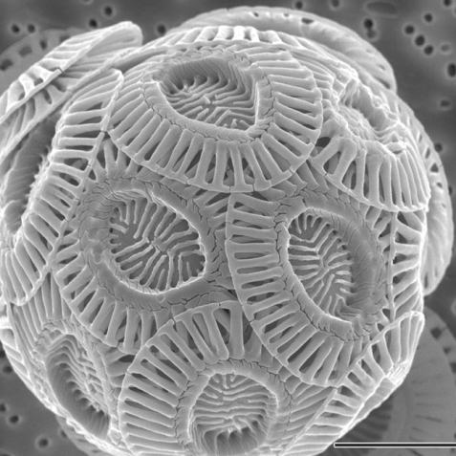
Figure 14: Image of a single coccolithophore cell produced with a high-resolution scanning electron microscope (Credit: Alison R. Taylor (University of North Carolina Wilmington Microscopy Facility) (https://commons.wikimedia.org/wiki/File:Emiliania_huxleyi_coccolithophore_(PLoS).png), https://creativecommons.org/licenses/by/2.5/legalcode).

