Worksheet 2: Where On Earth Am I?

Purpose of this activity
During this activity, you will investigate how a satellite navigation system like the GPS determines your location on Earth. A scenario is constructed in which you will have to pinpoint your location somewhere in Europe based on the measurements of the signal travel times from four simulated satellites. As a bonus exercise, you may even use the simulated measurements to correct the clock of the satellite receiver. In this way, you can use the GPS to measure time. In order to simplify the calculations, everything is done assuming a flat geometry. Natural influences that modify the satellite signals are neglected.

Activity: Lost in no-man’s land

Materials
- Worksheet 2
- Compasses (drawing tool)
- Pencil
- Ruler (at least 20 cm)
- Calculator

Background story
Imagine you were abducted by aliens and taken on a ride across the Solar System. On your return, you were dropped off somewhere in Europe. You have no idea where you are, but luckily you have your GPS receiver with you that should guide you to a place from where you can call help or return home.
But … oh no … the receiver is broken. Instead of showing your location on Earth, it only displays the signal travel times of four receiving satellite signals. You will have to do it all by yourself.
Since the clock in the receiver is not accurate, the time on the display can be off from the true value. But you can deal with that later. With the map you find in your pocket and the working calculator tool of the GPS receiver, you should be able to get along.

Instructions
The time the signals take to reach you is given in milliseconds (1000 ms = 1 s).
Radio signals are transmitted at the speed of light, so you only have to use the constant value of that speed (c = 299792.458 km/s) to convert the time into a distance.
Example:
Let us assume that the measured signal travel time is 10 ms (milliseconds). The measured distance to the satellite can be calculated as follows:
Δs = c · Δt
Δs: distance to the satellite
c: speed of light
Δt: signal travel time
Δs = 299792.458 km/s · 10 ms = 299792.458 km/s · 0.01 s = 2997.92 km
Be careful to always translate the times from milliseconds into seconds.

What is the scale of the map?
Try to determine the scale of the map as precisely as possible. How many kilometres in real distances correspond to how many millimetres on the map?

________________ km in real distances correspond to _______________ mm on the map.

How far away are the satellites?
For this task, only use the columns labelled ‘measured’ in the table below. Convert the signal travel times of each of the four satellites into a distance on the map. For this, you first translate the times into real distances. Enter the calculated values under the column ‘Distance (km), measured’. Remember that the signal travels at a speed of 299792.458 km/s.
You have already determined the scale of the map. With this, you can calculate the corresponding distance there. Add this value under the column ‘Distance on map (cm), measured’.
Satellite | Signal travel time (ms) |  | Correction (ms) | Distance (km) |  | Distance on map (cm)
 | measured | corrected | meas-corr | measured | corrected | measured | corrected
Sat 1 | 6.49
Sat 2 | 12.68
Sat 3 | 4.64
Sat 4 | 11.87
 |  | Average:

What is your location?
Now that you have determined the distances between your location and the satellites, you can use your compasses to draw arcs that show how far the signals have come. It is the same procedure as illustrated in Figure 2. Begin with satellite no. 1. Your position must be somewhere on the circle or arc drawn by the compasses. Which are the possible countries of your location? Allow for some uncertainty in determining the length of the signal path.
Continue with the other satellites. What do you notice about your likely position after adding each additional signal satellite arc?

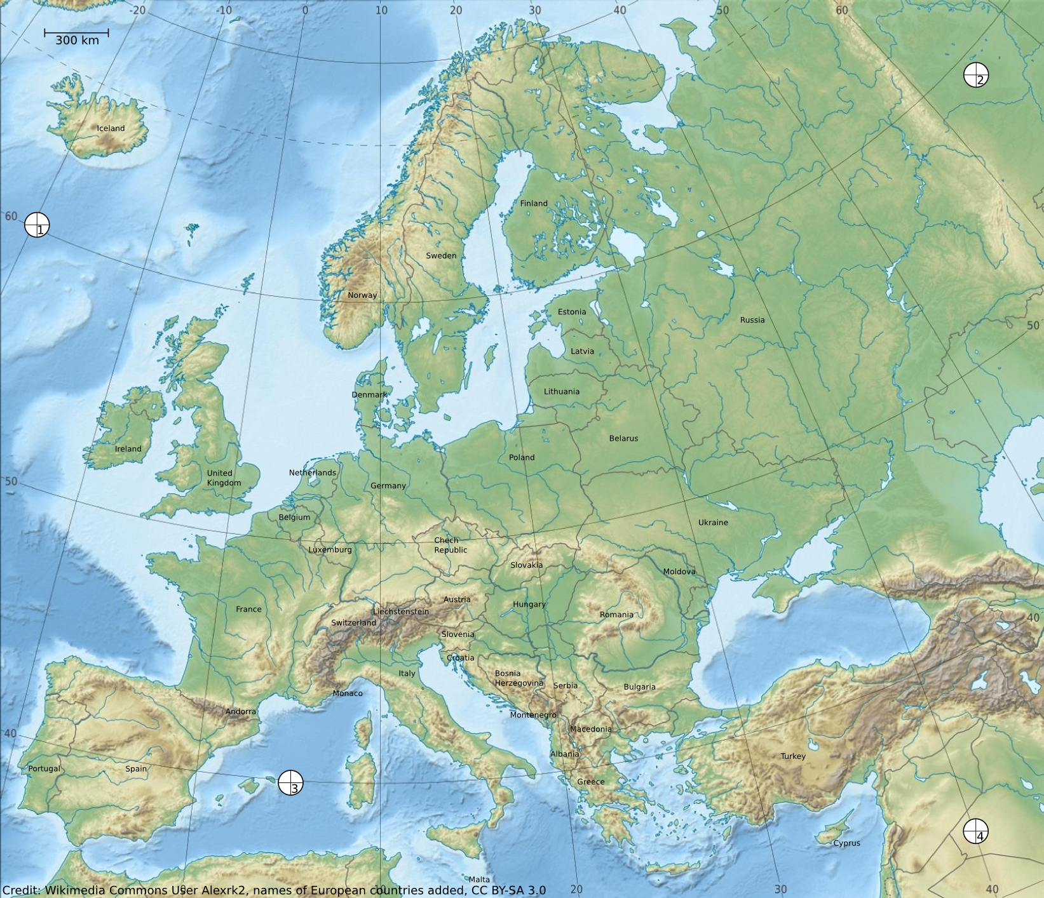
What are the possible countries of your current position?

The correct position must be somewhere inside the area determined above.

Option 1: Simple solution
Estimate the centre of that area.

Option 2: Advanced solution
The common area is surrounded by four arcs. Determine the bisectors of each of them. Then, connect the opposing bisectors with lines. This results in two crossing lines whose intersection can be defined as the centre of mass (see Error! Reference source not found.). It is a good approximation of the true location.
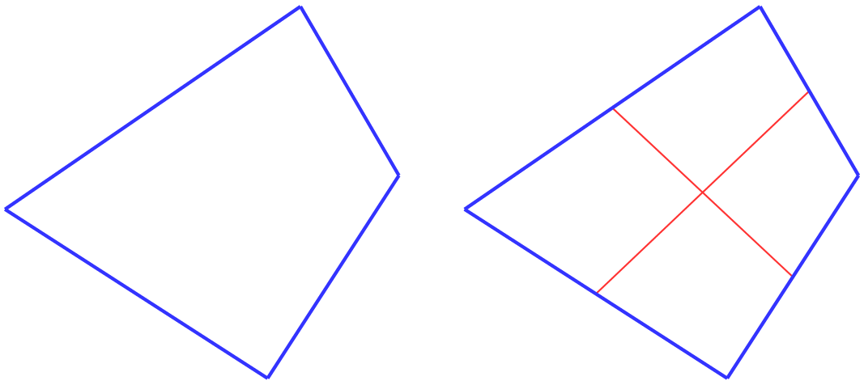
Figure 1: Illustration of how to approximate the centre of mass of an irregular tetragon. The shape is confined by four lines (left). After finding the bisectors of each line, the opposing bisectors are connected with a line (right). The intersection is an approximation for the centre of mass.
In which country are you located?

Optional Activity: Correcting the clock
You notice that the final location is a bit off from the distances you derived from the signal travel times provided in the table. What is the reason for this?

You can use the result to determine by how much the clock in the GPS receiver is off. For this, you only have to translate the error in the distance estimates into an error in the signal travel time. This time, we use the columns labelled ‘corrected’.
Measure the distance from your true location to each of the four satellites on the map. Add these values to the table in the column labelled ‘Distance on map (cm), corrected’.
Convert the map distances into real distances using the map scale. Enter the values in column ‘Distance (km), corrected’.
Convert the distances into signal travel times using the constant speed of light and enter the values in the table under the column ‘Signal travel time (ms), corrected’. Remember the earlier comments about how to convert times into distances and vice versa.
Calculate the difference between the measured and the corrected. Enter the values under the column named ‘Correction (ms), meas-corr’.
Finally, calculate the average of those four values. You simply have to add them up and divide it by the number of the values, i.e. four. This is the amount of time by which the GPS receiver clock is off. It is also the correction to be applied to the GPS receiver clock to get the correct signal travel times.

The GPS receiver clock is off by ____________ milliseconds.

Fun Activity
You can visualise the GPS satellites that are visible from your location using smartphone apps. Reception is usually very bad inside buildings.
Android:
https://play.google.com/store/apps/details?id=com.mictale.gpsessentials

Apple iPhone:
https://itunes.apple.com/de/app/ultimate-gps/id403066634?mt=8

Background Information

Satellite navigation
Navigation is an old technique that allows a person to locate a position on Earth. For this, one needs known reference points from which one’s own position can be derived. Satellite navigation provides moving references, i.e. satellites. The most prominent satellite navigation system is the Global Positioning System (GPS) (see corresponding section below). While hardly anyone knows how it actually works, most people know that is used in car navigation and in modern smartphones.
To derive one’s own location on Earth, the basic step is determining the distance to the satellites. From this the desired location can be calculated. This technique is called trilateration. To measure the distance to those satellites, the constant speed of light is used. If one knows the duration a signal takes to travel from the source to the receiver, the known velocity directly yields the distance.
An analogue to this technique is estimating the distance to a thunderstorm by noting the time between a bolt of lightning and the sound of thunder. Since lightning arrives almost instantly, the travel time of the following thunder can be converted into distance. The conversion is done by applying the sound speed. Under normal circumstances, the sound of the thunder travels 1 km in approximately 3 seconds (v = 343.2 m/s).
The challenge with satellite navigation is to exactly measure the signal travel time. Each transmitted signal contains a code that provides information about the satellite, its position and the time of transmission. Every satellite is equipped with an extremely exact and synchronised atomic clock. On receiving the signal, the clock inside the GPS receiver helps calculate the time the signal needed to travel.
Imagine a satellite sends a signal. After a given duration, the signal will have covered the same distance in all directions. Hence, it is transmitted on the surface of a sphere.
For the rest of this activity, the three-dimensional configuration of Earth and the satellites will be represented by simplified two-dimensional illustrations. Therefore, the surface of the satellite signal wave front will be depicted by circles instead of spheres. Consequently, the intersections of two satellite signals are points instead of lines or arcs. This is done to improve the visibility of the illustrations.
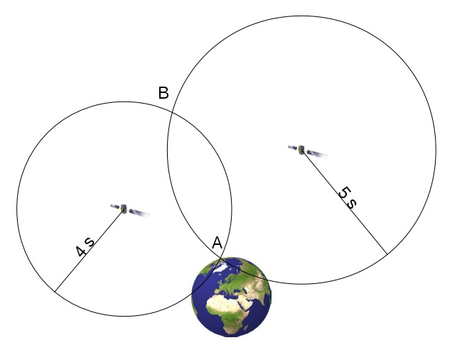
Figure 2: Configuration of two satellites. Position A on the Earth receives the signals after 4 and 5 seconds, respectively. The two signals intersect at points A and B. Since only A is on Earth, B can be discarded.
The principle of positioning is shown in Figure 2. At an unknown position on Earth, the signals of two satellites arrive at 4 and 5 seconds, respectively. Therefore, the location must be at one of the two intersections. Since only A is on Earth, position B can be discarded. However, this only works well, if the signal travel time is measured very accurately. Unfortunately, the clocks of the GPS receivers are usually quite inaccurate. If, for example, the receiving clock is 0.5 s fast, the measured intersection is A’ instead of A in Figure 3. The positioning is equally inaccurate. Therefore, at this step, the term pseudorange is introduced, which is the assumed distance to one of the satellites derived from the face values of time measurement.
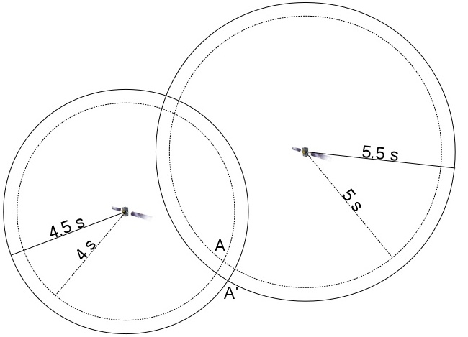
Figure 3: The same configuration as in Figure 2, but this time with a receiving clock running 0.5 s fast. Therefore, the signal transmission times are measured to be 0.5 s longer. This results in an intersection at A' instead of A.
This error can be reduced by adding another satellite (Figure 4). Again, the signal travel time is erroneously measured as 0.5 s later. This configuration is different from the previous situation with two satellites as it produces three intersections. It now becomes obvious that the measurement is inaccurate, and the true position must be surrounded by the apparent ones.
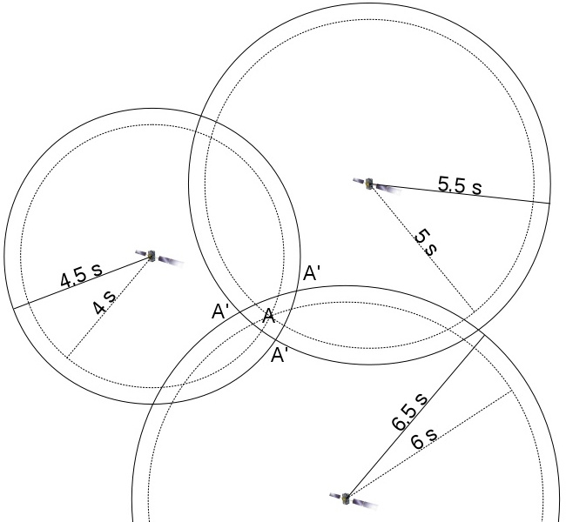
Figure 4: A third satellite is added, whose signal travel time is measured also measured wrongly. This leads to three intersections A' surrounding the true position A.
The GPS receiver notices the incompatible pseudoranges. It initiates an algorithm that changes the time of the receiver clock until a common intersection is found, or the difference between the pseudoranges is minimised. The GPS receiver clock can be corrected accordingly, and that speeds up the following positioning attempts. Each additional satellite improves the precision.
As mentioned before, this illustration uses a 2-D configuration. In reality, at least four satellites are needed to locate a position on Earth with acceptable accuracy.

Modern applications of satellite navigation
Initially, satellite navigation was developed for military purposes. Today, it is crucial for many modern commercial businesses and transport services. Often, we do not even notice that satellite positioning is involved. Different navigational techniques that were introduced for a large variety of transport vessels have now been replaced by satellite navigation (cars, trucks, ships, airplanes). They play a role in services as simple as package tracking and as complex as helping businesses distribute their goods. Satellite navigation can also help save lives; for example, an autonomous emergency system can automatically transmit the location of a car that has been involved in an accident.

GPS and Galileo
Global systems of satellites used for positioning and navigation are called global navigation satellite systems (GNSS). The most renowned GNSS is the GPS (Global Positioning System), or officially Navstar GPS. It was developed by the US military in the 1970s. Currently, it consists of 32 satellites, of which at least 24 are always operational. They are orbiting Earth at an altitude of 20200 km and on 6 trajectories inclined with respect to each other.
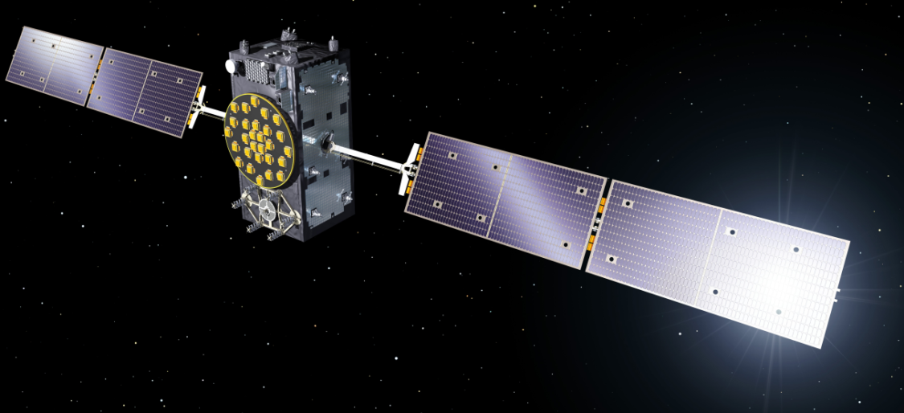
Figure 5: Computer image of a Galileo satellite (Credit: ESA/P. Carril).
Although it was originally designed for military purposes, its full capabilities have been available for general and civil use since 2000. Nevertheless, the USA holds the right to artificially reduce the accuracy of the GPS for tactical reasons at any time. Since many civilian applications rely on fully working services of the GPS, they are potentially in constant danger to fail.
This is one reason, and not necessarily the least, why the European Union (EU) decided to develop their own GNSS called Galileo to be controlled by civilian authorities. However, it is also intended to serve tactical, security and defence purposes.
At the same time, the USA is currently working on a third generation of the GPS. The new satellites will be equipped with an additional signal band that makes them compatible with the Galileo system. Moreover, they will lack the option to intentionally reduce the accuracy of the positioning.
In 2017, the fleet of 30 Galileo satellites, of which 6 are spares, is still incomplete. They will be in three orbits inclined with respect to one another and at an altitude of 23222 km. First services were initiated in 2016. Full operations are expected to start in 2020.
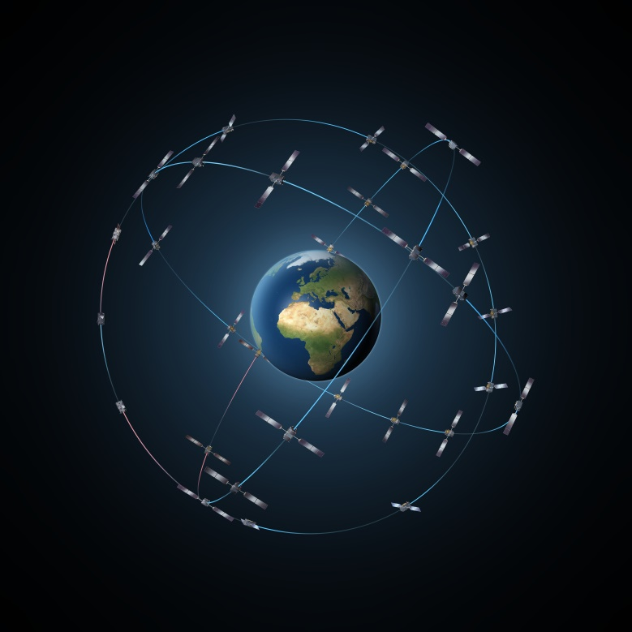
Figure 6: Illustration of the satellite orbits of the Galileo GNSS (Credit: ESA/P. Carril).

Signal speed
Radio signals are electromagnetic waves that travel at the speed of light. In vacuum conditions, its value is 299792458 m/s.

Glossary
Trilateration
Navigational technique to determine a position by measuring the distances to at least three reference points.
Pseudorange
The calculated distance to the reference points used in trilateration without applying the necessary corrections. The pseudorange is purely based on the face values of the underlying measurement.
Bisector
Mid-point of a straight line.

