The Quest for Longitude – Supplemental Background Information

Local time and time zones
The Sun attains its highest elevation during the day when it crosses the local meridian. In the northern hemisphere, this is in the south, while in the southern hemisphere, it is north. This is what defines local noon. Since the Earth rotates continuously, the apparent position of the Sun changes as well. This means that at any given point in time, ‘local noon’ is actually defined for a single longitude only. However, clocks show a different time. Among other effects, this is mainly due to the time zones (Figure 1). Here, noon happens at many longitudes simultaneously. However, it is obvious that the Sun cannot transit the meridian for all those places at the same time. Therefore, the times provided by common clocks are different from the ‘natural’ local time a sundial shows.
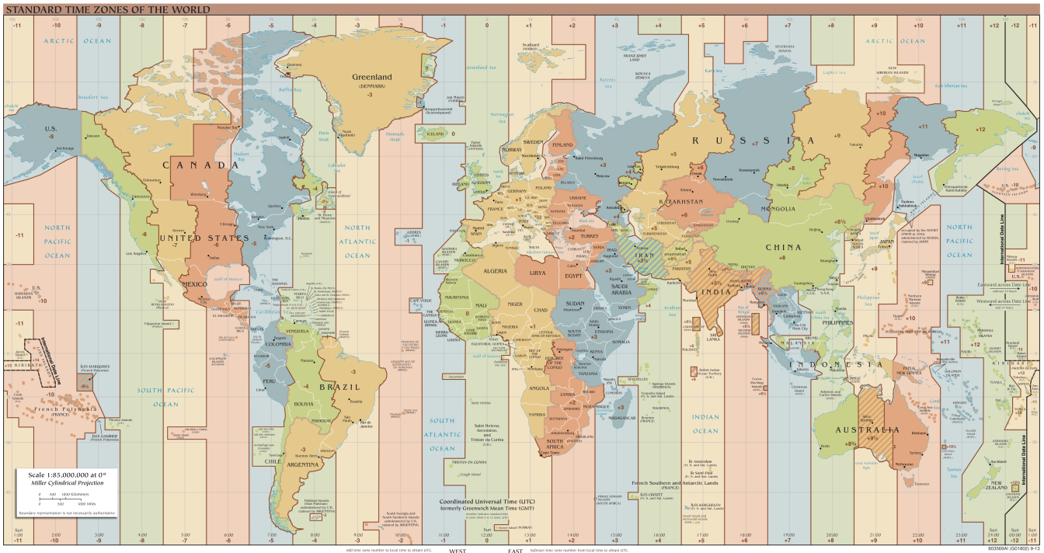
Figure 1: World time zones. Instead of the local time, which is based on the apparent path of the Sun in the sky and valid for single longitudes only, the common clocks show a time based on time zones, which apply to many longitudes simultaneously (Credit: TimeZonesBoy, https://commons.wikimedia.org/wiki/File:Standard_World_Time_Zones.png, https://creativecommons.org/licenses/by-sa/4.0/legalcode).

Determining longitude
With the Earth’s rotational rate,
$$ω=\frac{360°}{24 \text{h}}=15\frac{°}{\text{h}}$$
one can determine the longitude if both the time at the Prime Meridian and the local time are known. If one calculates the difference between these times, the longitude can be derived by simply multiplying this number with 15.
This concept was already proposed by the ancient Greek mathematician Hipparchus, who lived in the 2nd century BCE.
Several methods have been tried and used in history to determine this time difference. Many involve the exact prediction of astronomical events that can be observed anywhere on Earth (eclipses, lunar distances to known bright stars, constellations of Galilean moons around Jupiter). Ships used to take along tables with the times at 0° longitude for such events. But they often turned out to be too difficult to observe on a rocking ship.
The breakthrough was achieved by John Harrison, an 18th century clockmaker, who managed to invent highly accurate clocks that would work even on ships. His fourth version, the H4, had the design of a large pocket watch that always took along the local TST (True Solar Time) of Greenwich or, more precisely, of the Prime Meridian.
All navigators had to do was to determine their local time, which was usually done at local noon, when the Sun passes the local meridian.

The Search for the Longitude
While determining latitude with high accuracy has been possible for many centuries, tools and methods to determine longitude had been a long-standing problem in navigation. Until the 18th century, navigators mostly had to rely on their experience. The only reasonably effective method employed, for example, by early European explorers like Christoph Columbus, was ‘dead reckoning’. This method is used to plot a ship’s course by regularly recording its sailing direction and speed. The tools employed for this were the magnetic compass and the log. The latter is a simple wooden board that is attached to a long rope wound on a reel. The rope had knots tied at regular distances. When thrown overboard, the log unrolls the rope. Counting the knots for a defined amount of time yields the ship’s speed in knots (nautical miles per hour).
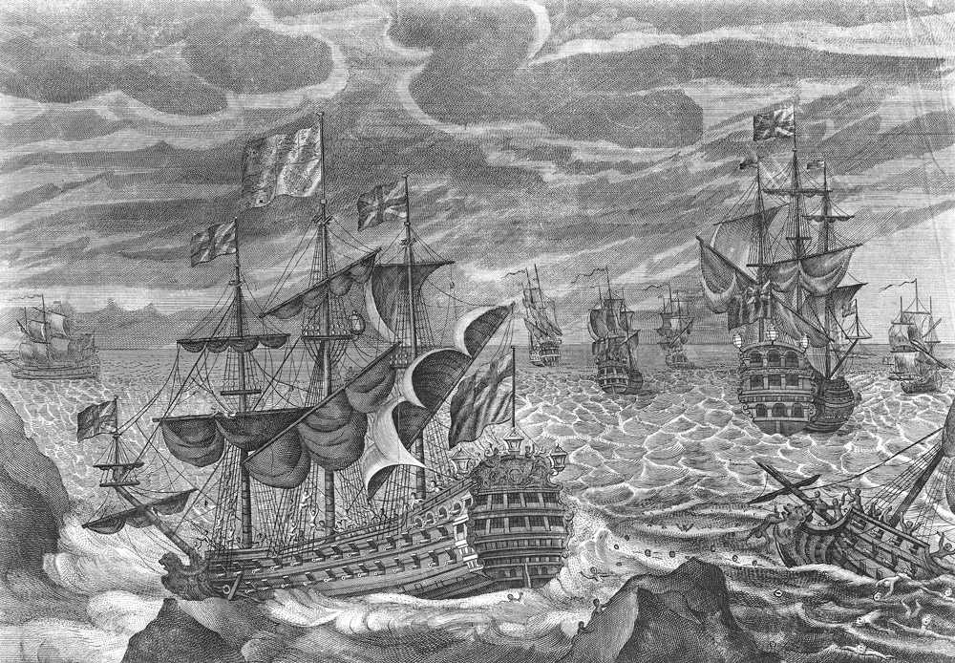
Figure 2: Engraving from the 18th century showing the sinking HMS Association during the Scilly Islands naval disaster (https://commons.wikimedia.org/wiki/File:HMS_Association_(1697).jpg, public domain).
Unfortunately, there are several factors on the open sea (wind, currents) that affect the course and speed. And such modifications were difficult to estimate, which often led to misjudgements and, not seldom, to catastrophic events.
One prominent example was the loss of a British fleet at the Scilly Islands in 1707. On 22 October 1707, the navigators on board the flagship of the Commander-in-Chief of the British Fleets, Sir Cloudesley Shovell, the HMS Association, believed they were just entering the English Channel near Brittany. However, the island they saw belonged to the Scilly Islands just west of Cornwall (Sobel, 2013). When they realised their mistake, it was too late. Four of the five ships were lost, and with them, the lives of some 1500 sailors. Legend has it that poor Sir Shovell, who barely survived this disaster and just made it to the shores of the islands, was struck dead by a woman for a valuable emerald ring he wore on his fingers (Pickwell, 1973; Sobel, 2013).
This naval catastrophe was probably the incident that convinced the British government of the need for a better way to determine longitude. In 1714, the Longitude Act was passed by the parliament of the United Kingdom (Higgitt & Dunn, 2015; Sobel, 2013). It provided rewards of up to £20,000 for finding a method that allowed navigators to determine longitude within half a degree. A Board of Longitude was set up to evaluate the submissions.
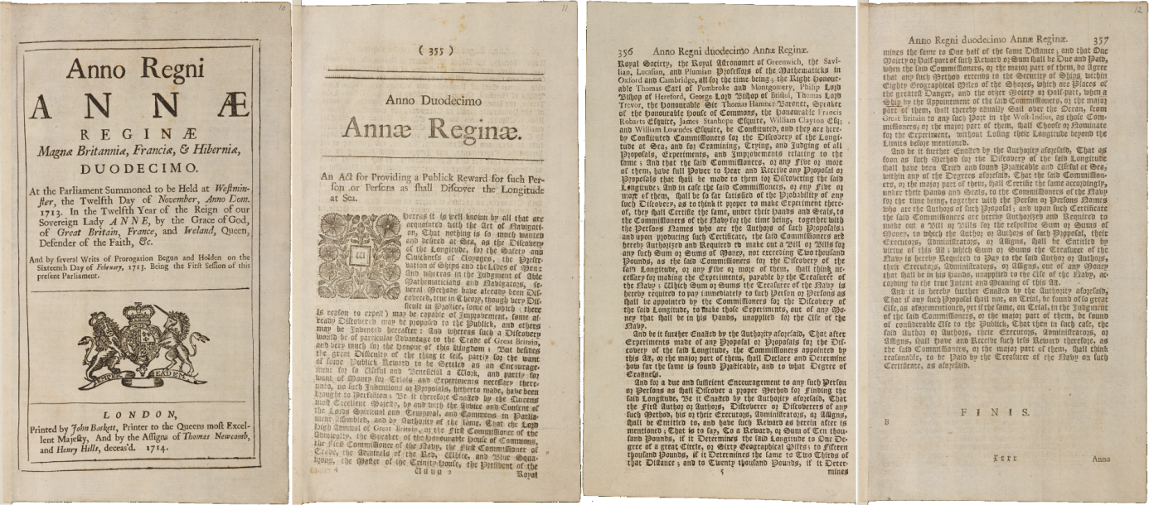
Figure 3: Transcript of the initial version of the Longitude Act issued by the British Parliament in 1714 (Cambridge University Library, https://cudl.lib.cam.ac.uk/view/MS-RGO-00014-00001/19, https://creativecommons.org/licenses/
by-nc/3.0/legalcode).
Astronomical methods already existed, but they were either not accurate enough or impractical at sea. But there was one thing they all had in common: the sailors had to be able to determine the difference in time, apparent solar time or true solar time, that is, between their own position and the Prime Meridian. From this, one was able to infer the difference in angle the Earth had rotated between the local noons of the two longitudes. These methods included lunar eclipses, lunar distances to known bright stars and configurations of the Galilean moons around Jupiter. All these events were tabulated for Greenwich local time and could be correlated to local times when observed at sea.
The most promising method among the many was the one that involved lunar distance. However, neither the exact orbit of the Moon nor the positions of the stars were known accurately enough for navigational purposes. As a result, several observatories in Europe were founded to improve this situation.
A much simpler method would have been to take along a clock that always displayed the time of the Prime Meridian. However, clocks manufactured until the early 18th century were neither accurate enough nor fit for sea voyages. This all changed with one person: John Harrison.

John Harrison
John Harrison (Figure 4) was an extraordinarily skilled English clockmaker in the 18th century. He made many inventions (Taylor & Wolfendale, 2007) that paved the road to the nautical chronometers which revolutionised navigation (Royal Museums Greenwich, 2015; Sobel, 2013).
After building several pendulum and church tower clocks that reached an unprecedented precision and longevity with only little maintenance needed (McArthur-Christie, 2015), he presented his first marine timekeeper in 1735, the H1 (Betts, 2006; Sobel, 2013). It was successfully tested during a journey from London to Lisbon and back. Harrison received several grants from the Board of Longitude to continue his work and improve on this model. In 1759, he managed to present a revolutionary design of a compact watch, the H4 (Shepherd, 2013). His son, William, took it on a transatlantic journey to Jamaica in 1761 and demonstrated its outstanding performance. The clock had only lost five seconds after being at sea for 81 days (Sobel, 2013).
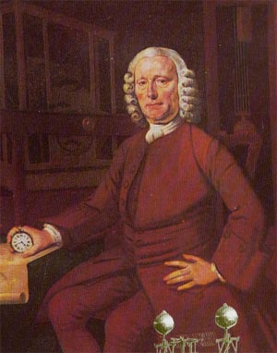
Figure 4: Portrait of John Harrison (Credit: Oil painting by Thomas King, 1767, Science Museum, London, public domain).

Captain James Cook
Captain James Cook (Figure 5) was a British explorer, navigator and cartographer in the 18th century and a captain of the Royal Navy. He is famous for his three voyages to and through the Pacific Ocean. On his first voyage, Cook was the first to map the entire coastline of New Zealand and the eastern coast of Australia. He also made first contact with aboriginal tribes there. The spot of his first landfall was later named Botany Bay, just south of present-day Sydney (Cook, 2014).
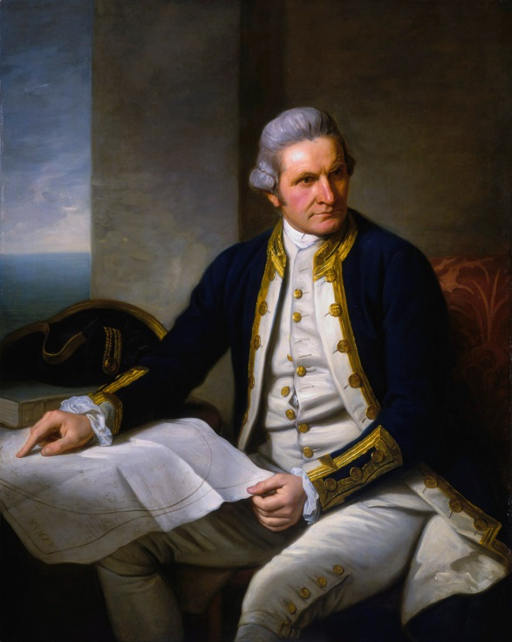
Figure 5: Portrait of Captain James Cook (Credit: Painting by Nathanial Dance-Holland, 1775-1776, National Maritime Museum, UK, public domain).
However, for our purposes, it is Cook’s second voyage from 1772 to 1775 (Cook, 1772) that interests us more (Figure 6). He took along a replica of John Harrison’s H4 watch to test its accuracy and its ability to determine longitude. It was manufactured in 1769 by Larcum Kendall and was known as the K1 (Betts, 2006). It proved very reliable and contributed to the success of clocks for determining longitude. This method surely has also played a role in the success of the Global British Empire, which was mainly based on the ability to control the oceans and intercontinental trade.
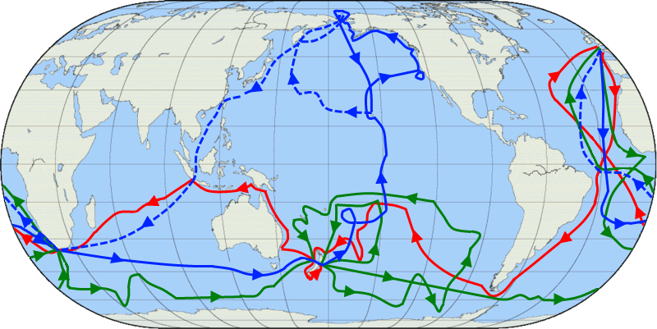
Figure 6: Map showing the three voyages of Captain James Cook, with the first coloured in red, second in green and third in blue. The route of Cook’s crew following his death is shown as a dashed blue line (Credit: Jon Platek. Blank map by en:User:Reisio. https://commons.wikimedia.org/wiki/File:Cook_Three_Voyages_59.png, ‘Cook Three Voyages 59’, https://creativecommons.org/licenses/by-sa/3.0/legalcode).

Bibliography
Betts, J. (2006). Time Restored: The Harrison timekeepers and R.T. Gould, the man who knew (almost) everything. Oxford University Press.
Cook, J. (1772). Journal of Captain Cook’s voyage round the world in HMS Resolution (Journal). National Maritime Museum. Retrieved from http://cudl.lib.cam.ac.uk/view/MS-JOD-00020/1
Cook, J. (2014). Captain Cook’s Journal during his First Voyage round the World, made in H.M. Bark Endeavour, 1768–71. (W. J. Lloyd Wharton, Ed.). Cambridge, UK: Cambridge University Press.
Higgitt, R., & Dunn, R. (2015). Introduction. In R. Dunn & R. Higgitt (Eds.), Navigational Enterprises in Europe and its Empires, 1730-1850 (pp. 1–10). Palgrave Macmillan.
McArthur-Christie, M. (2015). The 240 year old pendulum clock that’s more accurate than your watch. Retrieved 25 July 2016, from http://wornandwound.com/the-240-year-old-pendulum-clock-thats-more-accurate-than-your-watch/
Pickwell, J. G. (1973). Improbable legends surrounding Sir Cloudesley Shovell. The Mariner’s Mirror, 59(2), 221–223. https://doi.org/10.1080/00253359.1973.10657899
Royal Museums Greenwich. (2015). Longitude found: John Harrison. Retrieved 25 July 2016, from http://www.rmg.co.uk/discover/explore/longitude-found-john-harrison
Shepherd, D. (2013). Our trusty friend, the watch. In Mapping Our World: Terra Icognita to Australia (p. 185). National Library of Australia.
Sobel, D. (2013). Längengrad (Longitude). (M. Fienbork, Trans.) (Paperback). Munich: Piper Verlag GmbH.
Taylor, J. C., & Wolfendale, A. W. (2007). John Harrison: clockmaker and Copley medalist. A public memorial at last. The Royal Society Journal of the History of Science: Notes and Records, 61(1), 53–62. https://doi.org/10.1098/rsnr.2006.0164

