PLUTO AND CHARON

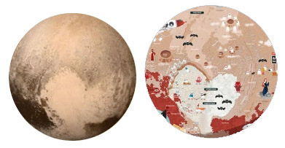

Pluto was discovered in 1930 by Clyde Tombaugh, and first visited by the New Horizons spacecraft in 2015. We originally thought the Solar System only had two zones: the inner rocky planets and the outer gas and ice giants, Pluto didn’t fit. Pluto and the other small icy bodies discovered afterwards define what we now know as the Solar System’s third zone, called the Kuiper Belt. New Horizons showed us that Pluto has tall mountains made of water ice, very bright areas, and dark reddish areas. Sputnik Planitia* is a big low plain of frozen Nitrogen, and Nitrogen glaciers flow into it from the east. Charon’s water ice surface expanded long ago, stretching apart to leave big cracks and cliffs.

Body type: double planet (Pluto and Charon) and irregular moons
Body composition: icy
Atmosphere: Pluto: thin, blue, mostly Nitrogen, Charon: None
Weather: Pluto: Blue sky, some haze, temperature around 40K/-230C/-390F. Nitrogen frost deposition at the deep equatorial ice plains.
Endogenic features: long and deep fractures
Exogenic features: Pluto: ice plains (different ices mixed: nitrogen, methane, CO), glaciers, glacial valleys, pits. Charon: none
Cosmogenic features: Impact craters. Charon: red tholin “cap” may be sourced from Pluto
Common features: craters, cracks, ices
Rare features: valleys, nitrogen glaciers, water ice icebergs
Life limiting parameter: too cold
Nomenclature*: The names on Pluto and Charon aren’t yet offcial, but include characters, creatures, and places from the underworld; explorers that crossed ‘new horizons’ in their own ways; scientists and engineers that have studied Pluto; fictional explorers, vessels, and places; and artists and authors associated with space exploration.
Age of the surface: cratered terrains on both Pluto and Charon are 4 billion years old, but smooth ice plains on Pluto are very young.
Highest point: to be determined. Sputnik Planitia is a deep and very smooth surface. Large cracks on Charon had >10 km cliffs. Water ice is granite hard at these very low temperatures.

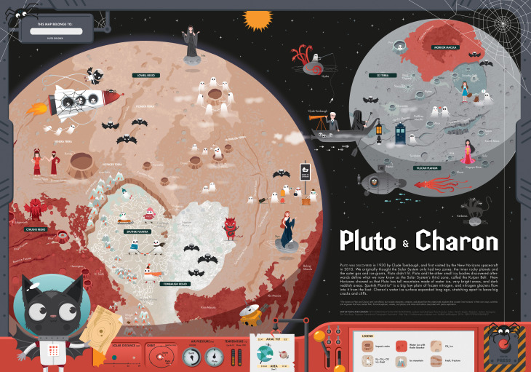

Pluto-Charon map: (Illustrator: Adrienn Gyöngyösi). The map uses the theme of Halloween that is the closest to the Greek underworlds myths. Unlike other maps, this map depicts only one hemisphere of two bodies because only one hemisphere was photographed in detail when New Horizons flew by the system. The sizes of Pluto and Charon are to scale. The southern polar areas were in darkness so it is completely unknown.
The four other, small and irregular moons are also shown on the map with the mythological character they were named for. The surface of Pluto and Charon is both composed of water ice rocks, and in places a reddish brown material is covering it. This material is called tholin and is produced in the atmosphere as the Sun’s radiation interacts with atmospheric molecules.
The left “lobe” of the large “heart” shaped bright feature is partially a large, deep, ancient, elliptical impact basin filled with ice.
There are three kinds of ices on Pluto: nitrogen, methane and carbon-monoxide ices in addition to the bedrock, which is water ice. In the past, the extent of ice cover was different. Pluto has a very elliptical orbit around the Sun so some of its ices may sublimate when it’s closest to the Sun.
Pluto and Charon are tidally locked to each other so they turn the same side towards each other and they orbit around their common center of mass, an invisible point between Pluto and Charon.
The small satellites are affected by both Pluto’s and Charon’s gravity (depending on when they are closer to which) so their orbit and rotation is somewhat irregular.

INSTRUCTIONS / PLUTO–CHARON
ACTIVITY 1
- Draw the Equators
- Mark the North Pole and South Pole of both bodies with letters N and S
- Write the name of each body
ACTIVITY 2 Read the handout, and underline words you don’t understand.
Graphic map. Using the map, draw a generalized (simplified) sketch map, showing the outlines of only the largest and most important features (draw several types of features, e.g., cracks and craters). You can use colors and/or lines.
- Pluto (left circle)
  - Glacial
    - "Heart" shaped frozen nitrogen ice plains (Sputnik Planitia) with cellular terrain and ice mountain peaks
  - Southern dark-red coated regions
  - impact craters
  - tectonic cracks
- Charon (right circle)
  - Tectonic – Equatorial deep chasms
  - Cosmogenic – North Polar red spot (red material coming from Pluto)
  - Impact
    - Few rayed craters
    - Non rayed craters everywhere

ACTIVITY 3 Your landing site. Where would you land? which place you find the most exciting for exploration? Find YOUR landing site. Mark it with a symbol. Name your landing site (s). Write down the names next to the symbol.
ACTIVITY 4 Names. After the graphic part is finished, create the nomenclature: write the names of the features you have drawn next to the feature itself. Write three names (you can add more later) onto the map. You can use different colors or letters for each feature type (e.g, capital letters for continents, red color for the lava channel etc. -- be consistent).
ACTIVITY 5 Make up a weather forecast for "tomorrow", based on the Weather information in the handout. Choose at least three places, and show weather data: display the min/max temperature in your unit (C or F) with LARGE numbers. Consider that on towards the poles it is colder. Next to the numbers, show the weather with a graphic symbol you design: clear (sunny), cloudy, rainy, foggy or any interesting, special weather phenomenon you learn from the handout. Find min/max temperature data on the map's control desk and additional information on the handout.
ACTIVITY 6 Design a flag (either for Pluto, Charon, or for both as one), and draw it on the map, based on the characteristics of the body (weather, color, geology etc).
ACTIVTY 7 Draw a map legend where YOUR symbols are explained on the map. You may group them by process (e.g., exogenic (atmospheric, aeolian), endogenic (volcanic, tectonic) and impact processes). Write down the title “LEGEND” and explain your symbols and indicate which feature it corresponds to.

