IO

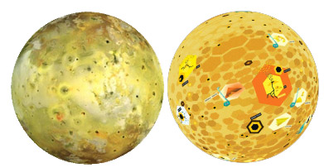

Io is the most active planetary body in the solar system. Even now, dozens of volcanoes eject gas and debris clouds on it. The eruptions spread into the shape of an umbrella; falling back onto the surface, they form a ring around the volcanic centre. There are many volcanoes from which lava flows out regularly. The volcanoes are not high mountains, like on Earth, because Io’s lava is very fluid and easy to flow away. The surface is covered mostly with lava flows coloured yellow by sulphur and a few collapsed volcanic craters, but no impact craters. The surface is made up of layers of lava flows covering each other. There are approximately one hundred mountains, which are pushed up in one piece from the crust along near-surface cracks; they are not volcanoes, but masses of rock derived from the old surface. Io is the nearest large moon to Jupiter, so the attraction of Jupiter affects it the strongest, along with strong tugs from the three large moons orbiting further from Jupiter. This force produces the heat required for volcanism and gives the pressure which raises the mountains.

Body type: moon
Body composition: rocky
Atmosphere: —
Liquid: —
Weather: always cold, 130K/-143C/-225F. Always high particle radiation from Jupiter. Air patches of volcanic sulphur gases near active volcanic eruptions. Ballistic airfall ash near volcanic eruptions. Sulphur snow/frost from volcanic gases. Warm surface (290K/20C/70F) near active lava flows and lava lakes.
Endogenic features: volcanic calderas, lava flows, volcanic plumes and their deposits, tectonic mountain blocks
Exogenic features: “snow” fields (bright plains from precipitating gases from volcanic eruptions)
Cosmogenic features: no craters observed, because lava fields are produced faster than impact craters and lavas bury old craters
Common features: calderas, mountain blocks
Rare features: lava channels, active volcanoes (few dozen)
Life limiting parameter: no atmosphere, high radiation (from Jupiter)
Nomenclature: Gods of fire and Sun, and places and people associated with the Io myth (in greek mythology).
Highest point: Boösaule Montes, a group of mountain peaks
Age of the surface: less than 10 million years old (volcanically so active that new volcanic material covers all surface).
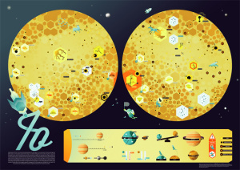Io map: (Illustrator: Dóri Sirály) The map of Io is the most abstract one: its landforms are shown in hexagonal symbols. This approach gives the appearance of honeycomb cells, which is partly related to the yellow color of sulfur and partly to the Io mythology, of which some scenes are also shown. The main task for the graphic artist was to find a balance between scientific accuracy and the needs of the children, all using the minimalist geometric style. The main character is a young astronaut chasing bees (or horseflies). Mountain heights are shown for the highest mountains. Major active volcanic centers are shown as ejecting material. Black calderas are filled with lava, yellow calderas are lava-free. This map has a very simple legend that explains complicated orbital and physical parameters without words, using only visual elements

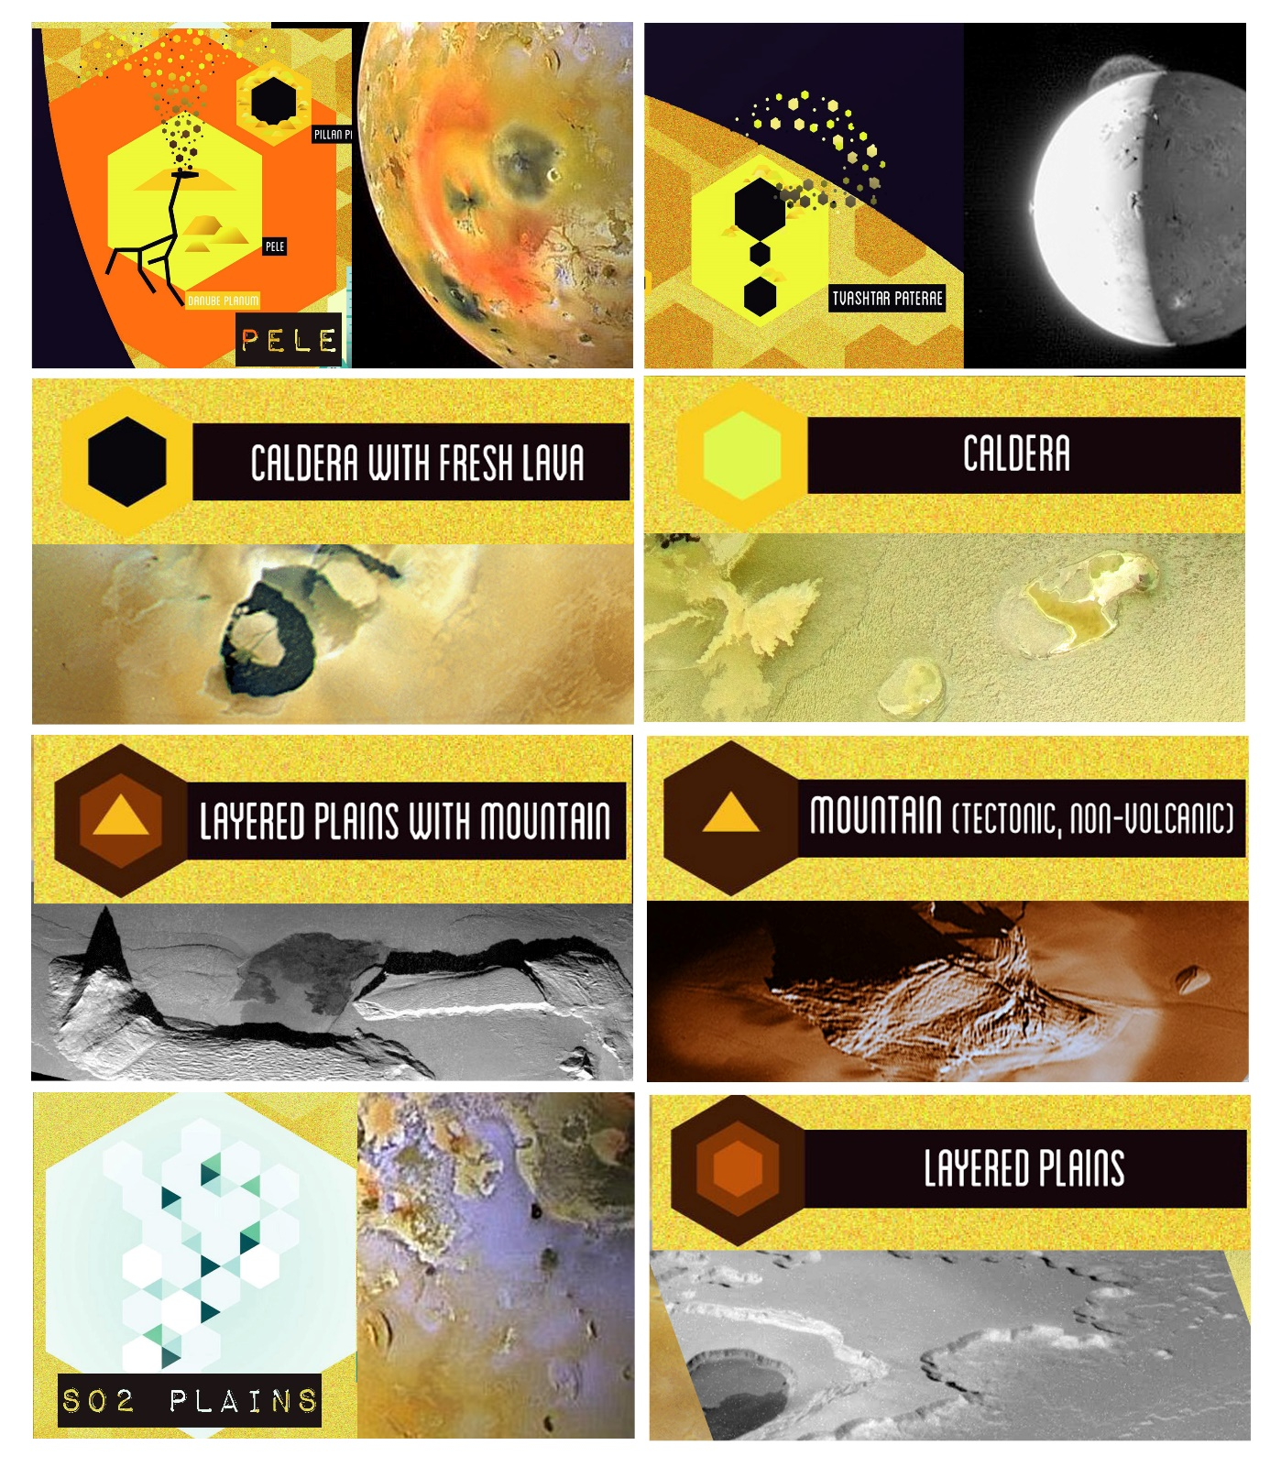
INSTRUCTIONS / IO
ACTIVITY 1
- Draw the Equator
- Mark the North Pole and South Pole in both hemispheres with letters N and S
- Write the name of the body
ACTIVITY 2 Read the handout, and underline words you don’t understand.
Graphic map. Using the map, draw a generalized (simplified) sketch map, showing the outlines of only the largest and most important features (draw several types of features, e.g., cracks and craters). You can use colors and/or lines.
- Volcanic
  - Two major active volcanoes with plumes and deposit rings: Pele, Prometheus
  - Numerous calderas filled with lava, e.g., Loki Patera and other "Patera"
- Tectonic (fractures in brittle crust)
  - Mountain blocks: Haemus Montes, Boosaule Montes and other "Mons"
- Deposits
  - Bright sulphur frost covered regions (e.g., Bactria Regio)
  - In other places: lava flows coated by yellow sulphurous deposit

ACTIVITY 3 Your landing site. Where would you land? which place you find the most exciting for exploration? Find YOUR landing site. Mark it with a symbol. Name your landing site (s). Write down the names next to the symbol.
ACTIVITY 4 Names. After the graphic part is finished, create the nomenclature: write the names of the features you have drawn next to the feature itself. Write three names (you can add more later) onto the map. You can use different colors or letters for each feature type (e.g, capital letters for continents, red color for the lava channel etc. -- be consistent).
ACTIVITY 5 Make up a weather forecast for "tomorrow", based on the Weather information in the handout. Choose at least three places, and show weather data: display the min/max temperature in your unit (C or F) with LARGE numbers. Consider that on towards the poles it is colder. Next to the numbers, show the weather with a graphic symbol you design: clear (sunny), cloudy, rainy, foggy or any interesting, special weather phenomenon you learn from the handout. Find min/max temperature data on the map's control desk and additional information on the handout.
ACTIVITY 6 Design a flag for the planet or moon, and draw it on the map, based on the characteristics of the body (weather, color, geology etc).
ACTIVTY 7 Draw a map legend where YOUR symbols are explained on the map. You may group them by process (e.g., exogenic (atmospheric, aeolian), endogenic (volcanic, tectonic) and impact processes). Write down the title “LEGEND” and explain your symbols and indicate which feature it corresponds to.

