Venus

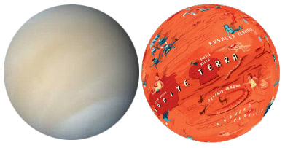

Venus is the hottest planet in the solar system because a runaway greenhouse effect in its thick CO₂ atmosphere traps heat from the Sun. Its surface is mostly covered with plains of solidified lava that welled up from the deep. Lava covered nearly the entire planet; the only areas that avoided it were higher than the level of the lava flood. These uplifted areas are now the oldest exposed areas (their name is tesserae), they are marked with intersecting rifts. In the beginning, there was probably water on Venus, but when greenhouse heating intensified, any water vanished without a trace. If there were ancient seas, any traces of them are today under many kilometers of solid lava. The sun never shines on the surface of Venus, because of the thick cloud layers covering the entire planet. The sulphuric acid rain evaporates before even reaching the surface. Above the clouds, life may be possible, but not in the great heat present below the clouds.

Body type: Planet
Body composition: Rocky
Atmosphere: Very thick atmosphere (from volcanic degassing), full, thick cloud cover, and very hot because of the greenhouse effect (it is also closer to the Sun than Earth).
Liquid: Lava rivers remain liquid for longer than on Earth because it is so hot on the surface
Weather: 480C from pole to equator, day and night. -20C inside the south polar vortex (permanent hurricane’s eye). Sulfuric rain falls at high altitudes. Very dry at the surface. Metal frost on high mountains.
Endogenic features: Millions of small volcanoes on lava plains, long fractures, coronae
Exogenic features: Metal snow at high mountains
Cosmogenic features: About 900 impact craters
Common features: Lava plains, volcanoes
Rare features: “Tesserae” – tectonically reworked old areas; long lava channels (canali), pancake volcanoes, landslides, dunes, anemone volcanoes
Life limiting parameter: Too hot
Nomenclature: Names of women (first names and women scientists) and goddesses. Venus is the “planet of beauty” for its bright appearance in the night or morning sky. (Its bright clouds reflects the sunshine). The only exception is Maxwell Montes, the highest mountain that was discovered in terrestrial radar data before the naming convention was defined.
Highest point: Maxwell Montes, 11 km
Age of the surface: Maximum 1 billion years, surfaces older than this have been covered by lava.
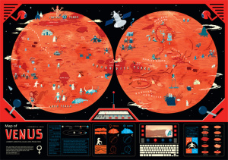Venus map: (Illustrator: András Baranyai) The map shows a wide variety of creatures, from funny to mythological creatures. Before the space age, scientists thought that it could be a hot jungle because it has clouds and is close to the Sun, so it should be rainy. Dinosaurs were discovered at about this time and it was known that the mesosoic era, when dinosaurs lived, was a hot period, so some authors fantasized that there were dinosaur like creatures on Venus. When the first spacecraft arrived on Venus, they realised that it is very hot and any water must have evaporated long ago. The creature shown are derived partly from the early twentieth century view of Venus as a hot jungle with dinosaurs, as well as from the current female-centered International Astronomical Union–adopted nomenclature.
Some of the features that would be invisible at this scale, such as canali (lava channels), are enhanced here for clarity. The redness reflects the hot and lava-covered surface, the only feature that are older are the higher elevated tesserae that are remnants of the past surface. Clouds symbolize that in reality the surface can be never seen from space because the entire planet is blanketed by multiple, very thick cloud layers. Even if there is a hole in one layer, others will hide the surface. The surface topography was studied by radar, which can see through the clouds.

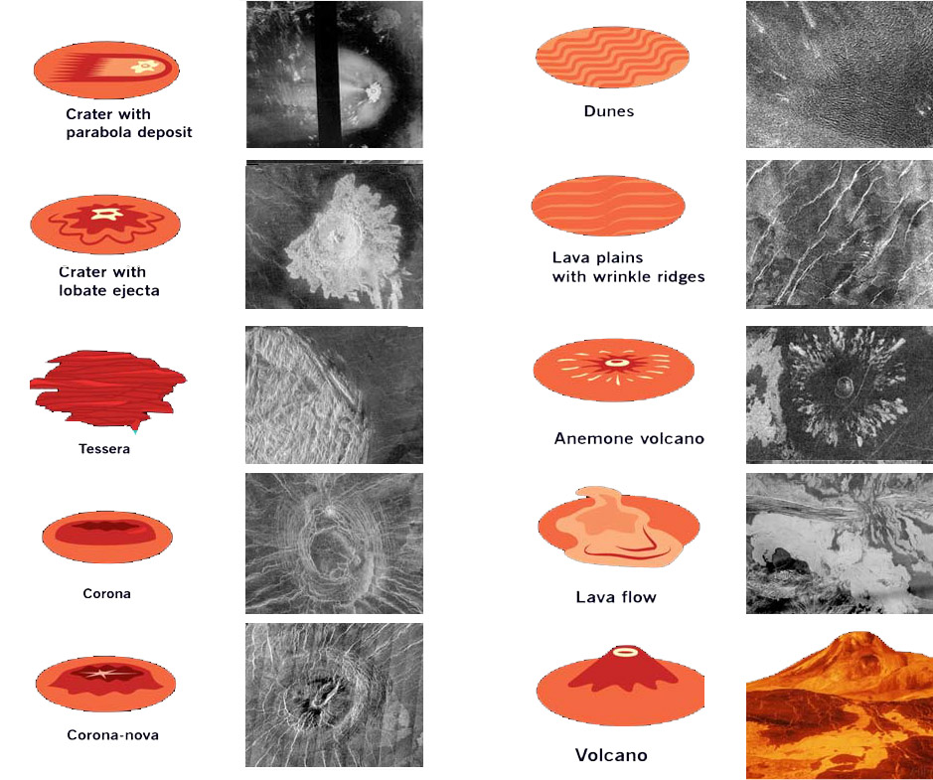

Legend: radar images. Bright areas are rough (rocks), dark areas are smooth (dust/smooth lava flow)

INSTRUCTIONS
ACTIVITY 1
- Draw the Equator
- Mark the North Pole and South Pole in both hemispheres with letters N and S
- Write the name of the body
ACTIVITY 2
Read the handout, and underline words you don’t understand.
Graphic map. Using the map, draw a generalized (simplified) sketch map, showing the outlines of only the largest and most important features (draw several types of features, e.g., cracks and craters). You can use colors and/or lines.
- Tectonic (fractures in brittle crust)
  - Approx. outlines of high standing continents (Ishtar Terra, Aphrodite Terra)
  - Highest mountain range / peak in Maxwell Montes
  - Long crack (trough, graben) of Devana Chasma, Artemis Chasma, the chasms of Atla Regio
- Volcanic (molten magma)
  - The long lava channel of Baltis Vallis
  - Volcanic shields (... Mons) in Atla Regio and South of Ishtar terra
  - In general, all other terrains are lava flows, generally with lots of very small volccanic cones
  - Cricular coronae in the Western hemisphere
- Most famous landers: Venera 9, Venera 10

ACTIVITY 3 Your landing site. Where would you land? Which place you find the most exciting for exploration? Find YOUR landing site. Mark it with a symbol. Name your landing site (s). Write down the names next to the symbol.
ACTIVITY 4 Names. After the graphic part is finished, create the nomenclature: write the names of the features you have drawn next to the feature itself. Write three names (you can add more later) onto the map. You can use different colors or letters for each feature type (e.g, capital letters for continents, red color for the lava channel etc. -- be consistent).
ACTIVITY 5 Make up a weather forecast for "tomorrow", based on the Weather information in the handout. Choose at least three places, and show weather data: display the min/max temperature in your unit (C or F) with LARGE numbers. Consider that on towards the poles it is colder. Next to the numbers, show the weather with a graphic symbol you design: clear (sunny), cloudy, rainy, foggy or any interesting, special weather phenomenon you learn from the handout. Find min/max temperature data on the map's control desk and additional information on the handout.
ACTIVITY 6 Design a flag for Venus, and draw it on the map, based on the characteristics of the body (weather, color, geology etc).
ACTIVTY 7 Draw a map legend where YOUR symbols are explained on the map. You may group them by process (e.g., exogenic (atmospheric, aeolian), endogenic (volcanic, tectonic) and impact processes). Write down the title “LEGEND” and explain your symbols and indicate which feature it corresponds to.

